London Borough of Camden Camden Town Hall Argyle Street Euston Road London WC1H 8EQ  22 February 2018 | Our DTS Ref: 57191 Your Ref: 2018/0645/P

Dear Sir/Madam
Re: BARRIE HOUSE-29, ST. EDMUNDS TERRACE, LONDON, GREATER LONDON, NW8 7QH
Waste Comments
Thames Water would advise that with regard to sewerage infrastructure capacity, we would not have any objection to the above planning application.
Thames Water requests that the Applicant should incorporate within their proposal, protection to the property by installing for example, a non-return valve or other suitable device to avoid the risk of backflow at a later date, on the assumption that the sewerage network may surcharge to ground level during storm conditions.
We would expect the developer to demonstrate what measures he will undertake to minimise groundwater discharges into the public sewer. Groundwater discharges typically result from construction site dewatering, deep excavations, basement infiltration, borehole installation, testing and site remediation. Any discharge made without a permit is deemed illegal and may result in prosecution under the provisions of the Water Industry Act 1991. Should the Local Planning Authority be minded to approve the planning application, Thames Water would like the following informative attached to the planning permission: A Groundwater Risk Management Permit from Thames Water will be required for discharging groundwater into a public sewer. Any discharge made without a permit is deemed illegal and may result in prosecution under the provisions of the Water Industry Act 1991. We would expect the developer to demonstrate what measures he will undertake to minimise groundwater discharges into the public sewer. Permit enquiries should be directed to Thames Water’s Risk Management Team by telephoning 02035779483 or by emailing wwqriskmanagement@thameswater.co.uk. Application forms should be completed on line via www.thameswater.co.uk/wastewaterquality.
Water Comments
Thames Water recommend the following informative be attached to this planning permission. Thames Water will aim to provide customers with a minimum pressure of 10m head (approx 1 bar) and a flow rate of 9 litres/minute at the point where it leaves Thames Waters pipes. The developer should take account of this minimum pressure in the design of the proposed development.
Thames Water recommend the following informative be attached to any planning permission: There are large water mains crossing the proposed development. Thames Water will not allow any building within 5 metres of them and will require 24 hours access for maintenance purposes. Please contact Thames Water Developer Services, Contact Centre on Telephone No: 0800 009 3921 for further information.
No piling shall take place until a piling method statement (detailing the depth and type of piling to be undertaken and the methodology by which such piling will be carried out, including measures to prevent and minimise the potential for damage to subsurface water infrastructure, and the programme for the works) has been submitted to and approved in writing by the local planning authority in consultation with Thames Water. Any piling must be undertaken in accordance with the terms of the approved piling method statement. Reason: The proposed works will be in close proximity to underground water utility infrastructure. Piling has the potential to impact on local underground water utility infrastructure. The applicant is advised to contact Thames Water Developer Services on 0800 009 3921 to discuss the details of the piling method statement.
Supplementary Comments
Water: Thames Water's corporate GIS shows trunk mains on all four sides of this site. From viewing the plans for this site, it appears that the proposed development North of the existing building is sited over two parallel trunk mains. Thames Water will not allow any building within 5 metres of trunk mains.
To the north east of the proposed development sits Barrow Hill Reservoir. There are also easements and wayleaves running throughout the site. These are Thames Water Assets. The company will seek assurances that it will not be affected by the proposed development. On the Map a blue outlined box shows the assets, yellow dashed lines show the easements and wayleaves and the proposed development area is identified by a red outlined box.
The applicant should contact Thames Water to discuss their proposed development in more detail. All enquiries from developers in relation to proposed developments should be made to Thames Waters Developer Services team. Their contact details are as follows:
Thames Water Developer Services
Reading Mail Room
Rose Kiln Court
Rose Kiln Lane
Reading
RG2 0BY
Tel: 0800 009 3921
Email: developer.services@thameswater.co.uk
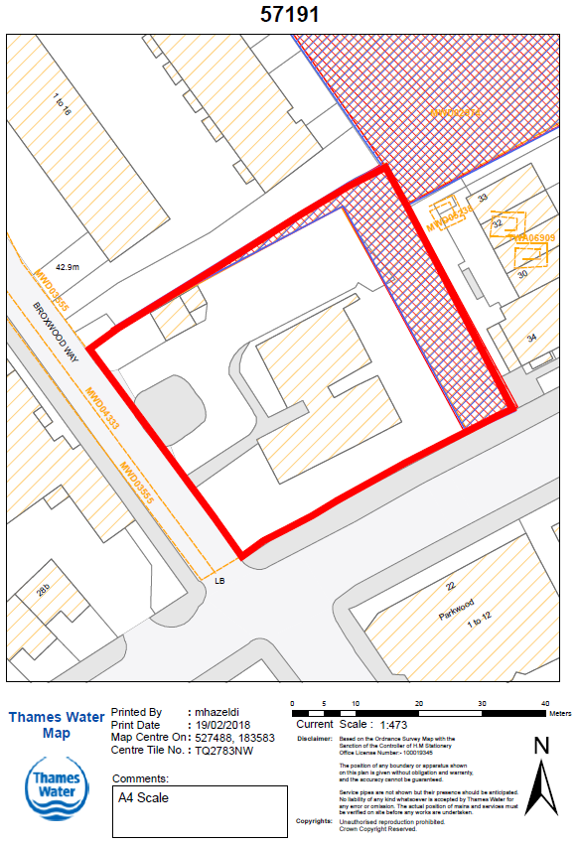
Yours faithfully
Development Planning Department
Development Planning, Thames Water, Maple Lodge STW, Denham Way, Rickmansworth, WD3 9SQ Tel:020 3577 9998 Email: devcon.team@thameswater.co.uk

