**Atunbi Court 3 Farrier Street NW1 8PF**

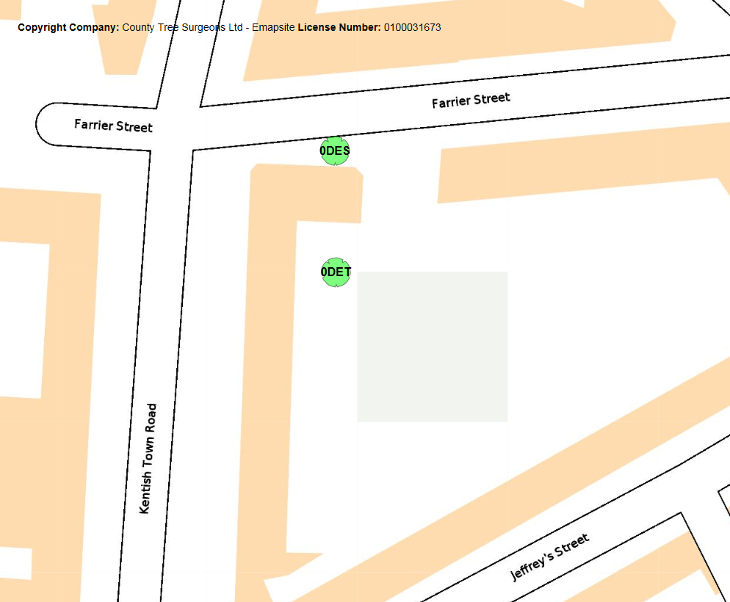



**Proposed works to reshape crowns by no more than 1m to appropriate pruning points to maintain canopy shape and mitigate potential encroachment issues to adjacent footpath, building and car park respectively.**