PBA

DESIGN & ACCESS STATEMENT accompanying householder planning application for work at
flat 1, 4 GLENLOCH ROAD, LONDON NW3 4BU.

As far as they apply, this statement has been prepared in accordance with the headings and guidelines issued by DC-CABE.

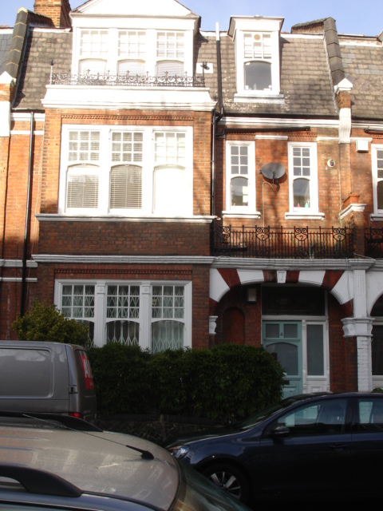

www.peterbradesarchitects.co.uk tel: 020 7226 3884
Peter Brades Architects, 42 Colebrooke Row, London N1 8AF
February 2018

- USE

  - The flat is on the ground floor of a mid-terraced property, with two other self-contained flats above; it has a rear garden backing onto a car-park.

  - The building and is in the Belsize conservation area.

  - The proposal is to enlarge the existing single-storey rear garden extension to create a new dining area and second bedroom.

- AMOUNT

  - The proposal adds 11.5 sqm to the present 72 sqm gross internal floor area.

- LAYOUT

  - The proposal does not alter the overall layout of the house. The aim is to incorporate a little-used portion of the garden into additional accommodation.

- SCALE

  - The scale is in keeping with its neighbours.

- LANDSCAPE

  - Most of the rear garden is retained, with new planting and decking.

- APPEARANCE

  - The extension will be mainly hidden from view by the timber fencing to the car-park. It is the same size overall as the garden extension to no. 2, adjoining.

  - The brickwork and timber sliding sash window will match the existing materials.

- ACCESS

  - There are no particular changes to the current arrangements.

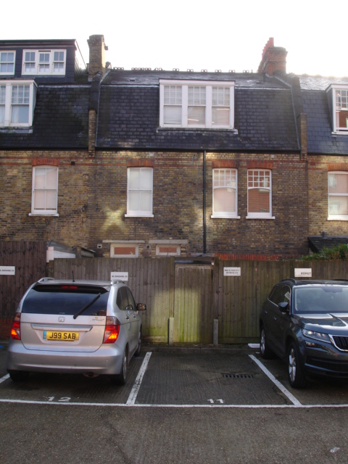

view from rear car-park; high-level window to kitchen are visible and will be retained

