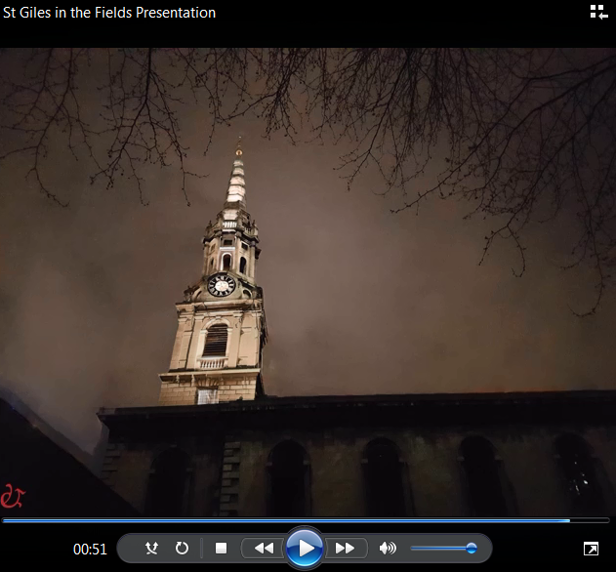

Showing maximum overall level of illumination of belfry and spire