DAVID R. DAVIES
(CONSULTING & ARCHITECTURAL ENGINEERS)
23, CHARLTON RISE,
LUDLOW.
SHROPSHIRE SY8 1ND.
TELE: 01584 874717 – 01743 351418
FAX: 01584 875991
Email: admin@daviesconsultants.com
www.daviesconsultants.com

ALSO AT: 43, HILL CRESCENT, SHREWSBURY, SHROPS. SY3 7RW
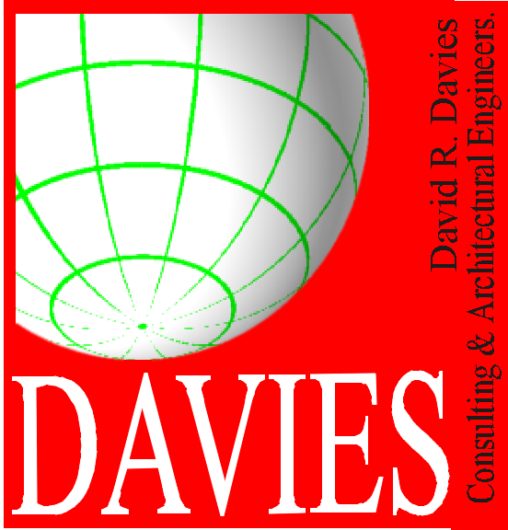
YOUR REFERENCE:
OUR REFERENCE:

Our Ref: 5710: 3: Tottenham Street
Your Ref:
Date 21st December 2017

William G McMorran Dip. Arch. RIBA - Director
The Line House
Tedstone Delamere, Bromyard
Herefordshire
HR7 4PT

Dear William,

28 Tottenham Street Fitzrovia London W1

Thank you for forwarding the comments from the planning and conservation officer regarding the above and we would clarify our design concept as follows;

The central dividing timber stud partitions on the first and second floors carry the floor joists which run at right angles to the partitions and run from front to back of the property.

These partitions are currently partly supported by timber beam bearers that run in line with the partitions and are in turn supported at ground floor level by two slender timber posts and partly by the existing timber stud partition forming the corridor.

Below the posts a new steel beam has been installed in the basement which carries both the loads transferred from the posts and the load from the corridor partition.

Above these posts are two existing timber beams set side by side and parallel to each other.

The beams are currently of differing dimensions with the larger beam being typically 270 x 100mm with a further beam typically 150x100 fixed to the side forming a step to the lower chord of the larger beam.

The overall span between masonry walls is 4.600mm and the clear span between the masonry wall and corridor partition is 3.600mm.

By infilling the lower recess of the existing beams with a purpose made plywood fillet all screwed and glued to the existing timbers with a further side plywood liner to each vertical

side will increase the strength of the beams to create a plywood box beam and act like a laminated timber beam.

The existing corridor partition can be further upgraded by applying a plywood liner to one side to make the existing partition a structural partition and therefore capable to accepting increased applied loads.

The padstones to each end of the beam may or may not be required and will not be fully ascertained until the surface finish has been exposed as there is a great possibility that such padstones exist and will not require replacement.

If these are to be replaced then simple dense concrete padstones typically 450mm long 150mm deep and 100mm thick can be recessed and fully bedded into the walls and the surface reinstated.

Padstones have the effect of transferring loads over a greater distance within the masonry wall and the loads within the wall are transferred at 45 degrees down from the ends of the padstones therefor the additional effect on the masonry will be virtually nil.

The new strengthened timber beams can be over lined with and timber laminate or plasterboard and finished out with the redecoration works.

By using the method suggested there will be no requirement to remove the existing timbers nor affect the main structure other than providing simple temporary “acrow prop” supports during the works and therefore there will be no undue effect on the building structure.

We hope that the above will clarify the proposals and aide the planners and conservation officer in their determinations.

Yours faithfully,
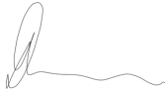

David R Davies

