**Xdisp Horizontal Displacement Contours (CIRIA Excavation/Installation + LT Foundation Loading):**

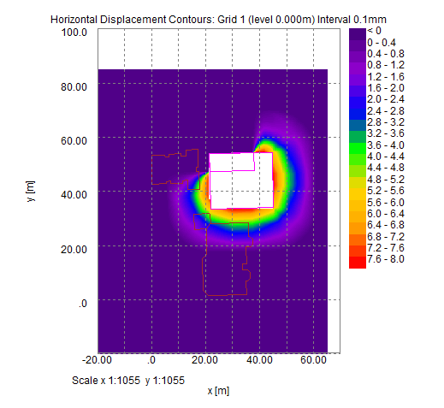

**Xdisp Vertical Displacement Contours (CIRIA Excavation/Installation + LT Foundation Loading):**

