 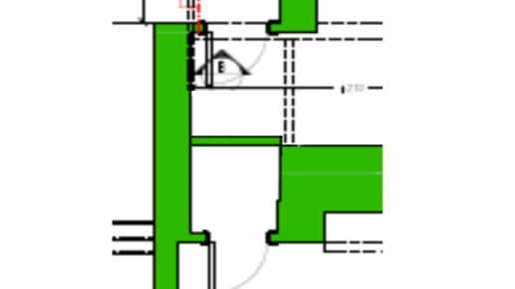

Consented detail en-suite WC Proposed move of modern block partition to reduce floor area requiring cut-out and lowering

 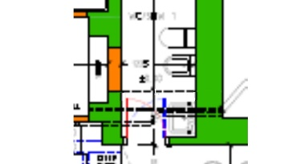

Consented detail bathroom Proposed removal of small modern block wall forming secondary doorway