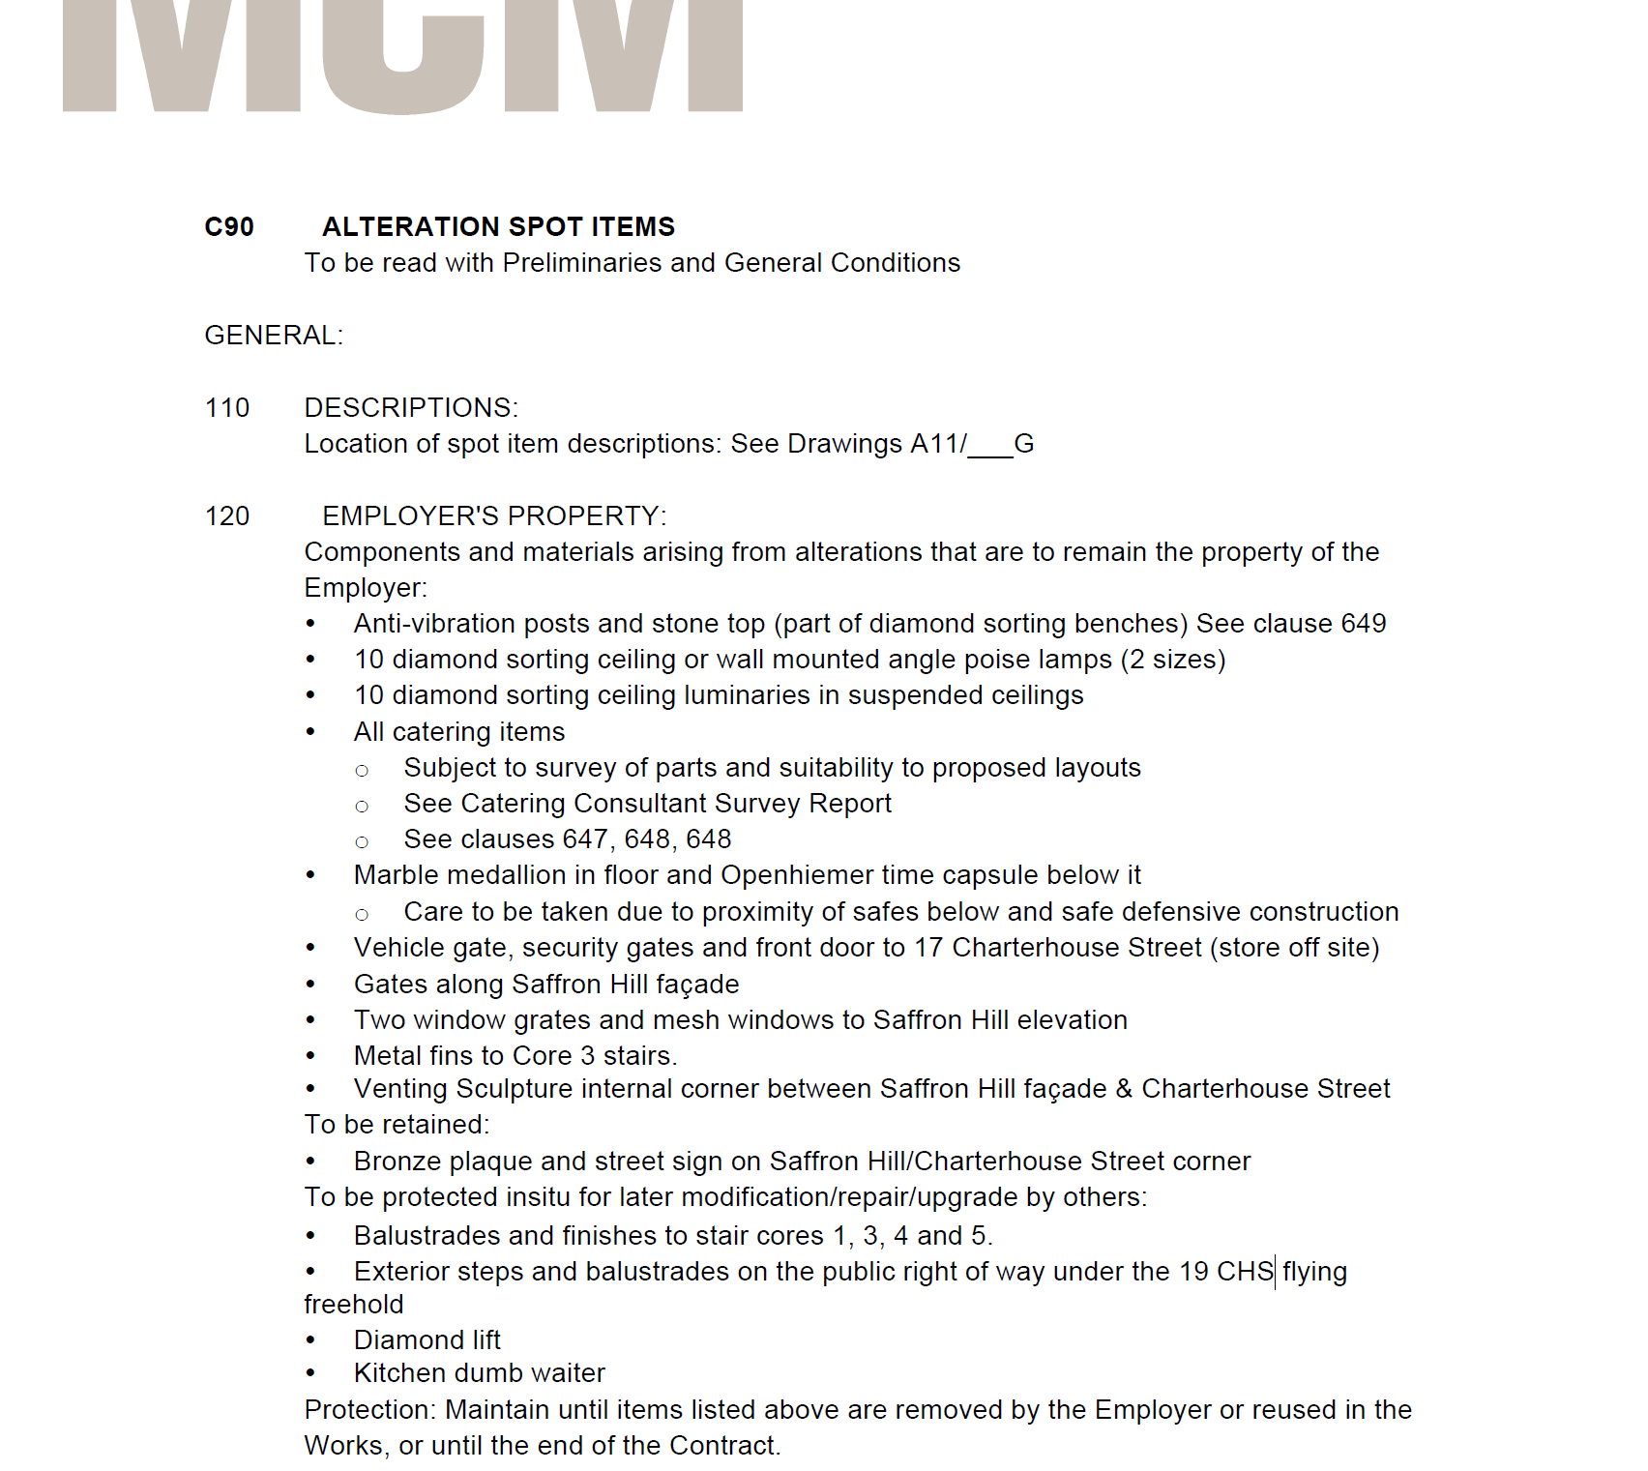

Note: Extract from the Shell and Core Specification for the Demolition and Soft Strip Contract