**Construction Management**

**Plan**

**pro forma** v2.2

**Contents**

**Revisions 3**

**Introduction 4**

**Timeframe 6**

**Contact** **7**

**Site** **9**

**Community liaison** **12**

**Transport** **15**

**Environment** **25**

**Agreement**  **30**

# Revisions & additional material

Please list all iterations here:

|  |  |  |
| --- | --- | --- |
| **Date** | **Version** | **Produced by** |
| **04.12.17** | **DRAFT** | **Bronwen Gombert** |

**Additional sheets**

Please note – the review process will be quicker if these are submitted as Word documents or searchable PDFs.

|  |  |  |
| --- | --- | --- |
| **Date** | **Version** | **Produced by** |
|  |  |  |

# Introduction

The purpose of the **Construction Management Plan (CMP)** is to help developers to minimise construction impacts, and relates to both on site activity and the transport arrangements for vehicles servicing the site.

It is intended to be a live document whereby different stages will be completed and submitted for application as the development progresses.

The completed and signed CMP must address the way in which any impacts associated with the proposed works, and any **cumulative impacts of other nearby construction sites**, will be mitigated and managed. The level of detail required in a CMP will depend on the scale and kind of development. Further policy guidance is set out in Camden Planning Guidance [**(CPG)** 6: Amenity](http://www.camden.gov.uk/ccm/content/environment/planning-and-built-environment/two/planning-policy/supplementary-planning-documents/camden-planning-guidance.en) and [**(CPG)** 8: Planning Obligations](http://www.camden.gov.uk/ccm/content/environment/planning-and-built-environment/two/planning-policy/supplementary-planning-documents/camden-planning-guidance.en).

This CMP follows the best practice guidelines as described in [Transport for London’s](https://www.tfl.gov.uk/info-for/freight/safety-and-the-environment/improving-construction-safety) (TfL’s Standard for [Construction Logistics and Community Safety](http://www.clocs.org.uk/standard-for-clocs/) (**CLOCS**) scheme) and [Camden’s Minimum Requirements for Building Construction](http://www.camden.gov.uk/ccm/cms-service/download/asset?asset_id=3257318) **(CMRBC)**.

The approved contents of this CMP must be complied with unless otherwise agreed with the Council in writing. The project manager shall work with the Council to review this CMP if problems arise in relation to the construction of the development. Any future revised plan must also be approved by the Council and complied with thereafter.

It should be noted that any agreed CMPdoes not prejudice or override the need to obtain any separate consents or approvals such as for road closures or hoarding licences.

If your scheme involves any demolition, you need to make an application to the Council’s Building Control Service. Please complete the “[**Demolition Notice**](http://www.camden.gov.uk/ccm/content/environment/building-control/file-storage-items/demolition-notice---the-building-act-1984-section-80-notice-bc104-.en)**.**”

Please complete the questions below with additional sheets, drawings and plans as required. The boxes will expand to accommodate the information provided, so please provide as much information as is necessary. **It is preferable if this document, and all additional documents, are completed electronically and submitted as Word files to allow comments to be easily documented. These should be clearly referenced/linked to from the CMP.**

Please notify that council when you intend to start work on site. Please also notify the council when works are approximately **3 months from completion.**

(Note the term 'vehicles' used in this document refers to all vehicles associated with the implementation of the development, e.g. demolition, site clearance, delivery of plant & materials, construction, etc.)

Revisions to this document may take place periodically.Timeframe

**DEVELOPER ACTIONS**

**COUNCIL ACTIONS**

**Post app submission**

**0ommunity liaison**

**Appoint principal contractor**

**Requirement to submit CMP**

**Begin community liaison**

**Council response to second draft**

**Work can commence if draft CMP is approved**

**Resubmission of CMP if first draft refused**

**2ommunity liaison**

**3ommunity liaison**

**1ommunity liaison**

INDICATIVE TIMEFRAME (MONTHS)

**4ommunity liaison**

**Council response to draft**

**Submit draft CMP**

# Contact

1. Please provide the full postal address of the site and the planning reference relating to the construction works.

Address: St. Aloysius Convent, 32 Phoenix Road, London, NW1 1TA

Planning reference number to which the CMP applies: 2017/6448/P

2. Please provide contact details for the person responsible for submitting the CMP.

Name: Bronwen Gombert

Address:

Email: bronwen@connectedarchitecture.com

Phone: 07504213966

3. Please provide full contact details of the site project manager responsible for day-to-day management of the works and dealing with any complaints from local residents and businesses.

Name: To be confirmed following appointment of Main Contractor

Address:

Email:

Phone:

4. Please provide full contact details of the person responsible for community liaison and dealing with any complaints from local residents and businesses if different from question 3. In the case of [**Community Investment Programme (CIP)**](http://www.camden.gov.uk/ccm/content/environment/planning-and-built-environment/two/placeshaping/twocolumn/the-community-investment-programme.en), please provide contact details of the Camden officer responsible.

Name: To be confirmed following appointment of Main Contractor

Address:

Email:

Phone:

5. Please provide full contact details including the address where the main contractor accepts receipt of legal documents for the person responsible for the implementation of the CMP.

Name: To be confirmed following appointment of Main Contractor

Address:

Email:

Phone:

# Site

6. Please provide a site location plan and a brief description of the site, surrounding area and development proposals for which the CMP applies.

The St Aloysius Convent, (32 Phoenix Rd, London, NW1 1TA), is positioned between the Maria Fidelis Catholic School FCJ currently under development and the St. Aloysius Infant School in Somers Town.

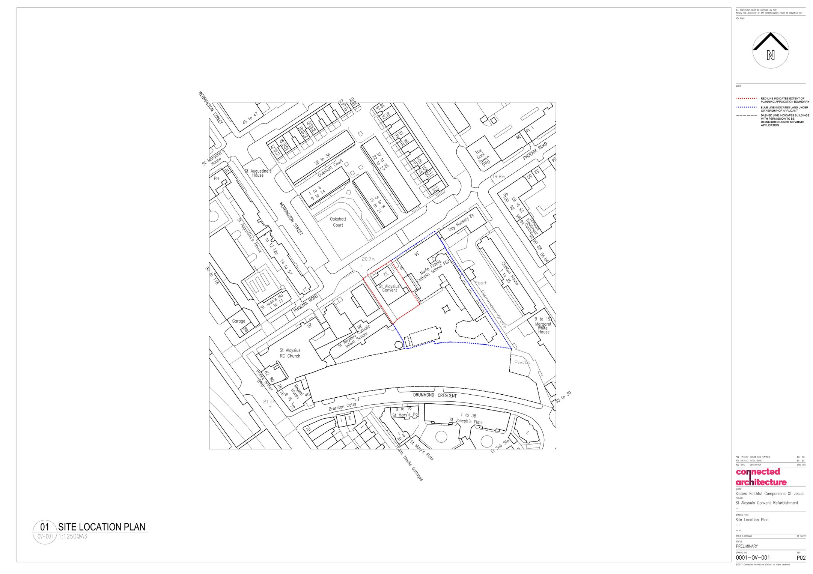

The works comprise: “Erection of infill extension at ground floor level and two-storey rear extension at second and third floors and replacement of external staircase to east elevation. Replacement of existing windows and introduction of new windows, provision of a new entrance ramp, stairs and canopy.”

7. Please provide a very brief description of the construction works including the size and nature of the development and details of the main issues and challenges (e.g. narrow streets, close proximity to residential dwellings etc).

The Convent currently has a gross internal floor area of approximately 797m2 and the proposed extensions amount to an additional floor area of approximately 247m2, bringing the total floor area to circa 1037m2.

The proposed refurbishment will consist largely of internal reconfiguration, however, it will also include a ground floor infill extension to what is currently an under croft car parking area (approximately 139m2) and a two-storey, highly glazed extension to the second and third floor to what is currently an accessible roof terrace on the rear façade (South) (approximately 108m2 across two floors).

The site has good access roads and footpaths, some of which consist of one way systems. It lies within a mainly residential area close to Euston main line station. Residential & Commercial Properties in Eversholt Street along with Maria Fidelis Catholic School FCJ, St. Aloysius RC Church and St. Aloysius Infant School in Phoenix Rd are all at the boundary of the site.

The main issue is the existing 4.3m wide vehicular route down the west side of the Convent currently provides access to the Convent car parking and to Maria Fidelis School, usually for refuse collection, service vehicles, deliveries and emergency vehicles including fire tender access. This arrangement will remain the same following completion of the works. However, this access route is also currently being used by the Main Contractor (Kier Construction Ltd) to redevelop the Maria Fidelis School Site and continued access arrangements have been discussed and agreed with Kier Construction Ltd and will require ongoing liaison between both contractors to ensure neither project is detrimentally impacted.

This route also forms the fire escape route for both Maria Fidelis School and St. Aloysius Infant School, which will be incorporated in to the site emergency procedures as this will need to be maintained throughout the works.

8. Please identify the nearest potential receptors (dwellings, business, etc.) likely to be affected by the activities on site (i.e. noise, vibration, dust, fumes, lighting etc.).

Properties along Phoenix Road, largely St. Aloysius Infant School and Maria Fidelis Catholic School FCJ as direct neighbours.

9. Please provide a scaled plan detailing the local highway network layout in the vicinity of the site. This should include details of on-street parking bay locations, cycle lanes, footway extents and proposed site access locations.

Site Location

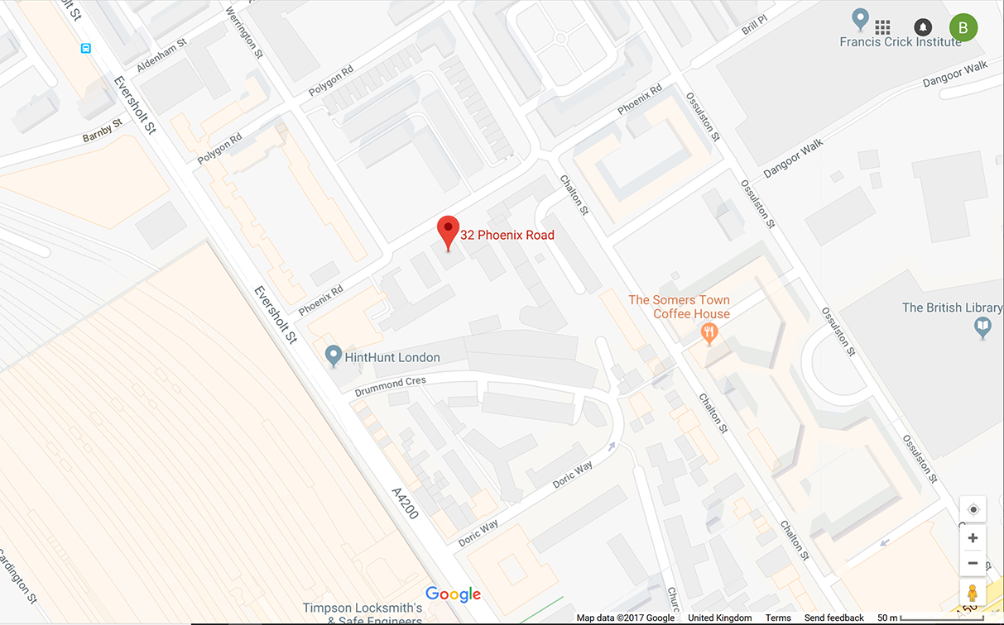

There are on street parking bays on the north side of Phoenix Road to the East of the Convent. The vehicular entrance to the Convent is directly off of Phoenix Road. There are further on street car parking bays in Werrington Street. There is currently no cycle lane, but there is cycle parking just outside the Covent. There are footpaths to both sides of Phoenix Road.

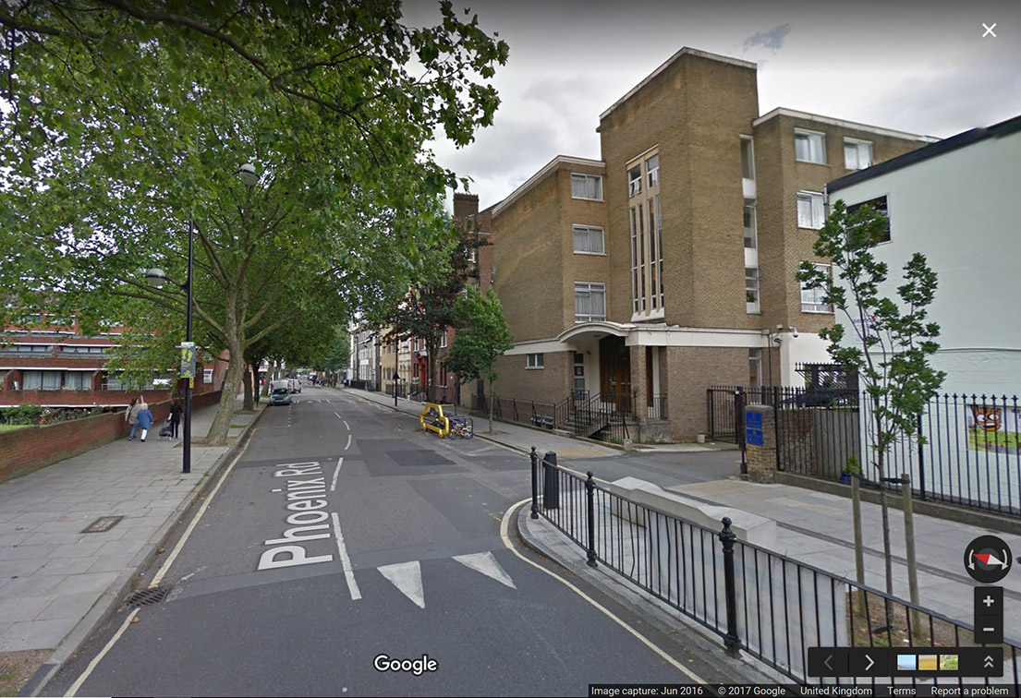

10. Please provide the proposed start and end dates for each phase of construction as well as an overall programme timescale. (A Gantt chart with key tasks, durations and milestones would be ideal).

Further details to be provided once Main Contractor is appointed, but construction is due to start on 8th January 2018 with completion by 31st August 2018. Strip out and demolition works will take approximately 1 month.

11. Please confirm the standard working hours for the site, noting that the standard working hours for construction sites in Camden are as follows:

* 8.00am to 6pm on Monday to Friday
* 8.00am to 1.00pm on Saturdays
* No working on Sundays or Public Holidays

The normal working hours for this site will be as the Camden permitted hours:

* 0800hrs to 1800hrs Monday to Friday
* 0800hrs to 1300hrs to 13.00pm on Saturdays
* No working on Sundays or Public Holidays

If work needs to be undertaken outside of these hours we will engage with the LB Camden Network Management Team to agree in advance any out of hour’s works prior to undertaking any alterations.

Delivery vehicles will access the site from Phoenix Road and there will be no deliveries between the following times 0815 to 0915hrs and 1445 to 1545hrs to avoid school start and finish periods during term times.

All deliveries and vehicular access will be controlled using trained traffic marshals and/or

banksmen who will be responsible for the vehicle movements around the site.

12. Please indicate if any changes to services are proposed to be carried out that would be linked to the site during the works (i.e. connections to public utilities and/or statutory undertakers’ plant). Larger developments may require new utility services. If so, a strategy and programme for coordinating the connection of services will be required. If new utility services are required, please confirm which utility companies have been contacted (e.g. Thames Water, National Grid, EDF Energy, BT etc.) You must explore options for the utility companies to share the same excavations and traffic management proposals. Please supply details of your discussions.

To be confirmed following appointment of Main Contractor.

# Community Liaison

**A neighbourhood consultation process must have been undertaken prior to submission of the CMP first draft. This consultation must relate to construction impacts, and should take place following the granting of planning permission in the lead up to the submission of the CMP. A consultation process specifically relating to construction impacts must take place regardless of any prior consultations relating to planning matters. This consultation must include all of those individuals that stand to be affected by the proposed construction works. These individuals should be provided with a copy of the draft CMP, or a link to an online document. They should be given adequate time with which to respond to the draft CMP, and any subsequent amended drafts. Contact details which include a phone number and email address of the site manager should also be provided.**

Significant time savings can be made by running an effective neighbourhood consultation process. This must be undertaken in the spirit of cooperation rather than one that is dictatorial and unsympathetic to the wellbeing of local residents and businesses.

These are most effective when initiated as early as possible and conducted in a manner that involves the local community. Involving locals in the discussion and decision making process helps with their understanding of what is being proposed in terms of the development process. **The consultation and discussion process should have already started, with the results incorporated into the CMP first draft submitted to the Council for discussion and sign off.**This communication should then be ongoing during the works, with neighbours and any community liaison groups being regularly updated with programmed works and any changes that may occur due to unforeseen circumstances through newsletters, emails and meetings.

Please note that for larger sites, details of a construction working group may be required as a separate S106 obligation. If this is necessary, it will be set out in the S106 Agreement as a separate requirement on the developer.

**Cumulative impact**

Sites located within high concentrations of construction activity that will attract large numbers of vehicle movements and/or generate significant sustained noise levels should consider establishing contact with other sites in the vicinity in order to manage these impacts.

**The Council can advise on this if necessary.**

**13. Consultation**

The Council expects meaningful consultation. For large sites, this may mean two or more meetings with local residents **prior to submission of the first draft CMP**.

Evidence of who was consulted, how the consultation was conducted and a summary of the comments received in response to the consultation should be included. Details of meetings including minutes, lists of attendees etc. should be appended.

In response to the comments received, the CMP should then be amended where appropriate and, where not appropriate, a reason given. The revised CMP should also include a list of all the comments received. Developers are advised to check proposed approaches to consultation with the Council before carrying them out. If your site is on the boundary between boroughs then we would recommend contacting the relevant neighbouring planning authority.

Please provide details of consultation of draft CMP with local residents, businesses, local groups (e.g. residents/tenants and business associations) and Ward Councillors.

There has been several discussions and information sharing meetings with the neighbouring school to ensure pupil safety has been taken into consideration along with the redevelopment works at Maria Fidelis Catholic School.

Once a Main Contractor is appointed then further liaison with relevant neighbours will take place.

**14. Construction Working Group**

Please provide details of community liaison proposals including any Construction Working Group that will be set up, addressing the concerns of the community affected by the works, the way in which the contact details of the person responsible for community liaison will be advertised to the local community, and how the community will be updated on the upcoming works i.e. in the form of a newsletter/letter drop, or weekly drop in sessions for residents.

To be confirmed following appointment of Main Contractor.

**15. Schemes**

Please provide details of your ‘Considerate Constructors Scheme’ registration, and details of any other similar relevant schemes as appropriate. Contractors will also be required to follow the “[Guide for Contractors Working in Camden](http://www.camden.gov.uk/ccm/cms-service/download/asset?asset_id=799001)” also referred to as “[Camden’s Considerate Contractors Manual](http://www.camden.gov.uk/ccm/cms-service/download/asset?asset_id=799001)”.

To be confirmed following appointment of Main Contractor.

**16. Neighbouring sites**

Please provide a plan of existing or anticipated construction sites in the local area and please state how your CMP takes into consideration and mitigates the cumulative impacts of construction in the vicinity of the site. The council can advise on this if necessary.

As stated above under item 6. The only existing project we are aware of is the neighbouring Maria Fidelis Catholic School which is currently being redeveloped and this is being carefully considered as part of these CMP proposals.

A number of mitigation measures will be implemented to minimise the effects of construction traffic movements, particularly HGV's, as far as possible. These include the following:

* The site will be organised to ensure that vehicles and pedestrians passing and visiting the site can move safely. The site will separate pedestrians and vehicles.
* The size of the delivery vehicles will be monitored and only small to medium vehicles will be utilised wherever possible.
* Material deliveries will be restricted to non-peak traffic periods already advised.
* Where possible, heavy or special loads will be delivered to the site during off peak hours. To be fully pre-planned, local residents to be notified depending on the works being done, road closures etc
* Materials and equipment will be stored securely on site to minimise unnecessary traffic movements.
* All deliveries and vehicular access will be controlled using trained traffic marshals and/or banksmen who will be responsible for the vehicle movements around the site.
* Careful planning is required in terms of offloading in the vicinity of a school. This will also require careful control on site, and will need to be resourced sufficiently to ensure it is always carried out in a controlled and planned way.
* Some points that will be developed are:
  + Booking in system for deliveries and rubbish removal.
  + Restrictions to be clearly highlighted on purchase orders to suppliers and subcontract orders. Site to enforce.
  + How to deal with deliveries as they arrive to site. Who takes control of the vehicles and the unloading, who manages the traffic and pedestrians (off peak hours perhaps temporary barriers and road signage, if allowed, can be employed so we have an enclosed designated area for deliveries) Traffic Management Plan.
  + Timely and efficient offloading of delivers.
  + How to get the materials to the works area, e.g. a goods hoist supported and loaded from the gantry serving the upper floors. Or ground level programme permitting.
  + Loose material delivery – which has to be taken off by hand how to deal with this (e.g. allow for a designated area at ground level for such deliveries, make sure adequate labour to deal with volume)
  + How to get rubbish out, and removed to be considered

We have contacted HS2 and have been assured that there are no planned works on Phoenix Road during the duration of our works.

# Transport

**This section must be completed in conjunction with your principal contractor. If one is not yet assigned, please leave the relevant sections blank until such time when one has been appointed.**

Camden is a CLOCS Champion, and is committed to maximising road safety for Vulnerable Road Users (VRUs) as well as minimising negative environmental impacts created by motorised road traffic. As such, all vehicles and their drivers servicing construction sites within the borough are bound by the conditions laid out in the [CLOCS Standard.](http://www.clocs.org.uk/)

This section requires details of the way in which you intend to manage traffic servicing your site, including your road safety obligations with regard to VRU safety. It is your responsibility to ensure that your principal contractor is fully compliant with the terms laid out in the CLOCS Standard. It is your principal contractor’s responsibility to ensure that all contractors and sub-contractors attending site are compliant with the terms laid out in the CLOCS Standard.

Checks of the proposed measures will be carried out by the council to ensure compliance. Please refer to the CLOCS Standard when completing this section. Guidance material which details CLOCS requirements can be accessed [here](http://www.camden.gov.uk/ccm/cms-service/stream/asset?asset_id=3550016&), details of the monitoring process are available [here](http://www.camden.gov.uk/ccm/cms-service/stream/asset?asset_id=3550014&).

Please contact [CLOCS@camden.gov.uk](mailto:CLOCS@camden.gov.uk) for further advice or guidance on any aspect of this section.

**Please refer to the CLOCS Overview and Monitoring Overview documents referenced above which give a breakdown of requirements.**

**CLOCS Contractual Considerations**

17. Name of Principal contractor:

To be confirmed following appointment of Main Contractor.

18. Please submit the proposed method for checking operational, vehicle and driver compliance with the CLOCS Standard throughout the duration of the contract (please refer to our [CLOCS Overview document](http://www.camden.gov.uk/ccm/cms-service/stream/asset?asset_id=3550016&) and [Q18 example response](http://www.camden.gov.uk/ccm/cms-service/stream/asset?asset_id=3550015&)).

To be confirmed following appointment of Main Contractor.

19. Please confirm that you as the client/developer and your principal contractor have read and understood the [CLOCS Standard](http://www.clocs.org.uk/wp-content/uploads/2015/05/CLOCS-Standard-v1.2-APRIL_15.pdf) and included it in your contracts. Please sign-up to join the [CLOCS Community](http://www.clocs.org.uk/links-to-partners/) to receive up to date information on the standard by expressing an interest online.

I confirm that I have included the requirement to abide by the CLOCS Standard in my contracts to my contractors and suppliers:

To be confirmed following appointment of Main Contractor.

Please contact [CLOCS@camden.gov.uk](mailto:CLOCS@camden.gov.uk) for further advice or guidance on any aspect of this section.

**Site Traffic**

**Sections below shown in blue directly reference the CLOCS Standard requirements. The CLOCS Standard should be read in conjunction with this section.**

**20. Traffic routing**: *“Clients shall ensure that a suitable, risk assessed vehicle route to the site is specified and that the route is communicated to all contractors and drivers. Clients shall make contractors and any other service suppliers aware that they are to use these routes at all times unless unavoidable diversions occur.”* (P19, 3.4.5)

Routes should be carefully considered and risk assessed, taking into account the need to avoid where possible any major cycle routes and trip generators such as schools, offices, public buildings,museums etc. Where appropriate, on routes that use high risk junctions (i.e. those that attract high volumes of cycling traffic) installing Trixi mirrors to aid driver visibility should be considered.

Consideration should also be given to weight restrictions, low bridges and cumulative impacts of construction (including neighbouring construction sites) on the public highway network. The route(s) to and from the site should be suitable for the size of vehicles that are to be used.

a. Please indicate routes on a drawing or diagram showing the public highway network in the vicinity of the site including details of how vehicles will be routed to the [Transport for London Road Network](http://www.lscp.org.uk/lrsu/engineering_tlrn.html) (TLRN) on approach and departure from the site.

To be confirmed following appointment of Main Contractor.

b. Please confirm how contractors, delivery companies and visitors will be made aware of the route (to and from the site) and of any on-site restrictions, prior to undertaking journeys.

To be confirmed following appointment of Main Contractor.

**21. Control of site traffic, particularly at peak hours**: “*Clients shall consider other options to plan and control vehicles and reduce peak hour deliveries”* (P20, 3.4.6)

Construction vehicle movements are generally acceptable between 9.30am to 4.30pm on weekdays and between 8.00am and 1.00pm on Saturdays). If there is a school in the vicinity of the site or on the proposed access and/or egress routes, then deliveries must be restricted to between 9.30am and 3pm on weekdays during term time. (Refer to the [*Guide for Contractors Working in Camden*](http://www.camden.gov.uk/ccm/cms-service/download/asset?asset_id=799001)).

A delivery plan should ensure that deliveries arrive at the correct part of site at the correct time. Instructions explaining such a plan should be sent to all suppliers and contractors**.** Consideration should be given to the location of any necessary holding areas for large sites with high volumes of traffic. Vehicles must not wait or circulate on the public highway. Whilst deliveries should be given set times to arrive, dwell and depart, no undue time pressures should be placed upon the driver at any time.

a. Please provide details of the typical sizes of all vehicles and the approximate frequency and times of day when they will need access to the site, for each phase of construction.You should estimate the average daily number of vehicles during each major phase of the work, including their dwell time at the site. High numbers of vehicles per day and/or long dwell times may require vehicle holding procedures.

Delivery vehicles will access the site from Phoenix Road and there will be no deliveries between the following times 0815 to 0915hrs and 1445 to 1545hrs to avoid school start and finish periods during term times.

All deliveries and vehicular access will be controlled using trained traffic marshals and/or

banksmen who will be responsible for the vehicle movements around the site.

The size of the delivery vehicles will be monitored and only small to medium vehicles will be

utilised wherever possible with articulated vehicles avoided wherever possible.

b. Please provide details of other developments in the local area or on the route.

As stated above under item 6. The only existing project we are aware of is the neighbouring Maria Fidelis Catholic School which is currently being redeveloped and this is being carefully considered as part of these CMP proposals.

c. Please outline the system that is to be used to ensure that the correct vehicle attends the correct part of site at the correct time.

The Main Contractor will where possible employ a just in time delivery arrangement, as the site is restricted in terms of external storage areas and delivery times.

Gatesmen and Traffic Marshalls will be briefed on a daily basis. They will be issued with the daily schedule which will identify time/type of vehicle/correct location and the process will be controlled and managed to ensure alignment with this schedule. No changes will be permitted without authorisation from the Site Manager.

A number of mitigation measures will be implemented to minimise the effects of construction traffic movements, particularly HGV's, as far as possible. These include the following:

* The site will be organised to ensure that vehicles and pedestrians passing and visiting the site can move safely. The site will separate pedestrians and vehicles.
* The size of the delivery vehicles will be monitored and only small to medium vehicles will be utilised wherever possible.
* Material deliveries will be restricted to non-peak traffic periods already advised.
* Where possible, heavy or special loads will be delivered to the site during off peak hours. To be fully pre-planned, local residents to be notified depending on the works being done, road closures etc
* Materials and equipment will be stored securely on site to minimise unnecessary traffic movements.
* All deliveries and vehicular access will be controlled using trained traffic marshals and/or banksmen who will be responsible for the vehicle movements around the site.
* Careful planning is required in terms of offloading in the vicinity of a school. This will also require careful control on site, and will need to be resourced sufficiently to ensure it is always carried out in a controlled and planned way.
* Some points that will be developed are:
  + Booking in system for deliveries and rubbish removal.
  + Restrictions to be clearly highlighted on purchase orders to suppliers and subcontract orders. Site to enforce.
  + How to deal with deliveries as they arrive to site. Who takes control of the vehicles and the unloading, who manages the traffic and pedestrians (off peak hours perhaps temporary barriers and road signage, if allowed, can be employed so we have an enclosed designated area for deliveries) Traffic Management Plan.
  + Timely and efficient offloading of delivers.
  + How to get the materials to the works area, e.g. a goods hoist supported and loaded from the gantry serving the upper floors. Or ground level programme permitting.
  + Loose material delivery – which has to be taken off by hand how to deal with this (e.g. allow for a designated area at ground level for such deliveries, make sure adequate labour to deal with volume)
  + How to get rubbish out, and removed to be considered

d. Please identify the locations of any off-site holding areas (an appropriate location outside the borough may need to be identified, particularly if a large number of delivery vehicles are expected) and any measures that will be taken to ensure the prompt admission of vehicles to site in light of time required for any vehicle/driver compliance checks. Please refer to question 24 if any parking bay suspensions will be required for the holding area.

To be confirmed following appointment of Main Contractor.

e. Please provide details of any other measures designed to reduce the impact of associated traffic (such as the use of [construction material consolidation centres](https://www.google.co.uk/url?sa=t&rct=j&q=&esrc=s&source=web&cd=2&cad=rja&uact=8&ved=0ahUKEwi5hKjPiLjRAhVqLcAKHQduC_gQFggkMAE&url=http%3A%2F%2Fcontent.tfl.gov.uk%2Fdirectory-london-construction-consolidation-centres.pdf&usg=AFQjCNFhB34aaqw3M3fmDpJYUUBw_PjbdA&sig2=KXhGnTR3slzf0kN4XMOcQg&bvm=bv.143423383,d.ZWM)).

All site workers will be encouraged to use public transport as the site has excellent public transport connections located near is Euston/St Pancras and Kings Cross Stations and there is numerous local bus services.

There will be no on-site parking. If need be staff and operatives need to drive (exceptional circumstances) then public car parks will be used.

**22. Site access and egress:** “*Clients shall ensure that access to and egress from the site is appropriately managed, clearly marked, understood and clear of obstacles.”* (P18, 3.4.3)

Vehicles entering and leaving the site should be carefully managed, using gates that are clearly marked and free from obstacles. Traffic marshals must ensure the safe passage of all traffic on the public highway, in particular pedestrians and cyclists, when vehicles are entering and leaving site, particularly if reversing.

Traffic marshals, or site staff acting as traffic marshals, should hold the relevant qualifications required for directing large vehicles when reversing. Marshals should be equipped with ‘STOP – WORKS’ signs (not STOP/GO signs) if control of traffic on the public highway is required. Marshals should have radio contact with one another where necessary.

a. Please detail the proposed access and egress routes to and from the site

Access and egress from the site will be from Phoenix Road. Routes to be confirmed following appointment of Main Contractor.

b. Please describe how the access and egress arrangements for construction vehicles will be managed.

Delivery vehicles will access the site from Phoenix Road and there will be no deliveries between the following times 0815 to 0915hrs and 1445 to 1545hrs to avoid school start and finish periods during term times.

All deliveries and vehicular access will be controlled using trained traffic marshals and/or banksmen who will be responsible for the vehicle movements around the site.

c. Please provide swept path drawings for any tight manoeuvres on vehicle routes to and from the site including proposed access and egress arrangements at the site boundary (if necessary).

To be confirmed following appointment of Main Contractor.

d. Provision of wheel washing facilities should be considered if necessary. If so, please provide details of how this will be managed and any run-off controlled.

To be confirmed following appointment of Main Contractor.

**23. Vehicle loading and unloading:** *“Clients shall ensure that vehicles are loaded and unloaded on-site as far as is practicable.”* (P19, 3.4.4)

If this is not possible, Traffic Marshalls must ensure the safe passage of pedestrians, cyclists and motor traffic in the street when vehicles are being loaded or unloaded.

Please provide details of the parking and loading arrangements for construction vehicles with regard to servicing and deliveries associated with the site (e.g. delivery of materials and plant, removal of excavated material). This is required as a scaled site plan, showing all points of access and where materials, skips and plant will be stored, and how vehicles will access and egress the site. If loading is to take place off site, please identify where this is due to take place and outline the measures you will take to ensure that loading/unloading is carried out safely. Please outline in question 24 if any parking bay suspensions will be required.

To be confirmed following appointment of Main Contractor.

Delivery vehicles will access the site from Phoenix Road and there will be no deliveries between the following times 0815 to 0915hrs and 1445 to 1545hrs to avoid school start and finish periods during term times.

All deliveries and vehicular access will be controlled using trained traffic marshals and/or banksmen who will be responsible for the vehicle movements around the site.

**Highway interventions**

**Please note that Temporary Traffic Orders (TTOs) and hoarding/scaffolding licenses may be applied for prior to CMP submission but won’t be granted until the CMP is signed-off.**

**If the site is on or adjacent to the TLRN, please provide details of preliminary discussions with Transport for London in the relevant sections below.**

**24. Parking bay suspensions and temporary traffic orders**

Please note, parking bay suspensions should only be requested where absolutely necessary. Parking bay suspensions are permitted for a maximum of 6 months, requirement of exclusive access to a bay for longer than 6 months you will be required to obtain [Temporary Traffic Order (TTO)](http://camden.gov.uk/ccm/content/transport-and-streets/traffic-management/temporary-road-restrictions/) for which there is a separate cost.

Please provide details of any proposed parking bay suspensions and TTO’s which would be required to facilitate construction. **Building materials and equipment must not cause obstructions on the highway as per your Considerate Contractors obligations unless the requisite permissions are secured.**

Information regarding parking suspensions can be found [here.](http://www.camden.gov.uk/ccm/navigation/transport-and-streets/parking/parking-bay-suspensions/)

To be confirmed following appointment of Main Contractor.

**25. Scaled drawings of highway works**

Please note that use of the public highway for storage, site accommodation or welfare facilities is at the discretion of the Council and is generally not permitted. If you propose such use you must supply full justification, setting out why it is impossible to allocate space on-site. You must submit a detailed (to-scale) plan showing the impact on the public highway that includes the extent of any hoarding, pedestrian routes, parking bay suspensions and remaining road width for vehicle movements. We prefer not to close footways but if this is unavoidable, you should submit a scaled plan of the proposed diversion route showing key dimensions.

a. Please provide accurate scaled drawings of any highway works necessary to enable construction to take place (e.g. construction of temporary vehicular accesses).

None anticipated, but to be confirmed following appointment of Main Contractor.

b.Please provide details of all safety signage, barriers and accessibility measures such as ramps and lighting etc.

None anticipated, but to be confirmed following appointment of Main Contractor.

**26. Diversions**

Where applicable, please supply details of any diversion, disruption or other anticipated use of the public highway during the construction period (alternatively a plan may be submitted).

None anticipated, but to be confirmed following appointment of Main Contractor.

**27. VRU and pedestrian diversions, scaffolding and hoarding**

Pedestrians and/or cyclist safety must be maintained if diversions are put in place. Vulnerable footway users should also be considered. These include wheelchair users, the elderly, those with walking difficulties, young children, those with prams, the blind and partially sighted. Appropriate ramping must be used if cables, hoses, etc. are run across the footway.

Any work above ground floor level may require a covered walkway adjacent to the site. A licence must be obtained for scaffolding and gantries. The adjoining public highway must be kept clean and free from obstructions. Lighting and signage should be used on temporary structures/skips/hoardings etc.

A secure hoarding will generally be required at the site boundary with a lockable access.

a. Please provide details describing how pedestrian and cyclist safety will be maintained, including any proposed alternative routes (if necessary), and any Traffic Marshall arrangements.

None anticipated on public footpath/highways, but to be confirmed following appointment of Main Contractor.

b. Please provide details of any temporary structures which would overhang the public highway (e.g. scaffolding, gantries, cranes etc.) and details of hoarding requirements or any other occupation of the public highway.

None anticipated on public footpath/highways, but to be confirmed following appointment of Main Contractor.

SYMBOL IS FOR INTERNAL USE

# Environment

To answer these sections please refer to the relevant sections of **Camden’s Minimum Requirements for Building Construction (**[**CMRBC**](http://www.camden.gov.uk/ccm/cms-service/download/asset?asset_id=3257318)**).**

28. Please list all [noisy operations](http://www.camden.gov.uk/ccm/content/environment/environmental-health--consumer-protection/noise/reducing-noise/noise-from-construction-sites.en?page=2)  and the construction method used, and provide details of the times that each of these are due to be carried out.

To be confirmed following appointment of Main Contractor.

29. Please confirm when the most recent noise survey was carried out (before any works were carried out) and provide a copy. If a noise survey has not taken place please indicate the date (before any works are being carried out) that the noise survey will be taking place, and agree to provide a copy.

To be confirmed following appointment of Main Contractor.

30. Please provide predictions for [noise](http://www.camden.gov.uk/ccm/content/environment/environmental-health--consumer-protection/noise/reducing-noise/noise-from-construction-sites.en?page=2) and vibration levels throughout the proposed works.

To be confirmed following appointment of Main Contractor.

31. Please provide details describing mitigation measures to be incorporated during the construction/[demolition](http://www.camden.gov.uk/ccm/navigation/environment/building-control/demolition/) works to prevent noise and vibration disturbances from the activities on the site, including the actions to be taken in cases where these exceed the predicted levels.

To be confirmed following appointment of Main Contractor.

Unacceptable impacts arising from demolition noise are not expected on this site. In general, Best Practicable Means as defined in section 72 of the Control of Pollution Act 1974 will be employed to minimise noise and vibration. Furthermore, the guidance provided within BS 5228-1:2009 – Code of practice for noise and vibration control on construction sites –part 1 will be followed. Such measures control the noise at source by using effective acoustic screens or barriers and ensuring regular maintenance of plant.

The following measures will be implemented:

* Apart from the noise reducing measures that will be adopted, another level of checks will be carried out by the Main Contractor. This involves recording at various points externally on the hoarding the noise being produced on site (more so during noisy work periods), dependant on the findings works will be modified if current measures are found to be lacking, temporary fixes may be employed, e.g. temporary shielding or Eco barriers as circumstances dictate.
* Restricted working hours as previously noted to reduce impact.
* Use the most environmentally acceptable and quietly operating plant and equipment compatible with the safe and efficient execution of the works.
* Items of plant operating on site will be shut down in intervening periods of use.
* Compressors brought onto site will be sound reduced models.
* All pneumatic tools will be fitted with silencers of mufflers.
* Where the use of impact hammers is necessary for the ground works, their attachment to larger and heavier excavators can often reduce the level of vibration.
* Care to be taken during the erection of scaffolding, if necessary, to avoid impacts from banging steel.
* Deliveries will be programmed to arrive during working hours only as previously described.
* Care will be taken when unloading vehicles and construction vehicles will be routed on major roads where possible.

32. Please provide evidence that staff have been trained on BS 5228:2009

To be confirmed following appointment of Main Contractor.

The Main Contractor will ensure all sub-contractors and operatives are trained on BS5228:2009 and provide evidence before works commence this will form part of selection of suitable sub-contractors.

33. Please provide details on how dust nuisance arising from dusty activities, on site, will be prevented.

Measures to reduce the levels of dust and prevent the deterioration of local air quality have will be included in this CMP as best practice and ensure that levels do not become significant.

The Main Contractor shall take all necessary measures to avoid creating a dust nuisance during demolition. Best Practicable Means will be used to minimise the creation and emission of dust.

The following measures take into account guidance prepared by the BRE of the control of Dust from demolition activities. These include;

* Water suppression or dust extraction technology to be fitted to drilling and grinding equipment.
* Where appropriate drilling and excavation surfaces will be wetted.
* During dry conditions, debris piles will be kept watered as necessary so that no dust nuisance may be caused.
* Suitable measures will be taken during the demolition period to prevent the deposition of mud and dirt onto public roads and to prevent the propagation of dust from the site.
* Sheeting of lorries during transportation of construction and demolition materials and spoil export.
* All containers will be totally enclosed or covered by tarpaulins to prevent escape of dust or waste materials during loading and transfer from site.

The Main Contractor shall take precautions to prevent the emission of smoke or fumes from construction vehicles, site plant and stored materials including volatile substances. Vehicles and plant shall be well maintained and measures shall be taken to ensure engines and motors are not left running for long periods when not in use.

The Main Contractor will comply with the provisions of the Environment Act 1995, the Clean Air Act 1993, the Health and Safety at Work Act 1974, the Control of Substances Hazardous to Health regulations (COSHH) 1999 and Health and Safety Executive Guidance notes EH 40/90 and EH 40/97 on Occupational Exposure Limits.

34. Please provide details describing how any significant amounts of dirt or dust that may be spread onto the public highway will be prevented and/or cleaned.

* Suitable measures will be taken during the demolition period to prevent the deposition of mud and dirt onto public roads and to prevent the propagation of dust from the site.
* Sheeting of lorries during transportation of construction and demolition materials and spoil export.
* All containers will be totally enclosed or covered by tarpaulins to prevent escape of dust or waste materials during loading and transfer from site.

35. Please provide details describing arrangements for monitoring of [noise](http://www.camden.gov.uk/ccm/content/environment/environmental-health--consumer-protection/noise/reducing-noise/noise-from-construction-sites.en?page=2), vibration and dust levels.

To be confirmed following appointment of Main Contractor.

A complete noise and vibration monitoring system will be in place for the main construction works, which will monitor levels 24/7. It will be located to measure levels at the boundary of the site at sensitive locations with the Maria Fidelis and St Aloysius Infant Schools, and residents.

36. Please confirm that a Risk Assessment has been undertaken at planning application stage in line with the GLA policy. [The Control of Dust and Emissions During Demolition and Construction 2104 (SPG)](https://www.london.gov.uk/file/18750/download?token=zV3ZKTpP), that the risk level that has been identified, and that the appropriate measures within the GLA mitigation measures checklist have been applied. Please attach the risk assessment and mitigation checklist as an appendix.

To be confirmed following appointment of Main Contractor.

37. Please confirm that all of the GLA’s ‘highly recommended’ measures from the [SPG](https://www.london.gov.uk/file/18750/download?token=zV3ZKTpP) document relative to the level of risk identified in question 36 have been addressed by completing the [GLA mitigation measures checklist.](https://www.london.gov.uk/what-we-do/planning/implementing-london-plan/supplementary-planning-guidance/control-dust-and)

To be confirmed following appointment of Main Contractor.

38. If the site is a ‘High Risk Site’, 4 real time dust monitors will be required. If the site is a ‘Medium Risk Site’, 2 real time dust monitors will be required. The risk assessment must take account of proximity to sensitive receptors (e.g. schools, care homes etc), as detailed in the [SPG](https://www.london.gov.uk/file/18750/download?token=zV3ZKTpP). Please confirm the location, number and specification of the monitors in line with the SPG and confirm that these will be installed 3 months prior to the commencement of works, and that real time data and quarterly reports will be provided to the Council detailing any exceedances of the threshold and measures that were implemented to address these.

39. Please provide details about how rodents, including [rats](http://www.camden.gov.uk/ccm/content/environment/environmental-health--consumer-protection/pest-control/about-the-pest-control-service.en), will be prevented from spreading out from the site. You are required to provide information about site inspections carried out and present copies of receipts (if work undertaken).

To be confirmed following appointment of Main Contractor.

Before starting the works, the site area and existing buildings will be assessed for the presence of rodents. Should any rodent or vermin issues arise an external specialist contractor will be appointed to deal with these.

40. Please confirm when an asbestos survey was carried out at the site and include the key findings.

There is an existing Asbestos Register dated 2007. Further Type 3 survey to be undertaken prior to demolition works to identify any further items and establish safe procedures for removal.

41. Complaints often arise from the conduct of builders in an area. Please confirm steps being taken to minimise this e.g. provision of a suitable smoking area, tackling bad language and unnecessary shouting.

To be confirmed following appointment of Main Contractor.

Site specific inductions will focus on not only the onsite construction works but also the surrounding community, with specific site rules regarding working by the schools. Operatives will be advised on how to behave on site and whilst interacting with the local area and its people. It will be made clear to all that they will be representing the site and therefore the Main Contractor and client. If staff or operatives were to be found or reported as having misbehaved whilst off of the site, then they will be asked to leave the site and not to return.

42. If you will be using non-road mobile machinery (NRMM) on site with net power between 37kW and 560kW it will be required to meet the standards set out below. The standards are applicable to both variable and constant speed engines and apply for both PM and NOx emissions.

**From 1st September 2015**

**(i) Major Development Sites** – NRMM used on the site of any major development will be required to meet Stage IIIA of EU Directive 97/68/EC

**(ii) Any development site within the Central Activity Zone -** NRMM used on any site within the Central Activity Zone will be required to meet Stage IIIB of EU Directive 97/68/EC

**From 1st September 2020**

**(iii) Any development site -** NRMM used on any site within Greater London will be required to meet Stage IIIB of EU Directive 97/68/EC

**(iv) Any development site within the Central Activity Zone -** NRMM used on any site within the Central Activity Zone will be required to meet Stage IV of EU Directive 97/68/EC

Please provide evidence demonstrating the above requirements will be met by answering the following questions:

1. Construction time period (mm/yy - mm/yy ):
2. Is the development within the CAZ? (Y/N):
3. Will the NRMM with net power between 37kW and 560kW meet the standards outlined above? (Y/N):
4. Please provide evidence to demonstrate that all relevant machinery will be registered on the NRMM Register, including the site name under which it has been registered:
5. Please confirm that an inventory of all NRMM will be kept on site and that all machinery will be regularly serviced and service logs kept on site for inspection:
6. Please confirm that records will be kept on site which details proof of emission limits, including legible photographs of individual engine plates for all equipment, and that this documentation will be made available to local authority officers as required:

SYMBOL IS FOR INTERNAL USE

# Agreement

The agreed contents of this Construction Management Plan must be complied with unless otherwise agreed in writing by the Council. This may require the CMP to be revised by the Developer and reapproved by the Council. The project manager shall work with the Council to review this Construction Management Plan if problems arise in relation to the construction of the development. Any future revised plan must be approved by the Council in writing and complied with thereafter.

It should be noted that any agreed Construction Management Plan does not prejudice further agreements that may be required such as road closures or hoarding licences.

**Please notify that council when you intend to start work on site. Please also notify the council when works are approximately 3 months from completion.**

**Signed:** …………………………………………………………………

**Date:** ……………………………………………..

**Print Name:** ……………………………………………………..….

**Position:** …………………………………………

Please submit to: [planningobligations@camden.gov.uk](mailto:planningobligations@camden.gov.uk)

End of form.