**Parliament Hill and William Ellis school banners**

These banners are to hang on the fence outside a school site. They describe a Community Investment Programme (CIP)-funded development that is already under way. The banners will have eyelets in the top and be hung from the top of a wooden fence about 1m 70 high in two locations:

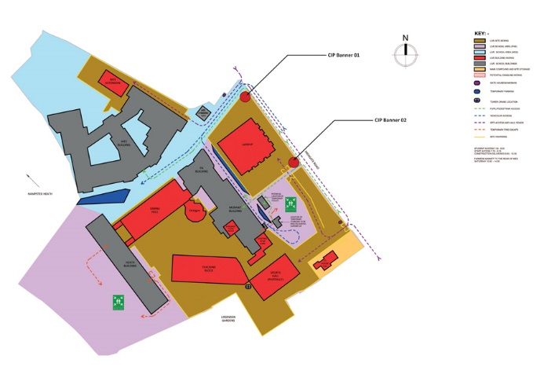

* Banner 1: This site is a new entrance point for Parliament Hill school which will be created by the contractors when they hoard up the existing entry point. It doesn’t exist at present. The photo below, taken outside Parliament Hill Schoolshows the approximate point for the new entry.

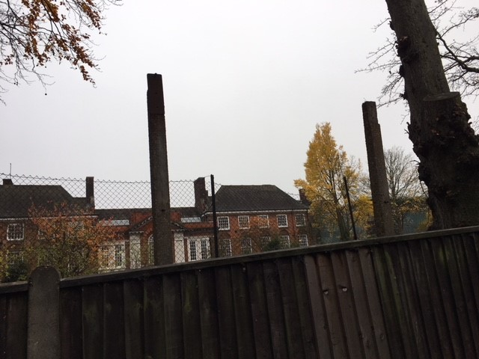

* Banner 2: Thered arrow shows approx. site of banner, near William Ellis school.

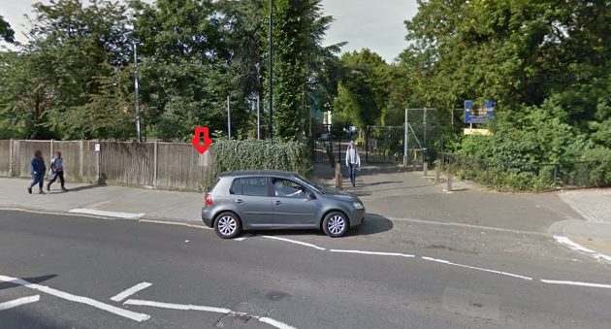

# The elevations and floor plans for the new buildings (separate attachments) are part of the current planning application: 2017/5395/P.

Banner 1

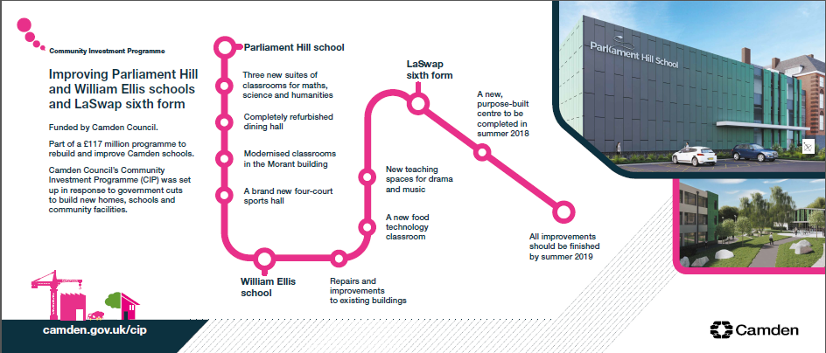 

🡨 3.5m 🡪

Banner 2

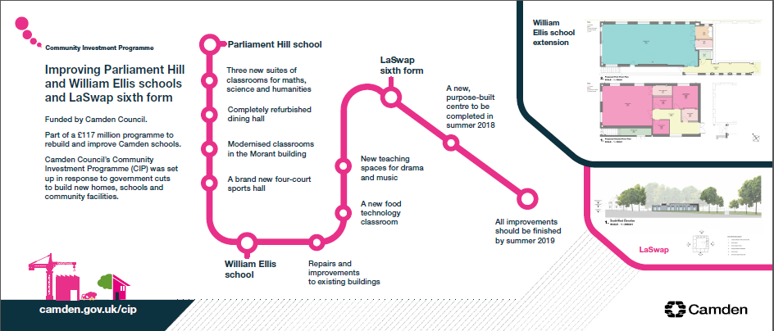 

🡨 3.5m 🡪