# Highwood Lodge, 31 Hampstead Lane London N6 4RT

# PLANNING, DESIGN & ACCESS STATEMENT

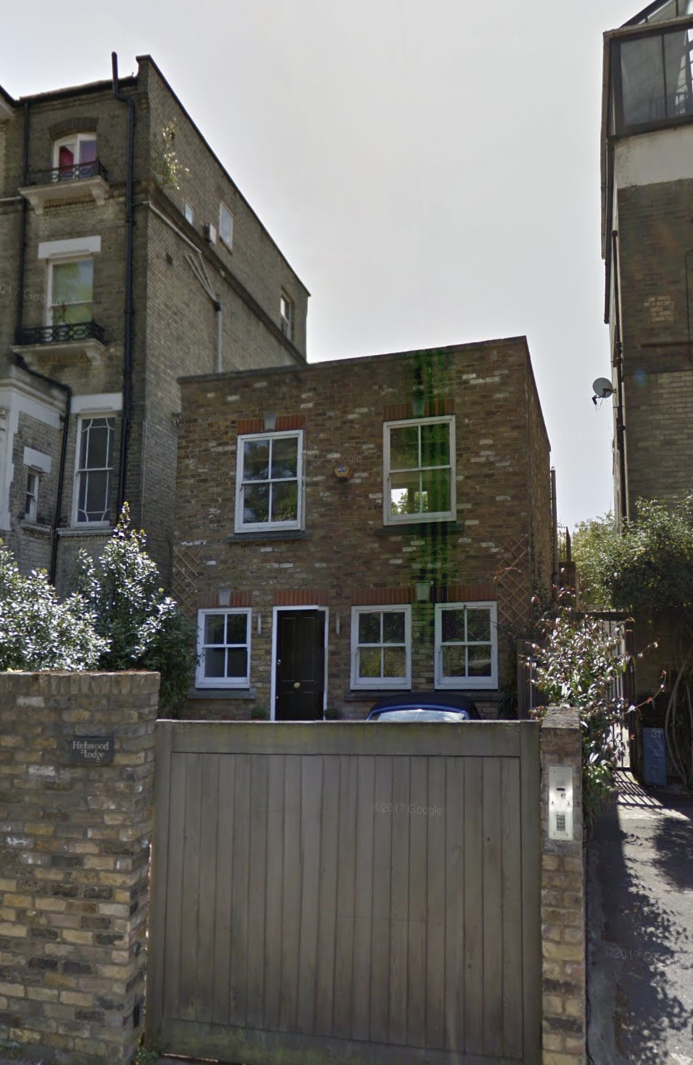LOCATION & CONTEXT

31 Hampstead Lane is located in a heavily residential area. The property is a two storey detached purpose built dwelling that replaces a garage and dates from the 1980’s. The property is not listed. The building is located in a conservation area.

PROPOSED WORKS

The proposed works include; a rear extension to the first floor with a balcony, and a new terrace to the roof of the building. The rear extension will create a larger living space with a WC and the roof terrace will provide additional amenity space as the property has no land to the rear.

The proposed roof access will be set back from the front of the building; therefore it will not be evident from Hampstead Lane. Furthermore, the proposal will not overlook neighbouring properties, as it is considerably lower than the surrounding buildings and any issues are no worse than currently.. The land to the rear is owned by a plant nursery and presents no overlooking issues.

It is proposed to replicate the brick gate posts of the adjoining properties to the entrance from the road. These were part of the original planning permission but were never built.

DESIGN

The design is intended to simplify the current rear of the building by replacing the jumble of mansard roofs with a more formal composition of a brick wall with 3 french windows acting as a piano nobile to the solid base. The extension will be faced in Smeed Dean Islington Yellow Rustica stock brick, the windows will be in painted hardwood and the roof terrace will be a green roof with a sedum finish.

AMENITY SPACE

The property currently has 12.45 sq metres of amenity space. The proposals will provide 38.5 sq metres on the roof terrace and 5.6 sq metres on the rear balcony which is a more acceptable level for a suburban house.

SUSTAINABILITY

The proposed works will upgrade a building which does not meet the current energy usage standards and involves the reuse of an existing structure and its embedded energy.

The new windows will be triple glazed to achieve a U value below 1W/(m²K). The roof will be insulated to achieve a U value of 0.12W/(m²K) or better and the new walls will be insulated to achieve 0.2W/(m²K).

A new A+ rated gas condensing boiler will be fitted.

Reuse of existing materials will be encouraged and materials not necessary for the project will be recycled.

Deliveries to site will be coordinated to minimize traffic movements and operatives on site will be encouraged to use public transport.

DISABLED ACCESS

The proposals do not affect disabled access.

CONCLUSION

The proposed extension will expand the living space within the dwelling house and provide a better spatial arrangement. The proposed roof terrace provides much needed additional amenity space.

# PLANNING HISTORY

Application number: 2015/5542/P

Date Registered: 14-10-2015

Description: Replacement of timber single glazed sash window with timber double glazed sash window to the front elevation at ground floor level.

Decision: Granted

Application number: 2008/0009/P

Date Registered: 04-01-2008

Description: Removal of condition 4 (relating to use of the garage for car parking purposes only) of planning permission dated 29/1/1991 to allow conversion of existing garage into habitable space for dwelling house and insertion of new sliding gate to front of dwelling house.

Decision: Granted