7TH November 2017

Planning - Development Control
Camden Council
Camden Town Hall
London
Dear Sir/Madam

I am applying in accordance with The Electronic Communications Code (Conditions and Restrictions) Regulations 2003, BT plc intend to install electronic communications equipment in the form of a Green Cabinet at the following location:

Consisting of - PCP CABINET RESHELL

OPENREACH REFERENCE - (75I54 PCP29)

At the following location:-

O/S 44 BELSIZE PARK GARDENS, HAMPSTED, LONDON NW3 4LY

Map Ref: 527259184752
I enclose:
- a plan indicating the proposed location of the development
- a written description of the proposed development shown above and
- The relevant fee (if applicable).

Where notice is required under Regulations 6(2) or 8(1) of the Electronic Communications Code (Conditions and Restrictions) Regulations 2003, please also regard this as a notice of our intention to install apparatus under those Regulations.
I have included
- a scaled plan (1:500 ) indicating the proposed location of the development
- a scaled plan (1:1250 ) indicating the proposed location of the development
- a scaled plan (1:4100 ) indicating the proposed location of the development
- a site photo(s)
- the dimensions of the apparatus

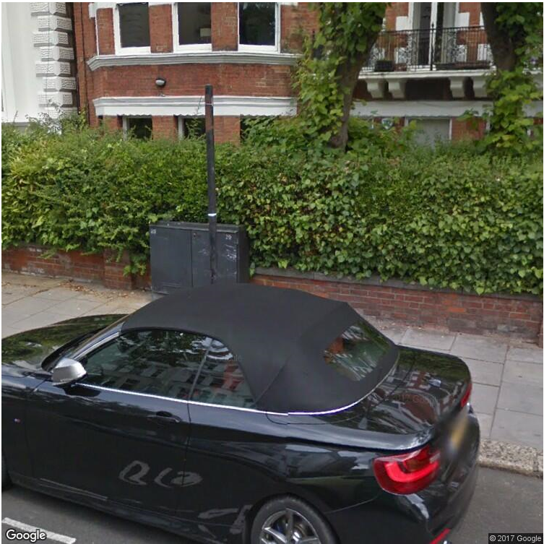

Installation for a new PCP type cabinet measuring:-
Cabinet Dimension is: - W = 1410MM. H1210MM. D= 370MM

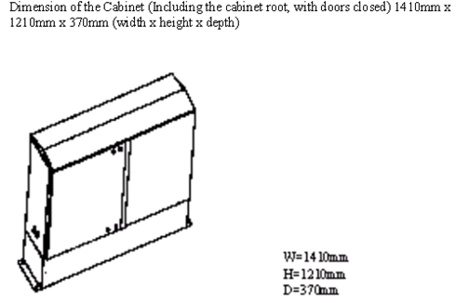

EXAMPLE OF NEW CABINET BELOW ON RIGHT

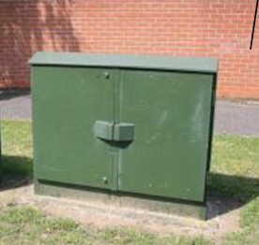

Should you wish to make any written representations please send all correspondence to me at the following address:

Yours faithfully

Dilip Amin
NGA Planning
dilip.amin@openreach.co.uk
Tel: 020 3251 8300

