**Heritage Statement - 41 Willow Road Frances Swain October 27 2017**

41 Willow Road is the top end of the terrace of ‘Willow Cottages’ which comprises 33-41 which are Grade II listed stucco cottages dating from approximately 1866. The cottages are judged to be a positive contribution to the Hampstead conservation area. The terrace is set back from the road at the bottom of long downward sloping front gardens. The roofs are grey slate.

Conservation Area Statement extract:

*Willow Cottages (listed), a pretty group of nine cottages, built in the mid- 19th Century. They are distinctive due to their pastel colours, long front gardens and unaltered boundary walls, windows and rooflines. The paving in front of the terrace is red brick. 33-41(Willow Cottages); 1,2&3(II*). Listed 1974, note: interiors not inspected.*

History:

*‘These homes were originally inhabited by watercress gatherers, workers who harvested watercress from ponds on Hampstead Heath. ...watercress beds were a feature of the streams owing from the Heath in the earlier nineteenth-century (see Elrington). Source: Camden,Willow Cottages. British Listed Buildings. Web. 28 July 2014.*

Listing text from britishhistoricbuildings.co.uk

CAMDEN

TQ2685NE WILLOW ROAD  
798-1/27/1724 (South side)  
14/05/74 Nos.33-41 (Consecutive)  
Willow Cottages

GV II

Terrace of 9 cottages. c1866. Stucco with rusticated quoins  
and 1st floor bands. Slated roofs. 2 storeys and  
semi-basements. 2 windows each. Square-headed doorways with  
splayed jambs, fanlights and panelled doors; Nos 33-37 with  
C20 Neo-Georgian doorcases and doors with arched heads.  
Entrances approached by stone steps with cast-iron railings.  
Round-arched recessed sashes with splayed jambs; ground floors  
with margin glazing. Shaped plaque inscribed "Willow Cottages"  
between 1st floor windows of Nos 37 and 38.  
INTERIORS: not inspected. HISTORICAL NOTE: built on the site  
of earlier almshouses.

Listing NGR: TQ2670985863

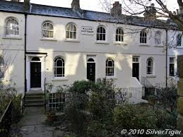 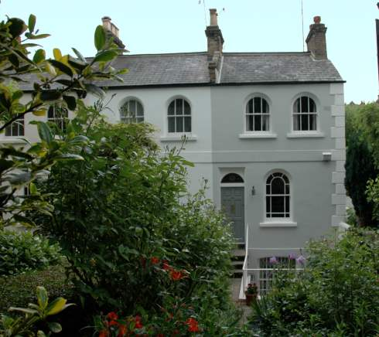

photo from web of middle section of Willow Cottages photo from web of 41 Willow Cottages, Willow Road