**Design and Access Statement - 41 Willow Road Frances Swain October 27 2017**

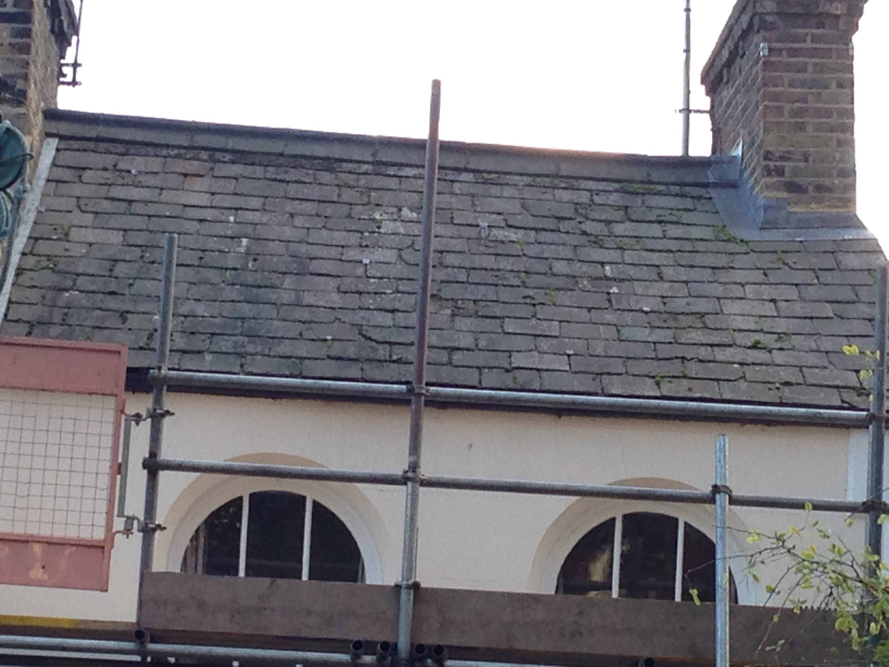

The front pitch of the roof is in poor repair, the tiles being chipped and flaky - see photo. The aim is to replace all of the tiles on the front pitch of our house with Welsh tiles of a similar colour to match the existing tiles and those of the roofs of rest of the terrace.

Canonbury roofing has supplied me with the following details.

The area of the front pitch of the roof is approximately 15 m2.

250 tiles will be required.

He has sourced dark blue grey ‘Cwt-y-Bugail’ Welsh slate from ’Welsh slate’ which can be viewed at welshslate.com ( <http://www.welshslate.com/our-portfolio/> ).

I enclose a section of his letter which details exactly what the proposed work entails:

ESTIMATE DATE 26-10-2017

PAUL SWAIN.  
41. WILLOW ROAD, LONDON. NW3.

Re. Front main roof pitched elevation.  
Access to the roof will be via the scaffolding provided for the gutter replacement.

To carefully remove the existing ridge tiles at the apex of the main roof and remove the existing lead flashings to the right hand chimney stack. Put these to one side for later replacement.

Take off the old slates, felt and battens, exposing the timber roof structure below. All old materials will be removed from site on completion of works.

Lay a breathable under felt to the common rafters. Fix 25 X 50mm treated timber battens to the existing rafters using 65mm galvanised wire nails. Lay either 250 X 500 natural Spanish or natural Welsh slates to the new battens, fixing the slates with 2 X 38mm copper nails. Incorporate code 3 lead soakers into the slate courses at the abutment with the left side party wall. To the same wall fix a code 4 lead cover flashing. Replace the previously removed lead flashings to the right hand chimney stack. Finally replace the previously removed ridge tiles to the apex of the main roof, bedding them on fresh mortar.

The cost for the works detailed above are.

Using natural Spanish slates. £3645-00 plus vat. 75 year guarantee on the product

Using natural Welsh slates. £4565-00 plus vat. 100 year guarantee on the product

We have opted for the Welsh slate. This is a photo of a sample dark blue grey ‘Cwt-y-Bugail’ Welsh slate.

