Enforcement Delegated Report |  |  |  |  | Receipt date: | 17/02/2016
Officer |  |  |  | Enforcement Case
John Sheehy |  |  |  | EN16/0157
Breach Address |  |  |  | Photos & Other material
Flat 2, 7 Regent Square,
London,
WC1H 8HZ
PO 3/4 | Area Team Signature |  | C&UD | Authorised Officer Signature

Alleged Breach
Inappropriate partition work, damage to decorative plaster cornice, removal of decorative fireplaces, inappropriate sealing of door opening and installation of a casement rear window in place of traditional timber sash unit.
Recommendation: |  | Issue a Listed Building Enforcement Notice
Priority: |  | P3

Site Description
This enforcement case relates to the ground floor flat of 7 Regent Square, a grade-II-listed 1820s terraced brick townhouse on the south side of the square.

The ground floor flat is a two-room unit which had largely retained its historic layout until recent works.

In terms of its special architectural and historic character, the key features of the ground floor unit are the layout of the front room with its curved wall to the rear; the original fireplaces to both front and rear rooms; and the original decorative plasterwork cornice as well as original skirtingboards.

In addition to being listed, the building is also a positive contributor to the Bloomsbury Conservation Area.

Investigation History
16 February 2016 complaint received about “extensive internal and structural alterations taking place in flat 2 no. 7 Regent Sq with no planning application”.

18 February 2016 officer site visit. Builder working at premises on the day of the visit. A significant amount of original material had been removed from the rear room, including the fireplace. Removed material was being stored in the front room. Officer advised the builder that works need to stop and a site visit needs to be arranged with the owner. In the meantime all removed material needs to be retained on site.

22 February 2016 officer site visit. Owner and builder present. Contrary to officers’ advice the removed material had been taken from site. Also, works had continued since the visit on 18-February-2016: the fireplace was removed from the front room and works to subdivide the front room were under way. Criminal offence apprehended: owner cautioned.

An application was invited to enable a scheme of alterations and rectification works to be considered.

03 May 2016 Listed building consent application received, ref. 2016/2487/L, description:

“Internal alterations to ground floor flat including relocation of the bathroom from the front to the rear room and including associated servicing and making good damaged features and replacing the rear window”.

4 August 2016 Listed building consent granted for 2016/2487/L.

October 2016 complaint received that works were not in accordance with approved drawings.

November 2016 site visit by officers; work not in accordance with approved drawings, in breach of listed building control.

Relevant policies / GPDO Category
LDF Core Strategy and Development Policies
CS5 Managing the impact of growth and development
CS14 Promoting High Quality Places and Conserving our Heritage

DP24 Securing High Quality Design
DP25 Conserving Camden’s Heritage
DP26 Managing the impact of development on occupiers and neighbours

Camden Planning Guidance 2011
London Plan 2011
NPPF 2011

Draft Camden Local Plan*
G1 – Delivery and location of growth
D1 – Design
D2 - Heritage
A1 – Managing the impact of development

* The emerging Camden Local Plan is reaching the final stages of its public examination. Consultation on proposed modifications to the Submission Draft Local Plan began on 30 January and ends on 13 March 2017. The modifications have been proposed in response to Inspector's comments during the examination and seek to ensure that the Inspector can find the plan 'sound' subject to the modifications being made to the Plan. The Local Plan at this stage is a material consideration in decision making, but pending publication of the Inspector's report into the examination only has limited weight.

Assessment
The listed building consent, ref. 2016/2487/L, allowed for the following works to the ground floor flat (drawings in appendix below):
- Partitioning: removal of non-original partition within the rear room and repositioning of the bathroom and kitchen to the front room;

- The new partitioned bathroom within the front room would be lower than the ceiling of the room, it would be set in from the curve of the wall and would include a shadow gap to its base;

- The bathroom would be clad with diagonal tongue and grove oak boards to differentiate it from the historic plastered walls;

- The kitchen units would affix to the new bathroom wall;

- The services, including waste and ventilations would be installed without affecting the historic fabric in a central run beneath the floorboards.

- Fireplaces: reinstatement of original fireplaces to the front and rear rooms;

- Decorative plasterwork and ceilings: restoration and reinstatement of damaged areas;

- Entrance door: sealing of previous entrance;

- Floorboards: new oak floor boards 180mm W to be installed;

- Windows: modern rear window to be replaced with a traditional six over six timber sash.

*********************************

Works as built – Assessment

Following evidence gathered during the November 2016 visit officers are concerned about a number of features, in particular inappropriate works of subdivision, the loss of the original decorative fireplaces, damage to decorative plasterwork, insertion of an unconsented door panel and retention of a modern window unit.
The unauthorised new works have harmed the special historic and the architectural quality of the listed building.
The main deviations from the permission are set out below.
- Partitioning:

The approved subdivision would enable the form and proportions of the front room to be appreciated whilst reinstating the proportions of the rear room.

However, the partitioning has been built without the following approved features:

- the separation to the ceiling;
- the shadow-gap at the base;
- the internal finish with diagonal light oak boarding - cream-painted plaster is used matching the walls of the room;
- the green kitchen units; the units that are have been installed are grey in colour and do not have the modest proportions shown in the approved drawings.

The walls of the partitioned bathroom continue up to the ceiling, contrary to the approved scheme. The bathroom also cuts across the historic cornice causing harm to this important feature. The finish of the bathroom is not as approved; the plaster treatment mimics the finish of the original walls of the room, failing to provide a contrasting appearance for the partitioned space.

The failure to build out the scheme in accordance with the approved drawings significantly and harmfully undermines the proportions of the front room which have been lost as a result of the works.

- Fireplaces

Neither of the original fireplaces has been reinstated. The loss of such important original features is unacceptable and significantly harmful to the special historic and the architectural quality of the listed building.
- Decorative plasterwork and ceilings

The approved drawings show the retention of cornicing within both the front and rear rooms and reinstatement of sections lost by historic subdivision.
The new unauthorised partitioning to the front room has resulted in removal/ damage of the partitioning to the rear of the front room. This is harmful to the special interest and architectural quality of the listed building.

- Entrance door

Under the approved drawings the former entrance door to the flat would be being sealed up and an existing door further forward on plan, opening into the larger room, would be brought into use in its place.

The door further forward has replaced the previous door as the entrance to the flat.

A panel has been installed in front of the rear door; this element projects into the room and is not flush with the wall as approved. This is not in accordance with the approved drawings and is a superfluous and incongruous feature. It is incompatible with the proportions and character of the rear room and harms the special historic and the architectural quality of the listed building.

- Floorboards

New wide oak floor boards installed, as approved.

- Windows

As approved the modern rear window was to be replaced with a traditional six over six timber sash, details of which have been approved as part of the application.

The approved window has not been installed; instead the modern casement window has been retained. This does not integrate with the listed building and harms its architectural quality and special interest.

Conclusion
Many of the original features and materials which had been removed were available to be reinstated and the owner was advised that this was necessary in February 2016.
Where original listed materials, finishes and treatments have been removed the only acceptable solution in the context of adopted policies is their reinstatement.
As a result, the reinstatement of the original floorplan, materials, finishes and detailing is required by the Notice.
The Notice can also be complied with by building out the Listed Building Consent ref. 2016/2487/L; this also involves reinstatement of the original items.
The works that have been carried out are not in accordance with LDF Policy CS5 and DP25 - and Policy D2 of the Draft Local Plan.
The above requirements are formally set out in the Enforcement Notice and will enable the owner to comply with listed building control.
Recommendation: That the Head of Legal Services be instructed to issue a Listed Building Enforcement Notice under Section 38 of the Planning (Listed Buildings and Conservation Areas) Act 1990, as amended, and, in the event of non-compliance with the Notice, the Head of Legal Services be authorised to pursue any legal action necessary to prosecute the owner under Section 43 of the Act and or other appropriate power and/or the Director of the Culture and Environment Department be authorised to take direct action under Section 42 of the Act to secure compliance with the Notice.

The notice shall allege the following breaches of planning control:

The notice shall allege that, without listed building consent, the following works were carried out:

Inappropriate partition work, damage to decorative plaster cornice, removal of decorative fireplaces, inappropriate sealing of door opening and installation of a casement rear window in place of traditional timber sash unit.

WHAT ARE YOU REQUIRED TO DO:

The Notice shall require the owner, within a period of 6 months:

- To remove the unauthorised partition, fireplaces, door panel and window and completely reinstate the plan form, fireplaces, cornices and window to match the original marked as “existing” on drawing 1610-10 Rev F and the rear window to be reinstated in accordance with drawing 1610-20 Rev. B, granted listed building consent on 4 August 2016 (ref. 2016/2487/L) (See appendix);

OR

- To remove the unauthorised partition, fireplaces and door panel, and reinstate the decorative plasterwork and window, carrying out the partitioning, fireplace-installation, door sealing and window works fully in accordance with drawing 1610-10 Rev. F, 1610-11 Rev. B, 1610-12 Rev A and 1610-20 Rev. B granted listed building consent on 4 August 2016 (ref. 2016/2487/L) (See appendix).

PERIOD OF COMPLIANCE: 6 months
REASONS WHY THE COUNCIL CONSIDER IT EXPEDIENT TO ISSUE THE NOTICE:
The unauthorised works, including the alterations to partitions, damage to decorative plasterwork, installation of door panel and removal of decorative fireplaces are detrimental to the special architectural and historic interest of the building, contrary to policy CS14 of the London Borough of Camden Local Development Framework Core Strategy and policy DP25 of the London Borough of Camden Local Development Framework Development Policies and policy D2 (Heritage) of the Camden Local Plan Submission Draft 2016.

Appendix
Approved drawings 2016/2487/L:
1610-10 Rev. F
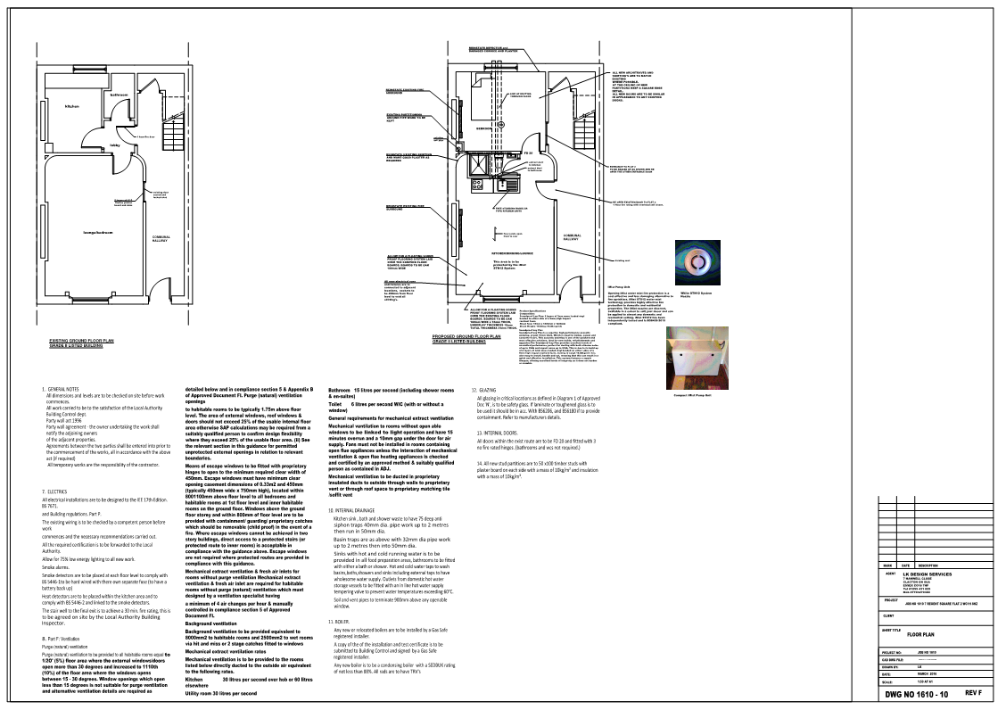

1610-11 Rev. B
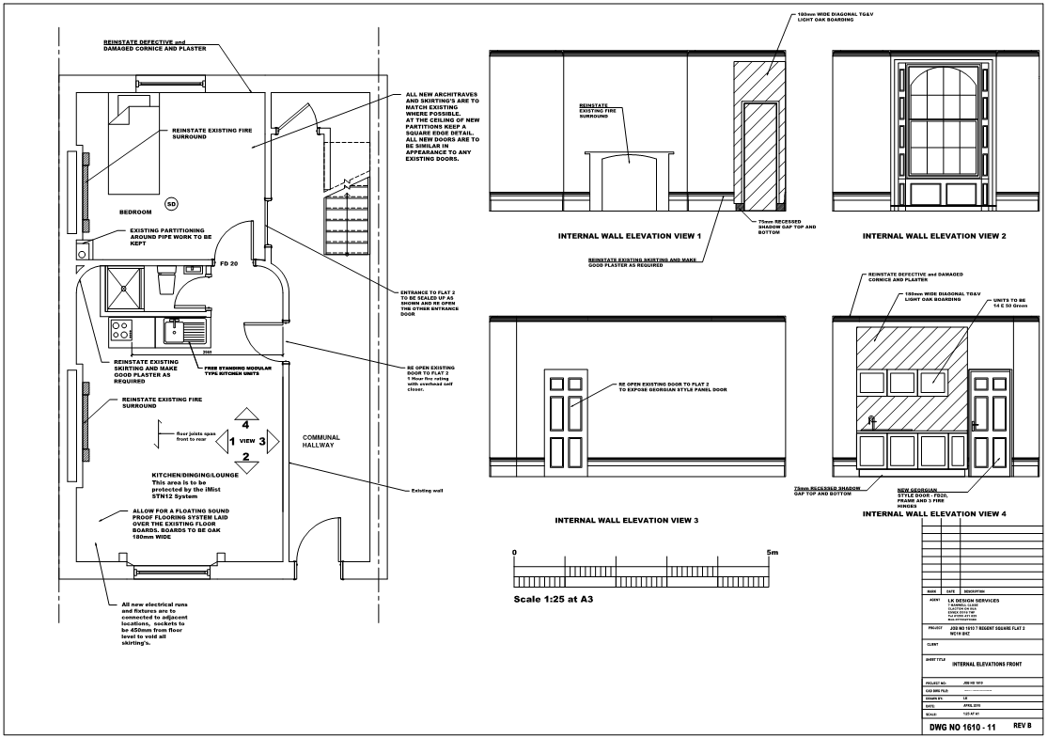

1610-12 A
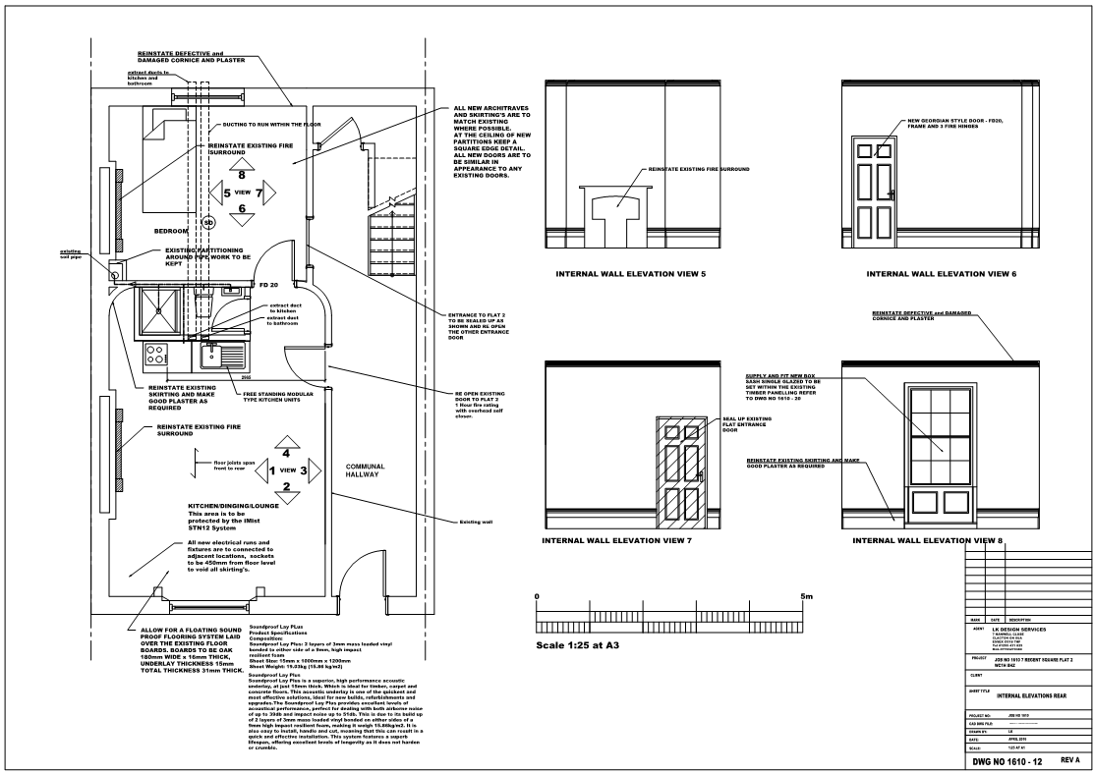

1610-20 Rev. B
