Broken Links

1. Transfer of license, terms and conditions link

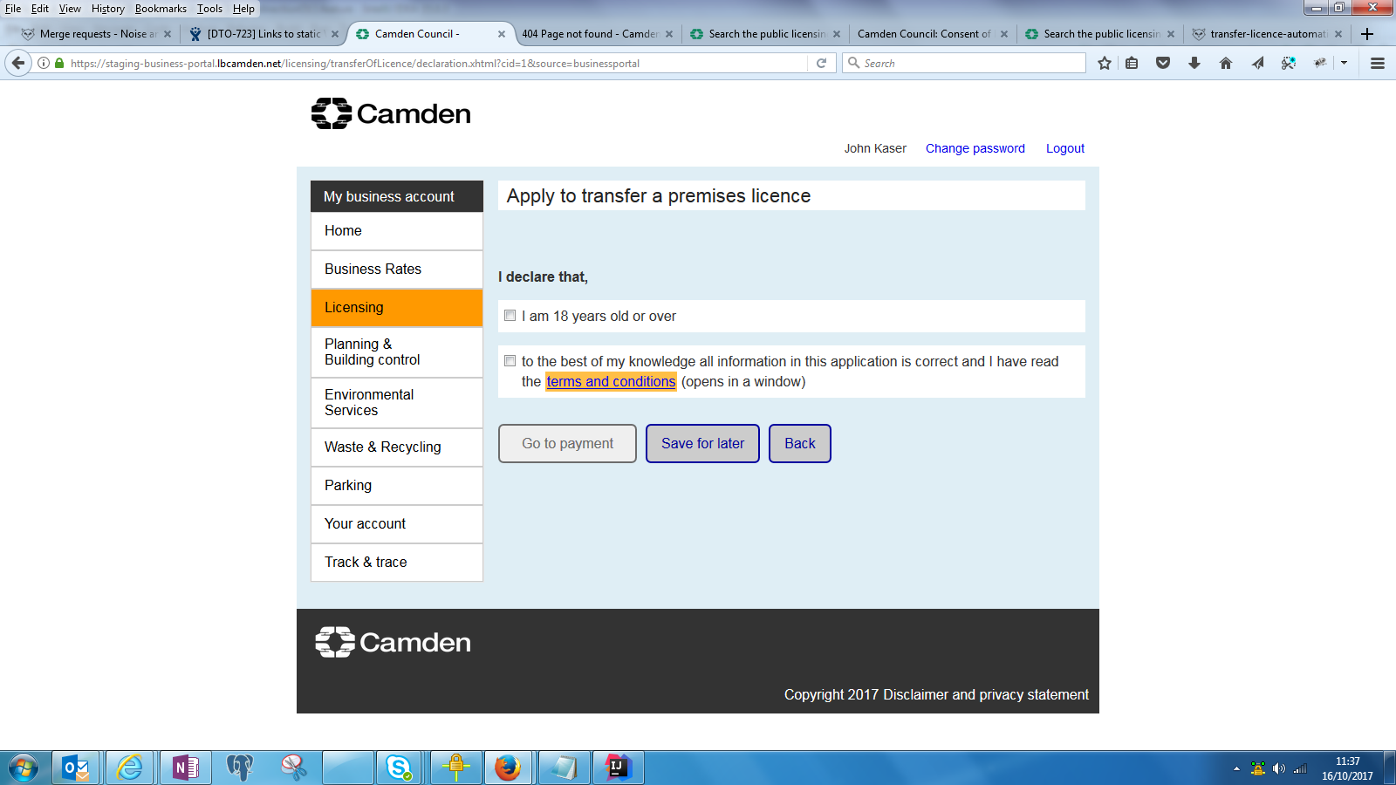

variation.licObjective.premisesGuide.link=http://www.camden.gov.uk/ccm/cms-service/stream/asset/Application%20guidance%20-%20premises%20licences%2026.04.2012.pdf?asset_id=3314240

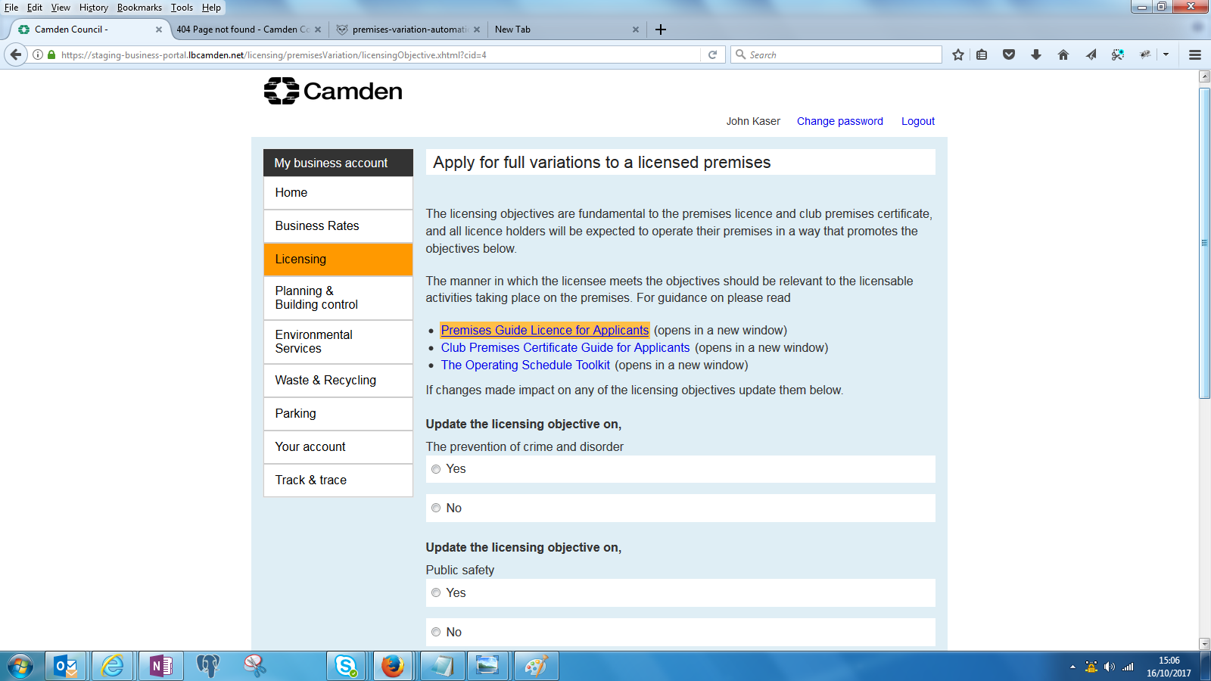

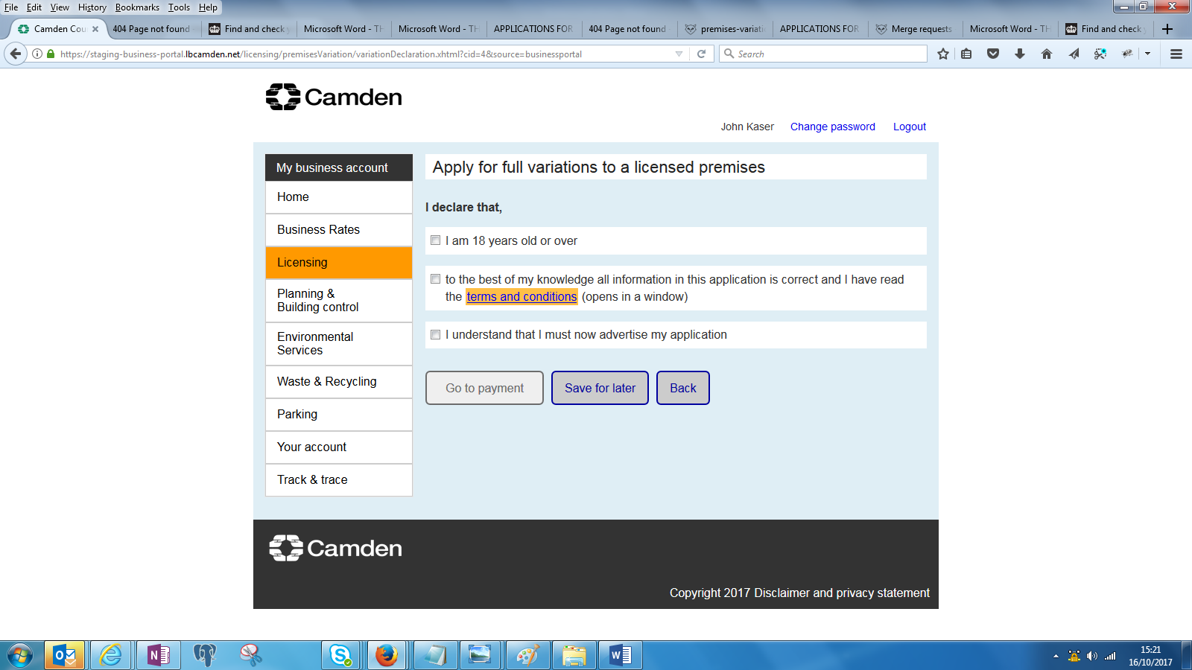

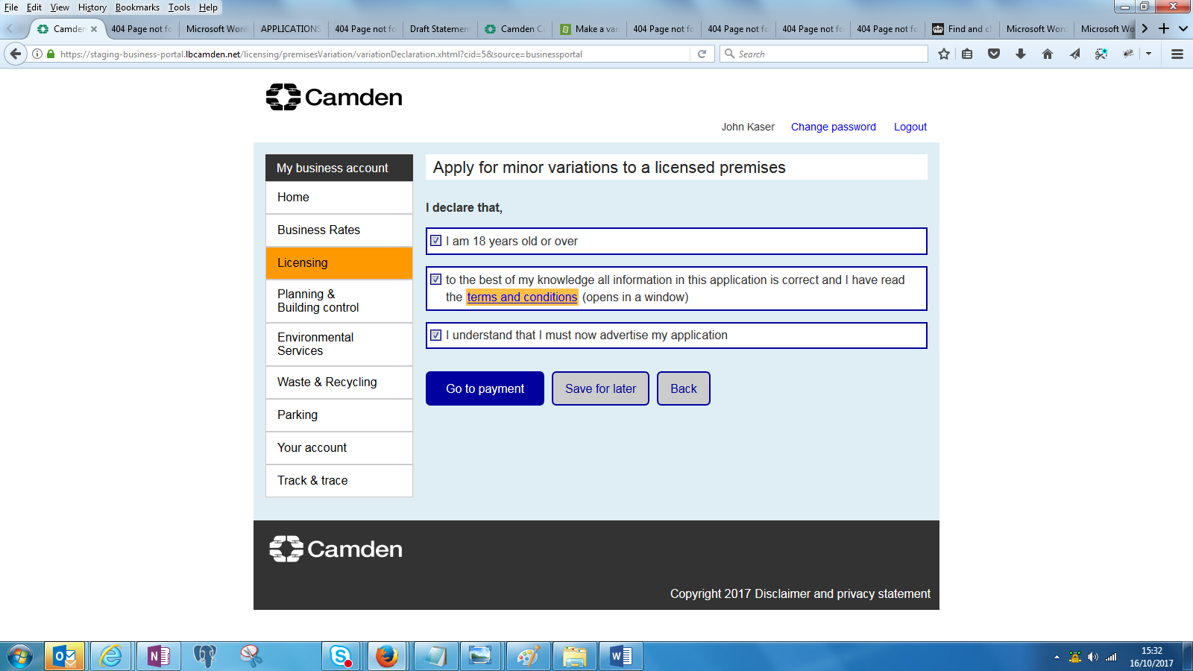

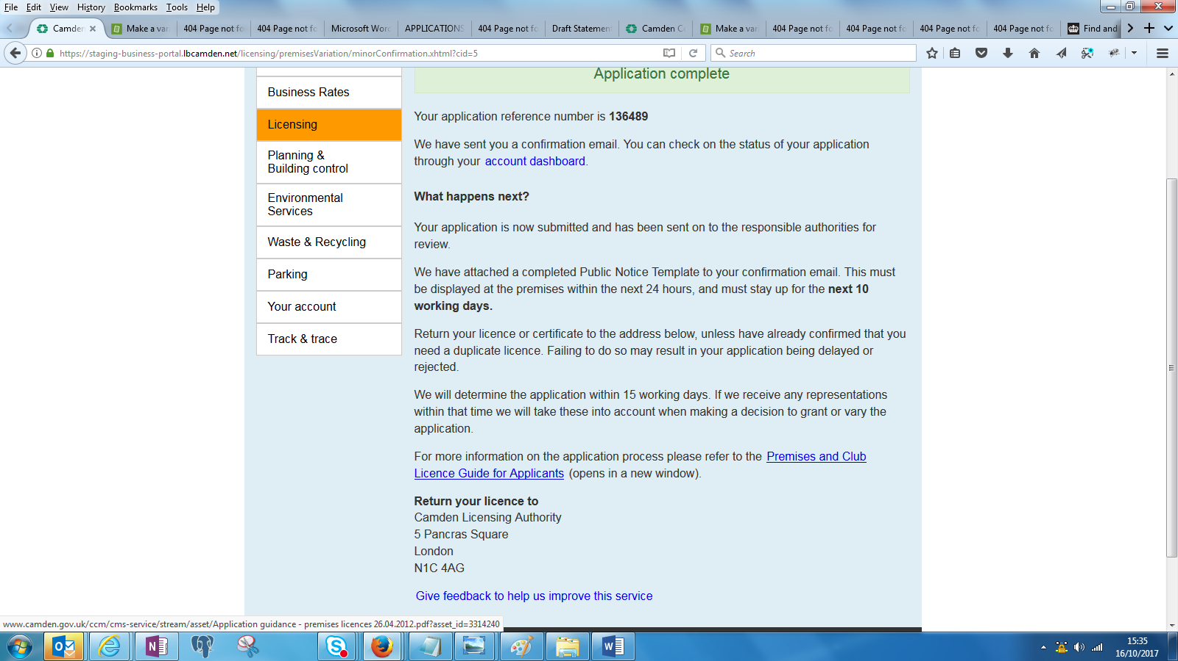

1. The below links do not open

