[Historic England](https://historicengland.org.uk/)

* [Menu](https://historicengland.org.uk/listing/the-list/list-entry/1113012)
* [Search](https://historicengland.org.uk/sitesearch)

Top of Form

What are you looking for?



Searching...

Click anywhere to close (ESC)

Bottom of Form

* [Listing](https://historicengland.org.uk/listing/)
  + [Search the List](https://historicengland.org.uk/listing/the-list/)
  + [Enrich the List](https://historicengland.org.uk/listing/enrich-the-list/)
  + [Apply for Listing](https://historicengland.org.uk/listing/apply-for-listing/)
  + [What is Listing?](https://historicengland.org.uk/listing/what-is-designation/)
  + [Listing Guidance](https://historicengland.org.uk/listing/selection-criteria/)
* [Advice](https://historicengland.org.uk/advice/)
  + [Your Home](https://historicengland.org.uk/advice/your-home/)
  + [Planning](https://historicengland.org.uk/advice/planning/)
  + [Latest Advice & Guidance](https://historicengland.org.uk/advice/latest-guidance/)
  + [Caring for Heritage](https://historicengland.org.uk/advice/caring-for-heritage/)
  + [Technical Guidance](https://historicengland.org.uk/advice/technical-advice/)
  + [Heritage at Risk](https://historicengland.org.uk/advice/heritage-at-risk/)
  + [Constructive Conservation](https://historicengland.org.uk/advice/constructive-conservation/)
  + [Heritage Protection Guide](https://historicengland.org.uk/advice/hpg/)
* [Research](https://historicengland.org.uk/research/)
  + [Our Research Strategy and Agenda](https://historicengland.org.uk/research/agenda/)
  + [Research Methods](https://historicengland.org.uk/research/methods/)
  + [Current Research](https://historicengland.org.uk/research/current/)
  + [Research Results](https://historicengland.org.uk/research/research-results/)
  + [Support & Collaboration](https://historicengland.org.uk/research/support-and-collaboration/)
  + [Inclusive Heritage](https://historicengland.org.uk/research/inclusive-heritage/)
  + [Heritage Counts](https://historicengland.org.uk/research/heritage-counts/)
* [Images & Books](https://historicengland.org.uk/images-books/)
  + [Find Photos](https://historicengland.org.uk/images-books/photos/)
  + [Search All Publications](https://historicengland.org.uk/images-books/publications/)
  + [Buy Books](https://historicengland.org.uk/images-books/books/)
  + [The Historic England Archive](https://historicengland.org.uk/images-books/archive/)
  + [Be an Archive Detective](https://historicengland.org.uk/images-books/archive-mysteries/)
* [Services & Skills](https://historicengland.org.uk/services-skills/)
  + [Education](https://historicengland.org.uk/services-skills/education/)
  + [Grants](https://historicengland.org.uk/services-skills/grants/)
  + [Our Planning Services](https://historicengland.org.uk/services-skills/our-planning-services/)
  + [Training & Skills](https://historicengland.org.uk/services-skills/training-skills/)
  + [Archive Services](https://historicengland.org.uk/services-skills/archive-services/)
  + [Heritage Action Zones](https://historicengland.org.uk/services-skills/heritage-action-zones/)
* [Get Involved](https://historicengland.org.uk/get-involved/)
  + [100 Places](https://historicengland.org.uk/get-involved/100-places/)
  + [Support Us](https://historicengland.org.uk/get-involved/support-us/)
  + [Be a Volunteer](https://historicengland.org.uk/get-involved/volunteer/)
  + [Visit Your Heritage](https://historicengland.org.uk/get-involved/visit/)
  + [Protect Your Heritage](https://historicengland.org.uk/get-involved/protect/)
  + [Help Write History](https://historicengland.org.uk/get-involved/help-write-history/)
  + [Angel Awards](https://historicengland.org.uk/get-involved/angel-awards/)
* [What's New](https://historicengland.org.uk/whats-new/)
  + [News](https://historicengland.org.uk/whats-new/news/)
  + [In Your Area](https://historicengland.org.uk/whats-new/in-your-area/)
  + [Latest Listings](https://historicengland.org.uk/whats-new/listing/)
  + [Latest Research](https://historicengland.org.uk/whats-new/research/)
  + [Heritage Online Debate](https://historicengland.org.uk/whats-new/debate/)
  + [Statements](https://historicengland.org.uk/whats-new/statements/)
  + [Stay Up To Date](https://historicengland.org.uk/whats-new/stay-up-to-date/)
  + [50 Years of Conservation Areas](https://historicengland.org.uk/whats-new/conservation-areas-50-years/)
  + [First World War Centenary](https://historicengland.org.uk/whats-new/first-world-war-home-front/)
  + [What We Do](https://historicengland.org.uk/about/what-we-do/)
  + [Who We Are](https://historicengland.org.uk/about/who-we-are/)
  + [Jobs](https://historicengland.org.uk/about/jobs/)
  + [Contact Us](https://historicengland.org.uk/about/contact-us/)
  + [Volunteer with Historic England](https://historicengland.org.uk/about/volunteering/)
  + [Website Terms and Conditions](https://historicengland.org.uk/terms/website-terms-conditions/)
  + [Data Protection](https://historicengland.org.uk/terms/data-protection-information-charter/)
  + [Privacy and Cookies](https://historicengland.org.uk/terms/privacy-cookies/)
  + [Links Policy](https://historicengland.org.uk/terms/links-policy/)
  + [Historic England Blog and Social: House Rules](https://historicengland.org.uk/terms/blog-house-rules/)
  + [Photo Competition Terms and Conditions](https://historicengland.org.uk/terms/photo-competition-terms-conditions/)
  + [Angel Awards 2017 Voting Terms and Conditions](https://historicengland.org.uk/terms/angel-awards-voting-terms-and-conditions/)
* [Home](https://historicengland.org.uk/)
* [...](https://historicengland.org.uk/listing/the-list/list-entry/1113012)
* [Listing](https://historicengland.org.uk/listing/)
* [Search the List](https://historicengland.org.uk/listing/the-list/)
* List Entry

[This browser is not fully supported](https://www.historicengland.org.uk/access/) by Historic England. Please update your browser to the latest version so that you get the best from our website.

We use cookies to give you the best possible experience online. By using this website, you consent to cookies being used in accordance with our [Cookie Policy](https://historicengland.org.uk/terms/).

* [Section Navigation](https://historicengland.org.uk/listing/the-list/list-entry/1113012)
  + [Map Search](https://historicengland.org.uk/listing/the-list/map/)
  + [Advanced Search](https://historicengland.org.uk/listing/the-list/advanced/)
  + [Minor Amendments](https://historicengland.org.uk/listing/the-list/minor-amendments/)
  + [Download Listing Data](https://historicengland.org.uk/listing/the-list/data-downloads/)
  + [Non-Listed Sites](https://historicengland.org.uk/listing/the-list/non-listed-sites/)
  + [About The List](https://historicengland.org.uk/listing/the-list/about-the-list/)
  + [Enrich the List](https://historicengland.org.uk/listing/the-list/enrich/)
  + [Understanding List Entries](https://historicengland.org.uk/listing/the-list/understanding-list-entries/)

**THE LODGE AND ATTACHED RAILINGS**

**List Entry Summary**

This building is listed under the Planning (Listed Buildings and Conservation Areas) Act 1990 as amended for its special architectural or historic interest.

Name: THE LODGE AND ATTACHED RAILINGS

List entry Number: 1113012

**Location**

THE LODGE AND ATTACHED RAILINGS, FLAXMAN TERRACE

The building may lie within the boundary of more than one authority.

County: Greater London Authority

District: Camden

District Type: London Borough

Parish:

National Park: Not applicable to this List entry.

Grade: II

Date first listed: 11-Jan-1999

Date of most recent amendment: Not applicable to this List entry.

**Legacy System Information**

The contents of this record have been generated from a legacy data system.

Legacy System: LBS

UID: 477338

**Asset Groupings**

This list entry does not comprise part of an Asset Grouping. Asset Groupings are not part of the official record but are added later for information.

**List entry Description**

**Summary of Building**

Legacy Record - This information may be included in the List Entry Details.

**Reasons for Designation**

Legacy Record - This information may be included in the List Entry Details.

**History**

Legacy Record - This information may be included in the List Entry Details.

**Details**

CAMDEN  
  
TQ2982NE FLAXMAN TERRACE 798-1/89/480 (East side) The Lodge and attached railings   
  
GV II  
  
Pair of semi-detached houses designed to appear as one lodge. c1907-8. By Joseph and Smitham. For the Vestry of St Pancras. Brick, roughcast upwards from ground floor window level; continuous 1st floor stone cornice. Tiled roof with central gable, bracketed eaves cornice and tall brick end chimneystacks with cornices. Copper domes with finials to angle turrets. 2 storeys and basement. Symmetrical design. Central entrances, approached by steps, of part-glazed doors with overlights under a single segmental-arched hood on large brackets. Flanking narrow windows. 2-light sash above porch and under the gable at 1st floor. Angle turrets have transom and mullion windows with glazing bars to ground floors and similar windows without transoms to 1st floor. INTERIOR not inspected. SUBSIDIARY FEATURES: attached cast-iron railings to areas and steps; front railings with the St Pancras Vestry coat of arms with the motto "Constans Justitiam Moniti" ("Well Versed in Justice").   
  
  
  
  
  
Listing NGR: TQ2993282558

**Selected Sources**

Legacy Record - This information may be included in the List Entry Details

National Grid Reference: TQ 29932 82558

**Map**

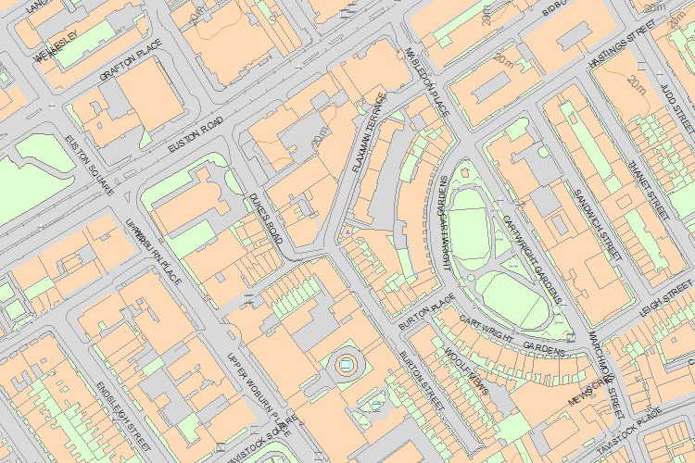© Crown Copyright and database right 2017. All rights reserved. Ordnance Survey Licence number 100024900.  
© British Crown and SeaZone Solutions Limited 2017. All rights reserved. Licence number 102006.006.  
Use of this data is subject to [Terms and Conditions](https://historicengland.org.uk/terms/website-terms-conditions/).

The above map is for quick reference purposes only and may not be to scale. For a copy of the full scale map, please see the attached PDF - [1113012 .pdf](http://mapservices.historicengland.org.uk/printwebservicehle/StatutoryPrint.svc/109477/HLE_A4L_Grade%7CHLE_A3L_Grade.pdf)

The PDF will be generated from our live systems and may take a few minutes to download depending on how busy our servers are. We apologise for this delay.

This copy shows the entry on 10-Oct-2017 at 09:52:45.

End of official listing

Your Contributions