[Historic England](https://historicengland.org.uk/)

* [Menu](https://historicengland.org.uk/listing/the-list/list-entry/1244097)
* [Search](https://historicengland.org.uk/sitesearch)

Top of Form

What are you looking for?



Searching...

Click anywhere to close (ESC)

Bottom of Form

* [Listing](https://historicengland.org.uk/listing/)
  + [Search the List](https://historicengland.org.uk/listing/the-list/)
  + [Enrich the List](https://historicengland.org.uk/listing/enrich-the-list/)
  + [Apply for Listing](https://historicengland.org.uk/listing/apply-for-listing/)
  + [What is Listing?](https://historicengland.org.uk/listing/what-is-designation/)
  + [Listing Guidance](https://historicengland.org.uk/listing/selection-criteria/)
* [Advice](https://historicengland.org.uk/advice/)
  + [Your Home](https://historicengland.org.uk/advice/your-home/)
  + [Planning](https://historicengland.org.uk/advice/planning/)
  + [Latest Advice & Guidance](https://historicengland.org.uk/advice/latest-guidance/)
  + [Caring for Heritage](https://historicengland.org.uk/advice/caring-for-heritage/)
  + [Technical Guidance](https://historicengland.org.uk/advice/technical-advice/)
  + [Heritage at Risk](https://historicengland.org.uk/advice/heritage-at-risk/)
  + [Constructive Conservation](https://historicengland.org.uk/advice/constructive-conservation/)
  + [Heritage Protection Guide](https://historicengland.org.uk/advice/hpg/)
* [Research](https://historicengland.org.uk/research/)
  + [Our Research Strategy and Agenda](https://historicengland.org.uk/research/agenda/)
  + [Research Methods](https://historicengland.org.uk/research/methods/)
  + [Current Research](https://historicengland.org.uk/research/current/)
  + [Research Results](https://historicengland.org.uk/research/research-results/)
  + [Support & Collaboration](https://historicengland.org.uk/research/support-and-collaboration/)
  + [Inclusive Heritage](https://historicengland.org.uk/research/inclusive-heritage/)
  + [Heritage Counts](https://historicengland.org.uk/research/heritage-counts/)
* [Images & Books](https://historicengland.org.uk/images-books/)
  + [Find Photos](https://historicengland.org.uk/images-books/photos/)
  + [Search All Publications](https://historicengland.org.uk/images-books/publications/)
  + [Buy Books](https://historicengland.org.uk/images-books/books/)
  + [The Historic England Archive](https://historicengland.org.uk/images-books/archive/)
  + [Be an Archive Detective](https://historicengland.org.uk/images-books/archive-mysteries/)
* [Services & Skills](https://historicengland.org.uk/services-skills/)
  + [Education](https://historicengland.org.uk/services-skills/education/)
  + [Grants](https://historicengland.org.uk/services-skills/grants/)
  + [Our Planning Services](https://historicengland.org.uk/services-skills/our-planning-services/)
  + [Training & Skills](https://historicengland.org.uk/services-skills/training-skills/)
  + [Archive Services](https://historicengland.org.uk/services-skills/archive-services/)
  + [Heritage Action Zones](https://historicengland.org.uk/services-skills/heritage-action-zones/)
* [Get Involved](https://historicengland.org.uk/get-involved/)
  + [100 Places](https://historicengland.org.uk/get-involved/100-places/)
  + [Support Us](https://historicengland.org.uk/get-involved/support-us/)
  + [Be a Volunteer](https://historicengland.org.uk/get-involved/volunteer/)
  + [Visit Your Heritage](https://historicengland.org.uk/get-involved/visit/)
  + [Protect Your Heritage](https://historicengland.org.uk/get-involved/protect/)
  + [Help Write History](https://historicengland.org.uk/get-involved/help-write-history/)
  + [Angel Awards](https://historicengland.org.uk/get-involved/angel-awards/)
* [What's New](https://historicengland.org.uk/whats-new/)
  + [News](https://historicengland.org.uk/whats-new/news/)
  + [In Your Area](https://historicengland.org.uk/whats-new/in-your-area/)
  + [Latest Listings](https://historicengland.org.uk/whats-new/listing/)
  + [Latest Research](https://historicengland.org.uk/whats-new/research/)
  + [Heritage Online Debate](https://historicengland.org.uk/whats-new/debate/)
  + [Statements](https://historicengland.org.uk/whats-new/statements/)
  + [Stay Up To Date](https://historicengland.org.uk/whats-new/stay-up-to-date/)
  + [50 Years of Conservation Areas](https://historicengland.org.uk/whats-new/conservation-areas-50-years/)
  + [First World War Centenary](https://historicengland.org.uk/whats-new/first-world-war-home-front/)
  + [What We Do](https://historicengland.org.uk/about/what-we-do/)
  + [Who We Are](https://historicengland.org.uk/about/who-we-are/)
  + [Jobs](https://historicengland.org.uk/about/jobs/)
  + [Contact Us](https://historicengland.org.uk/about/contact-us/)
  + [Volunteer with Historic England](https://historicengland.org.uk/about/volunteering/)
  + [Website Terms and Conditions](https://historicengland.org.uk/terms/website-terms-conditions/)
  + [Data Protection](https://historicengland.org.uk/terms/data-protection-information-charter/)
  + [Privacy and Cookies](https://historicengland.org.uk/terms/privacy-cookies/)
  + [Links Policy](https://historicengland.org.uk/terms/links-policy/)
  + [Historic England Blog and Social: House Rules](https://historicengland.org.uk/terms/blog-house-rules/)
  + [Photo Competition Terms and Conditions](https://historicengland.org.uk/terms/photo-competition-terms-conditions/)
  + [Angel Awards 2017 Voting Terms and Conditions](https://historicengland.org.uk/terms/angel-awards-voting-terms-and-conditions/)
* [Home](https://historicengland.org.uk/)
* [...](https://historicengland.org.uk/listing/the-list/list-entry/1244097)
* [Listing](https://historicengland.org.uk/listing/)
* [Search the List](https://historicengland.org.uk/listing/the-list/)
* List Entry

[This browser is not fully supported](https://www.historicengland.org.uk/access/) by Historic England. Please update your browser to the latest version so that you get the best from our website.

We use cookies to give you the best possible experience online. By using this website, you consent to cookies being used in accordance with our [Cookie Policy](https://historicengland.org.uk/terms/).

* [Section Navigation](https://historicengland.org.uk/listing/the-list/list-entry/1244097)
  + [Map Search](https://historicengland.org.uk/listing/the-list/map/)
  + [Advanced Search](https://historicengland.org.uk/listing/the-list/advanced/)
  + [Minor Amendments](https://historicengland.org.uk/listing/the-list/minor-amendments/)
  + [Download Listing Data](https://historicengland.org.uk/listing/the-list/data-downloads/)
  + [Non-Listed Sites](https://historicengland.org.uk/listing/the-list/non-listed-sites/)
  + [About The List](https://historicengland.org.uk/listing/the-list/about-the-list/)
  + [Enrich the List](https://historicengland.org.uk/listing/the-list/enrich/)
  + [Understanding List Entries](https://historicengland.org.uk/listing/the-list/understanding-list-entries/)

**SEVEN STARS PUBLIC HOUSE**

**List Entry Summary**

This building is listed under the Planning (Listed Buildings and Conservation Areas) Act 1990 as amended for its special architectural or historic interest.

Name: SEVEN STARS PUBLIC HOUSE

List entry Number: 1244097

**Location**

SEVEN STARS PUBLIC HOUSE, 53 AND 54, CAREY STREET

The building may lie within the boundary of more than one authority.

County: Greater London Authority

District: Camden

District Type: London Borough

Parish:

National Park: Not applicable to this List entry.

Grade: II

Date first listed: 14-May-1974

Date of most recent amendment: Not applicable to this List entry.

**Legacy System Information**

The contents of this record have been generated from a legacy data system.

Legacy System: LBS

UID: 476854

**Asset Groupings**

This list entry does not comprise part of an Asset Grouping. Asset Groupings are not part of the official record but are added later for information.

**List entry Description**

**Summary of Building**

Legacy Record - This information may be included in the List Entry Details.

**Reasons for Designation**

Legacy Record - This information may be included in the List Entry Details.

**History**

Legacy Record - This information may be included in the List Entry Details.

**Details**

CAMDEN  
  
TQ3081SE CAREY STREET 798-1/106/175 (North side) 14/05/74 Nos.53 AND 54 Seven Stars Public House   
  
II  
  
Formerly known as: The Log and Seven Stars Public House CAREY STREET. Public house. Perhaps C17 in origins (dated 1602) with later alterations and additions. Painted brick clads partial timber frame; slate roof. 2 storeys and attic; 4 windows, that to right broader and set in projecting jetty which may have been a separate building. Ground floor with C19 wooden public house frontage of 4 windows and 2 entrances flanked by pilasters; panelled aprons to windows. Gauged brick flat arches to 1st floor recessed sashes, except 1 window in jettied bay to right with reeded, architraved surround. INTERIOR: two rooms to ground floor. C19 bar backs with mirrors, that to larger bars with cupboards. Bar counters to both rooms of similar date. c1900 corner fireplace in right-hand bar, its joinery continues as ledges round side walls and across windows. Ceilings with thin beams of similar date masking earlier framing. Narrow stair to upper floors set behind main bar.   
  
  
  
  
  
Listing NGR: TQ3099281245

**Selected Sources**

Legacy Record - This information may be included in the List Entry Details

National Grid Reference: TQ 30997 81246

**Map**

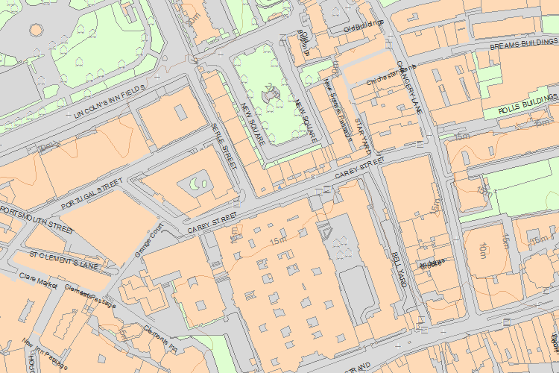© Crown Copyright and database right 2017. All rights reserved. Ordnance Survey Licence number 100024900.  
© British Crown and SeaZone Solutions Limited 2017. All rights reserved. Licence number 102006.006.  
Use of this data is subject to [Terms and Conditions](https://historicengland.org.uk/terms/website-terms-conditions/).

The above map is for quick reference purposes only and may not be to scale. For a copy of the full scale map, please see the attached PDF - [1244097 .pdf](http://mapservices.historicengland.org.uk/printwebservicehle/StatutoryPrint.svc/224001/HLE_A4L_Grade%7CHLE_A3L_Grade.pdf)

The PDF will be generated from our live systems and may take a few minutes to download depending on how busy our servers are. We apologise for this delay.

This copy shows the entry on 09-Oct-2017 at 10:40:43.

End of official listing