3rd October 2017

Charles Thuaire

Senior Planning Officer

Regeneration and Planning

Culture and Environment Directorate

London Borough Of Camden

2nd floor

5 Pancras Square

London N1C 4AG

Dear Charles

**Planning Application Ref: 2014/6449/P- Bartrams Convent Hostel, Rowland Hill Street, London NW3 2AD**

**Application to discharge condition 3.**

In relation to the above we submit an application to discharge the above pre-commencement condition.

Condition 3 requires the submission of:

“A sample panel (of no less than 3m x 3m) of the facing brickwork, demonstrating the proposed colour, texture, face-bond and pointing, shall be provided on site and approved in writing by the local planning authority before the relevant parts of the works are commenced and the development shall be carried out in accordance with the approval given. The approved panel shall be retained on site until the work has been completed.”

In pursuit of the above we have submitted via the planning portal (under reference no: PP-06430165) the following documents:

* A completed application form.
* A cover letter (this document)
* Photos showing the sample panel (of no less than 3m x 3m of the facing brickwork, demonstrating the proposed colour, texture, face-bond and pointing.
* The requisite fee (£97.00 submitted under separate cover).

We hope this is sufficient for your purposes. Please confirm if you need anything further.

Yours sincerely

For Tibbalds Planning and Urban Design

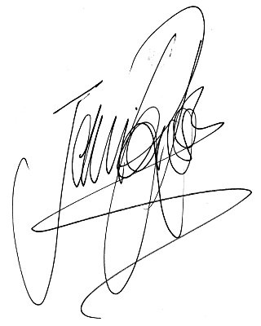Jennifer Ross

Director

[jennifer.ross@tibbalds.co.uk](mailto:jennifer.ross@tibbalds.co.uk)

Direct dial: 020 7089 2131

enc

cc