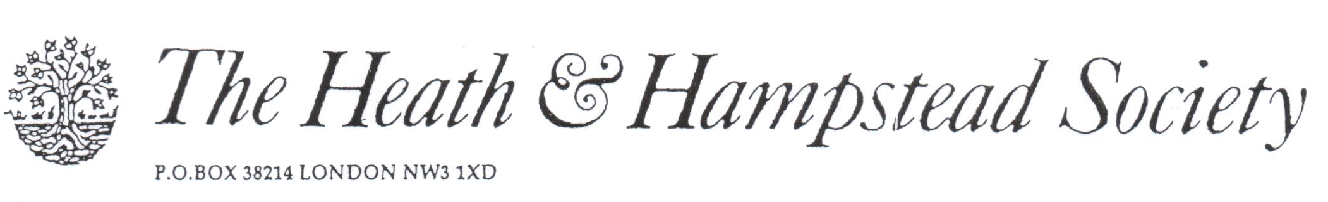
The Society examines all Planning Applications relating to Hampstead, and assesses them for their impact on conservation and on the local environment.

To London Borough of Camden, Development Control Team

Planning Ref: 2017/4582/P
Address: 2 Eldon Grove NW3
Description: Play structures in garden
Case Officer: Matthias Gentet Date: 18 September 2017

It is clear that this application is to validate existing work, shown in the attached photographs. We are inclined to take a negative view of all retrospective applications, where it is plain that the applicant though he/she could get away with this without approval.

The structures are largely oversize, intrusive, and harmful to the enjoyment of adjoining gardens. We refer particularly to the Play House, which appears to be at least 4 metres in height. The adjoining garden fences are no more than 1.8 metres high. The gazebo is less damaging.

Taken as a whole, the structures look as if they are intended to serve a nursery school, rather than a private house.

Nevertheless, we are reluctant to ask for their removal, but a reduction in height of the Play House might reduce the damaging effect on neighbouring gardens. We urge you to negotiate.

