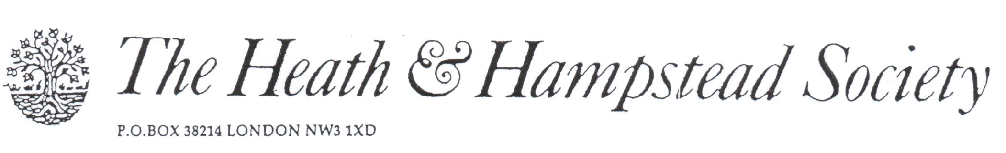
The Society examines all Planning Applications relating to Hampstead, and assesses them for their impact on conservation and on the local environment.

To London Borough of Camden, Development Control Team

Planning Ref: 2017/4366/P
Address: 66 Fitzjohns Avenue NW3
Description: Demolition of existing houses; 2 new 3-story houses
Case Officer: John Diver Date: 18 September 2017

We see that this is a proposed amendment to a previous permitted application, 2015/5847/P. You will note that we objected to this at the time.

We cannot go over old ground again, but we raise further objections to this proposal, on these grounds:

1. The increased height of the new houses, adding some 3 metres to their overall height, would be extremely damaging to the interests of the adjoining houses on each side: nos 64 Fitzjohns Avenue to the West, 12 Akenside Road to the East. The effect on no 64 Fitzjohns Av would be particularly severe, blocking daylight and sunlight.

2. There is no way that vehicles, especially public service vehicles and commercial vans etc , could enter, turn and leave the site in the confined space designed for them. This could affect public health and safety in emergencies.

The fact is that that the smaller houses originally proposed should have been considered overdevelopment of this tiny site; This enlargement is quite unacceptable.

Please refuse.

