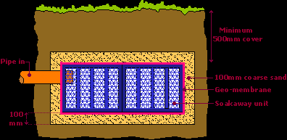

**Image LG05**

**Infiltration System Soakaway Receiving Surface Water**