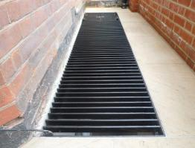

**Image LG03**

**Stainless Steel Light-Well Grill with Access Hatch**