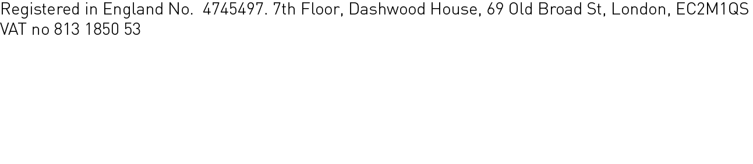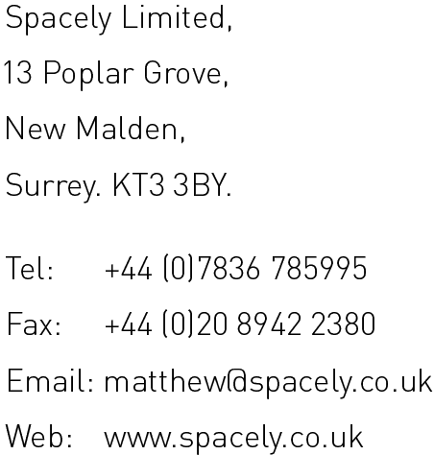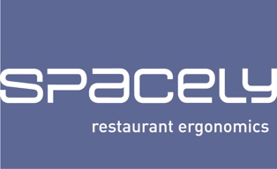

Brief statement regarding 178-192 Camden High Street.

These premises are currently an eyesore, with one permanent user in the centre, Cafe Metro, and retail booths used on an ad-hoc basis by various traders. Untidy when they are open, they are also ugly when closed because of the expanse of unfriendly steel roller shutters.

This application aims to create a more High Street-friendly set of premises, with shop-fronts, awnings and fascia signage that takes it into the mainstream. Finishes are designed to be durable and with individual premises that can be adjusted quickly to take into account changing tastes in the area for pop-up operators, without compromising the overall look of the small parade. The Cafe Metro is intended to stay as a permanent operator, with the surrounding units available for short term users.

The shopfronts are intended to be polyester powder coated aluminium, standard Comar or equivalent sections, with clear toughened glass within, and all the same dark grey as the fascia so that the frontage reads as one unit. The double doors are intended to be on parliament hinges, so they can open flat to the shopfront and be pinned back during opening hours.

The permanent signage is to be lacquered abraded mild steel letters on long spacers in front of the ventilation grills, and is to be supplemented by vinyls in the shopfront windows providing visibility for the pop-up operators in each unit.

The ventilation equipment is all internal, providing air in and extract over the cooking equipment and incorporating suitable filtration systems to allow for the low level discharge, as already present in the central unit. Only grills will be visible on the front of the building, and masked by the signage.

MS 05 IX 2017