**INVERFORTH HOUSE**

**List Entry Summary**

This building is listed under the Planning (Listed Buildings and Conservation Areas) Act 1990 as amended for its special architectural or historic interest.

Name: INVERFORTH HOUSE

List entry Number: 1113185

**Location**

INVERFORTH HOUSE, NORTH END WAY

The building may lie within the boundary of more than one authority.

County: Greater London Authority

District: Camden

District Type: London Borough

Parish:

National Park: Not applicable to this List entry.

Grade: II

Date first listed: 07-Sep-1988

Date of most recent amendment: Not applicable to this List entry.

**Legacy System Information**

The contents of this record have been generated from a legacy data system.

Legacy System: LBS

UID: 477610

**Asset Groupings**

This list entry does not comprise part of an Asset Grouping. Asset Groupings are not part of the official record but are added later for information.

**List entry Description**

**Summary of Building**

Legacy Record - This information may be included in the List Entry Details.

**Reasons for Designation**

Legacy Record - This information may be included in the List Entry Details.

**History**

Legacy Record - This information may be included in the List Entry Details.

**Details**

CAMDEN  
  
TQ2686NW NORTH END WAY 798-1/8/1217 (West side) 07/09/88 Inverforth House   
  
GV II  
  
Formerly known as: The Hill NORTH END WAY. Substantial house, now a convalescent home. Original house 1807, rebuilt c1895 and successively modified by WH Lever, Viscount Leverhulme, who owned the house from 1904 until his death in 1925. Alterations included rebuilding of central block and addition of north and south wings to garden front (now with C20 2nd storeys) of c1905 by Grayson and Ould of Liverpool who also designed the terrace along the garden front, to which Thomas H Mawson added an Ionic verandah c1910. Terrace later altered in 1923 by Leslie Mansfield who added a ballroom beneath it. South wing extended and remodelled 1924-5 by Mawson in conjunction with TH Mawson and Sons; library wing added to entrance front 1913-14 by William and Segar Owen of Warrington. Red brick; steeply pitched, hipped tiled roof to eaves. Neo-Georgian manner with Queen Anne style wings to garden front. EXTERIOR: 2 storeys plus roof storey and basement. North and south wings formerly single storey. Garden front unified horizontally by a Portland stone Ionic colonnade across the ground floor, with three segmental projections and balustrading to terrace. Dominant slightly projecting centre piece of 5 bays beneath hipped roof with open segmental pediment to central dormer. Canted bay window to 1st floor centre bay of 3 windows wide, flanked by smaller canted timber bay windows; 4 further windows to wings on either side. Flush frames with small panes, some with transoms and mullions. Stone eaves cornice. Projecting wings have brick half-columns applied between bays, the 3 bays closest to house being treated as an arcade with arches between piers; remaining bays with brick architraves to 18-paned sashes. Much rubbed brickwork; richly moulded brick cornices. INTERIORS: richly decorated in various styles ranging from Jacobean to William and Mary and Adamesque. Decorative features of interest throughout the house but of particular note are the Ionic pilastered entrance hall with carved marble staircase, the fine Adam-style room opening onto the terrace at ground floor level with its columnar screen and decorative plasterwork ceiling and cornice; also the marble columned lobby to the south of this at ground floor level and the music room, panelled in C17 style and probably reusing some C17   
  
  
  
woodwork, particularly in the decorative chimney-piece. A rich architectural amalgam reflecting the tastes of a notable patron. HISTORICAL NOTE: following Leverhulme's death in 1925, the house was bought by Lord Inverforth and when he died The Hill was presented to Manor House Hospital in 1956. The gardens were designed and laid out by Thomas H Mawson from 1906. Further northern garden laid out during 1920s by Leslie Mansfield. Garden west of the Formal Pond (qv) and further northern garden, now under separate ownership and known as The Hill Garden, North End Way; this garden is open to the public.  
  
  
  
Listing NGR: TQ2617986676

**Selected Sources**

Legacy Record - This information may be included in the List Entry Details

National Grid Reference: TQ 26179 86676

**Map**

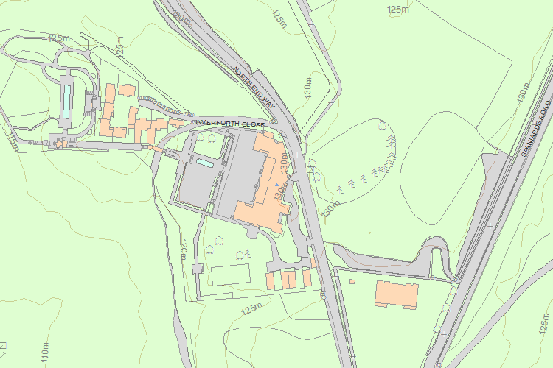© Crown Copyright and database right 2017. All rights reserved. Ordnance Survey Licence number 100024900.  
© British Crown and SeaZone Solutions Limited 2017. All rights reserved. Licence number 102006.006.  
Use of this data is subject to [Terms and Conditions](https://historicengland.org.uk/terms/website-terms-conditions/).

The above map is for quick reference purposes only and may not be to scale. For a copy of the full scale map, please see the attached PDF - [1113185 .pdf](http://mapservices.historicengland.org.uk/printwebservicehle/StatutoryPrint.svc/109621/HLE_A4L_Grade%7CHLE_A3L_Grade.pdf)

The PDF will be generated from our live systems and may take a few minutes to download depending on how busy our servers are. We apologise for this delay.

This copy shows the entry on 13-Sep-2017 at 11:33:05.

End of official listing

Your Contributions

Do you know more about this entry?

The following information has been contributed by users volunteering for our [Enriching The List project](http://historicengland.org.uk/listing/enrich-the-list/). For small corrections to the List Entry please see our [Minor Amendments procedure](http://historicengland.org.uk/listing/the-list/minor-amendments/).

The information and images below are the opinion of the contributor, are not part of the official entry and do not represent the official position of Historic England. We have not checked that the contributions below are factually accurate. Please see our [terms and conditions](http://historicengland.org.uk/terms/website-terms-conditions/enriching-the-list-contribution-terms/). If you wish to report an issue with a contribution or have a question please email [EnrichingTheList@HistoricEngland.org.uk](mailto:enrichingthelist@HistoricEngland.org.uk).

Top of Form



Email

Password

[Forgotten your password?](https://services.historicengland.org.uk/passportserver/RecoverPassword.aspx)

Log in

Don't have an account? [Sign up](https://services.historicengland.org.uk/passportserver/registration.aspx?app_id=1f8fb93f-56a7-4c10-91e4-6e9d04cbf7aa)

Bottom of Form

**1 contributionon INVERFORTH HOUSE**

There aren't any more contributions

Share