
Design Out Crime Office
North West DOCO Office,
Ruislip Police Station,
The Oaks,
Ruislip,
HA4 7LE

Telephone: 0208 7333703
Email:DOCOMailbox.NW@met.pnn.police.uk

Met Reference: NW 3077

FAO – Oluwaseyi Enirayetan

Dear Oluwaseyi

Thank you for inviting the Metropolitan Police to review and comment on this planning application for the ATM outside 143 Kings Cross Road, WC1X 9BM.

I have reviewed the crime rate in the ward that the proposed development is situated on, sourced from Police.uk as per the illustration below:
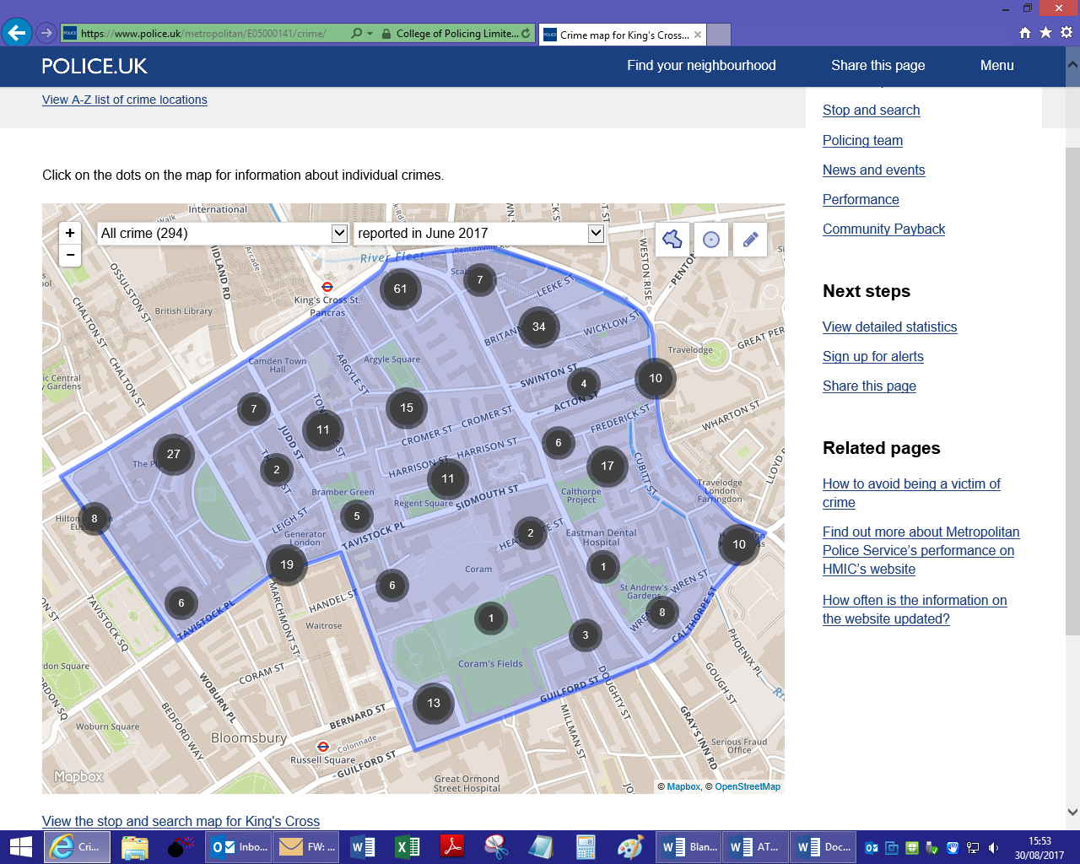


The crime map has highlighted that the following crimes were reported in the area and that the area is experiencing an increased number of ASB (Antisocial behavior), theft from person and other theft.

Specifically my research on Police.uk has highlighted that crime is occurring directly in the immediate vicinity of the proposed development.

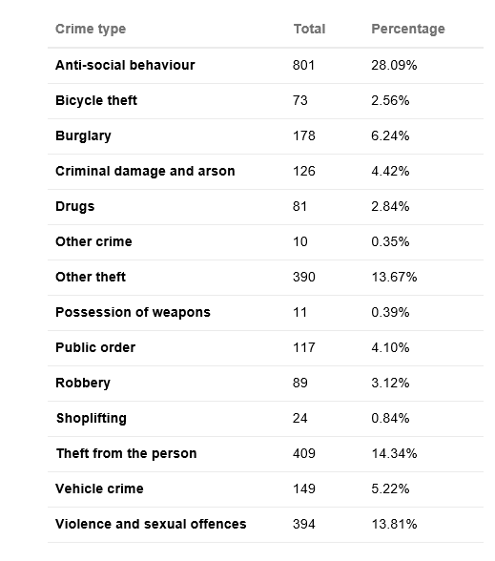
Comparison of Crime types in this area between July 2016 and June 2017

As such, serious consideration must be given to crime and ASB at the proposed development site.

Recommendations:

Therefore we would recommend:-
The following measures have been developed to minimise the risk of crime in a visually acceptable manner and meet the specific security needs of this individual site:
2.0 Recommended Minimum Standards

2.1 – Natural Surveillance –
Good natural surveillance of the ‘ATM/Payphone Pod’ from immediately adjacent roads and properties is vitally important. More specifically, the ‘ATM/Payphone Pod’ should NOT be located in recessed alcoves, on blind corners, quiet side frontages or semi-enclosed shopping parades. Other considerations include - obstructions such as other telephone kiosks, large planters, trees, highway signs and advertising hoardings that compromise natural surveillance. The ‘ATM/Payphone Pod’ should not be so positioned that it can be watched by potential robbers under the guise of legitimate citizens (e.g., from a nearby bus stop; or surveillance by criminals from first floor public areas overlooking the site).

2.2 – Mirrors –
The use of surrounding mirrors / polished surfaces to improve surveillance for the ATM user is an effective measure in reducing both crime and the fear of crime (e.g., to prevent ‘shoulder surfing’ and compromising the user’s PIN). Mirrors should be placed at an appropriate height so as to avoid reflection of the key pad numbers.

2.3 – CCTV –
The Installation should have both Overt and Covert 24hr CCTV provided with a min 28 day storage facility. This must be dedicated to the installation and be in accordance with the data protection guidelines. Overt coverage should be designed to capture the user and surrounding area (shoulder surfers and offenders tailing victims off etc). The Covert coverage should be designed to capture and identify any ATM user therefore identifying potential offenders interfering with the installation, using stolen cards, cash claws etc.

2.4 - Street Lighting –
Improved levels of street lighting have been shown to both reduce crime and the fear of crime.
The area surrounding the installation should conform to BS5489-1 the lighting source can be provided by the installation or surrounding existing light sources. (http://www.securedbydesign.com/pdfs/110107_LightingAgainstCrime.pdf ).

2.5 - Defensible space –
Ground markings (otherwise known as a ‘Privacy Zone’) should be employed at the front of the ATM, to indicate only one ATM user at a time may enter the space. These will usually be subject to local authority planning consent/condition.

2.6 – Bollards –
In addition to the anchoring system recommended, consideration should be given to the protecting the installation with anti-ram raid bollards, vehicle arresting systems, high-rise kerbs, raised planters, reinforced lamp posts or similar street furniture if the risk of a vehicle borne attack is likely . These will usually be subject to local authority planning authority consent or condition.

2.7 - PIN Shields -
PCI standard pin shields should be installed to prevent physical observation of the users pin code.

2.8 - Design of the ‘ATM/Payphone Pod’ -

The ATM should be positioned to prevent physical observation of PIN entry from adjoining telephone kiosks or payphones. The ATM and telephone uses of the combined kiosk must be positioned on opposite sides of the booth/pod.

The telephone leads in adjacent telephone kiosks or payphones should be shortened to prevent observation of PIN entry by persons using the payphone.
Where necessary, the door hinges of adjacent telephone kiosks should be reversed in order that payphone customers exit away from the ATM user.

3.0 Best Practice ‘ATM Security Working Group’ Guidelines

The following guidance should be considered.

3.1 – Anchoring systems –
As outlined in the above document, the ATM Security Working Group
‘Best Practice for Physical ATM Security’ Guidelines.

3.2 – Alarm Systems –
The ‘ATM/Payphone Pod’ should be independently alarmed for ‘Police Response’ (registered with the local police force and allocated a police alarm URN). For other alarm guidance please see the aforementioned document, the ATM Security Working Group ‘Best Practice for Physical ATM Security’ Guidelines.

3.3 – Fogging Systems -
As outlined in the attached document, the ATM Security Working Group
‘Best Practice for Physical ATM Security’ Guidelines.

3.4 – Tracking Systems –
As outlined in the attached document, the ATM Security Working Group
‘Best Practice for Physical ATM Security’ Guidelines.

3.5 – Cash Degradation Systems –
As outlined in the attached document, the ATM Security Working Group ‘Best Practice for Physical ATM Security’ Guidelines.

3.6 – Gas Attacks –
Consideration should be given as to whether the ‘ATM/Payphone Pod’ could be vulnerable to a ‘Gas Attack’.

3.7 – Other security measures –
Each application should be judged on its own merits and site-specific recommendations should be adopted. Any other security can be recommended as deemed suitable and outlined in the attached document, the ATM Security Working Group ‘Best Practice for Physical ATM Security’ Guidelines.

Should the applicants or the Planning Authority have any queries, please do not hesitate to contact this office either by email - DOCOMailbox.NW@met.pnn.police.uk or telephone quoting the reference number shown above.

I would ask that my interest in this planning application be noted and that I am kept appraised of developments.

Kind Regards,

PC Jim COPE
Designing Out Crime Officer
Metropolitan Police Service
Telephone: 0208 7333703
E-mail: james.cope@met.pnn.police.uk
Office Email: DOCOMailbox.NW@met.police.uk
Address: North West DOCO Office, Ruislip Police Station, The Oaks, Ruislip, HA4 7LE

The primary objective of an efficient Police Force is the prevention of crime

Crime Prevention advice can be found on the Metropolitan Police Service Website -http://content.met.police.uk/site/crimeprevention

Note - Section 17 of the Crime and Disorder Act 1988 states “It shall be the duty of each Authority to which this section applies to exercise its various functions with due regard to the likely effect of the exercise of those functions on and the need to do all it reasonably can to prevent Crime and Disorder in it’s area”, as clarified by PINS953.

