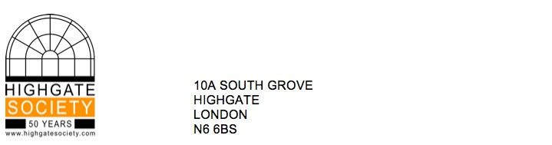

Sarah Freeman

Planning Solutions Team

Planning and Regeneration

London Borough of Camden

Town Hall

Argyle Street

London WC1H 8EQ

29 August, 2017

**By email only**

Dear Ms Freeman,

**RE: Planning Application Reference 2017/4474/L – 10 Holly Village, Highgate, N6 6QJ**

The society has some reservations about this application for emergency restoration work, in agreement with Historic England. We are encouraged by the applicants’ stated pledge to ensure like-for like replacement of any interior detail that proves beyond reasonable repair, but would urge extreme restraint in carrying out irreversible substitutions of original fabric. The proposed remedial works outlined by the contractor allow for considerable deviation from their specification due to the limitations of the initial investigation, and this could lead to historic structure being permanently lost or damaged in the event of unanticipated revelations. Specific details of the proposed replacement elements are also not included in the application drawings, and these should be required in addition to written statements of intention. This property has recently been updated and altered internally, resulting in some changes to its original layout, and we would not like to see further moves toward the establishment of a wholly contemporary interior space masked by a preserved external shell.

The Highgate Society would therefore stress that more information be provided by the applicant to the Council, in order to avoid unnecessary loss of original fittings and fixtures, particularly given the significance of the property’s architecture and heritage value, and in light of the ever dwindling stock of the nation’s historic interiors through modern-day development pressures.

Yours sincerely,

TR Blackshaw

Highgate Society Planning Group

Disclaimer:

The Highgate Society is an unincorporated association established for the public benefit. It endeavours to ensure that the information it provides as a free service is correct but does not warrant that it is accurate or complete. Nothing in this correspondence constitutes professional or legal advice and may not be relied on as such. In no event will the Society be liable for any loss or damage including without limitation, indirect or consequential loss or damage or any damage whatsoever arising from any objections, criticism, advice and information it provides.