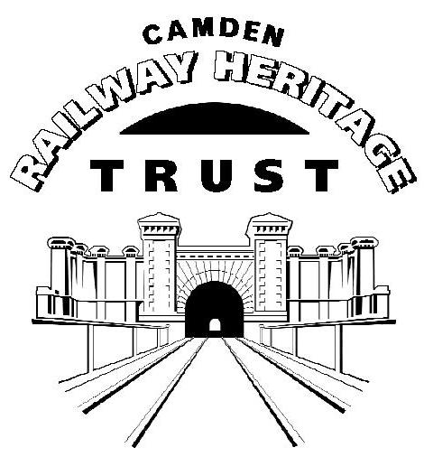**Morrisons Superstore and Petrol Filling Station, Chalk Farm Road, NW1 8EH**

**Application Ref. 2017/3847/P**

**Response from Camden Railway Heritage Trust**

This is a most untimely application in view of the many other developments that will interact on the wider area. These include those of the Roundhouse, One Housing Group (including Juniper Crescent and Gilbey’s Yard), Market-Tech at Camden Lock, Centric Close and Marine Ices.

The Camden Goods Yard (CGY) Planning Framework has been produced in a great hurry to provide a context for development of the wider area. Yet this area is too important for its development to be rushed.

While Morrisons’ planning application has raised key issues, we strongly urge that it be rejected in order that more time can be given to the necessary strategic thinking. The application is premature. Future development should be subjected to conditionality that will cause the parties to work together to meet strategic aims.

The foundations of any development must be rooted in:

1. The site’s history and heritage. This means taking account of the former Camden Goods Yard (CGY) including Juniper Crescent and Gilbey’s Yard, and not the separate areas that were sold in the early 1990s. It also means recognizing the importance and sensitivity of the historic areas that surround all sides of the development.
2. The creation of new linkages to join different communities through development while protecting residents from the night-time economy that flourishes along the Chalk Farm Road. The new communications must allow for circulation of commercial vehicles, cars, cycles and pedestrians
3. The creation of a coherent space that is sympathetic to, and in character with, its urban context, one in which businesses will be keen to work and long-term residents keen to live so as to foster a sustainable and vibrant community. This will require spaces for play and for leisure as well as key facilities that support the community, such as schools and medical centres.

It must be obvious to any independent observer that the current development plans fall far short of these fundamentals, with the result that the entire edifice of the planning application is founded on sand rather than on firm foundations.

It is easy to be impressed by the professionalism of the finished product, a highly detailed and complex planning application, until one asks the simplest of questions: does this development fit into its surroundings, and would you want to live here?

1. **History and Heritage**

It is not possible to respect the railway and canal heritage without taking the wider CGY area into account. It was unfortunate that CGY was sold as separate lots in the early 1990s, but we now have an unrepeatable opportunity to create something from the whole.

The shape of the CGY was that of a fan with its apex close to Primrose Hill Station. The fan was created by the complex of sidings that led to goods sheds and warehouses along the canal. Ideally such a fan shape should be retained in the new development, to include Juniper Crescent and Gilbeys Yard. It might feature terraces that ran concentrically, pierced by radial routes that mimic the railway sidings. It is accepted that the current main access route into the area will probably need to be superimposed on any such plan.

There should be open spaces located to enhance the three Grade II* listed structures and the Grade II Interchange Building. We do not believe Railway Park should be extended further to the west. The proper location for a new green corridor, that may in future link with a Camden Highline, is along the mainline railway, not the North London Railway. Here it can provide a SE to NW connection from the canal to, eventually, Primrose Hill Station and beyond.

The current proposals do not reflect any of the former CGY layout. They impose on the former CGY area an incoherent complex of blocks. These not only confuse the original layout, but by their height, mass and density serve to diminish, obscure and dwarf the remarkable, nationally important heritage.

The PFS site on Chalk Farm Road is totally inappropriate for the kind of architectural statement that is being proposed, and the harm to the Horse Hospital is severe.

1. **New Linkages**

Without proper understanding of the broad urban context, the development will serve to divide rather than knit together the diverse communities that inhabit this space and work in it. These include:

* Juniper Crescent
* Oval Road and Gilbey’s Yard
* Camden Lock Market
* Regent’s Canal towpath
* Stables Market
* Chalk Farm Road and the PFS frontage
* One Housing Group and the Roundhouse

Given the opportunities and threats, new linkages must sympathetically encourage movement in some locations and discourage it in others. The fact that such considerations are barely touched on by the applicant is hardly surprising, as this is not the applicant’s responsibility. The Council must act to coordinate communications and foster linkages with and between these diverse communities for public benefit.

1. **A New Urban Space**

Others have expressed their disappointment at the urban planning and the architecture presented in the application, often in the strongest terms. We concur with many of these critiques, but their consideration redirects us to the issue of planning one part of the CGY in isolation from the rest.

We would like to see a coherent streetscape that reflects the form of the former goods yard and enhances the surroundings of the key heritage elements. While not wishing to be prescriptive, we would challenge the way the applicant compares “shoulder heights” to those of warehouses on the Regent’s Canal, to justify a higher shoulder. The parapet height of the Interchange should be considered a key factor, and shoulder heights of five storeys will be more than sufficient.

Peter Darley

Secretary, CRHT