PLANNING APPLICATION
TREE WORKS IN A Conservation Area

Flask Tavern, 77 Highgate West Hill, London N6 6BB

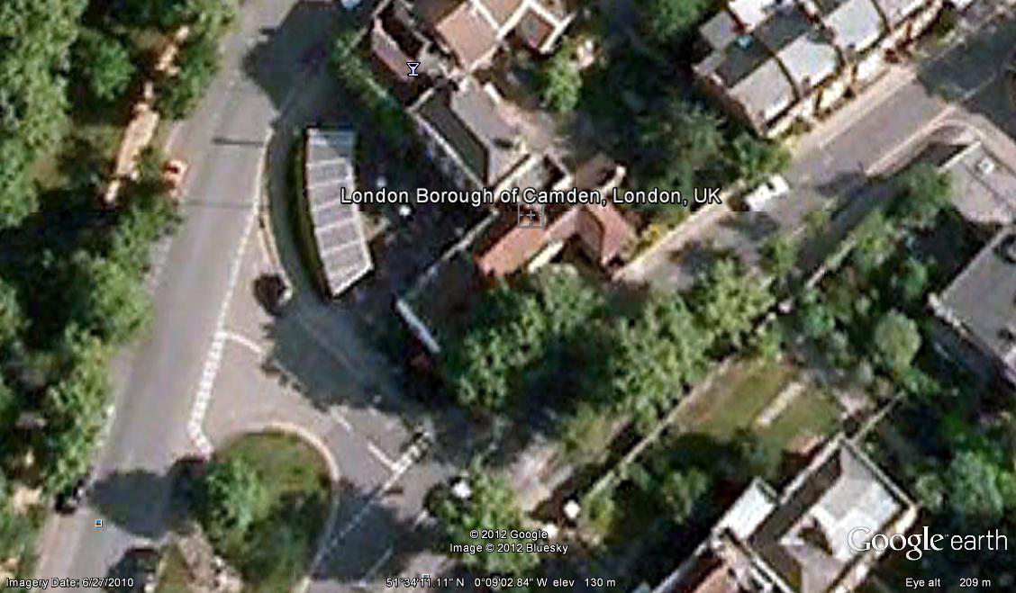
Reduce 3 no Apple trees by 1-2m in height and 1m width

Reduce 1 no., Hornbeam by 1m in height and 0.5m width

3 no. lime trees Approx. 13m-14m to the right hand side of the pub.
Reduce by 3m-4m in height and 1-2m in width, also to remove all lower growth
from around the bottom of the trees

