21st December 2015

Charles Thuaire

Senior Planning Officer

Regeneration and Planning

Culture and Environment Directorate

London Borough Of Camden

2nd floor

5 Pancras Square

London N1C 4AG

Dear Charles

**Planning Application Ref: 2014/6449/P- Bartrams Convent Hostel, Rowland Hill Street, London NW3 2AD**

**Application to discharge condition 4.**

In relation to the above we submit an application to discharge the above pre-commencement condition.

In pursuit of the above we enclose:

* A completed application form.
* The requisite fee.
* Condition 4: “No lights, meter boxes, flues, vents or pipes, and no telecommunications equipment, alarm boxes, television aerials, satellite dishes or rooftop 'mansafe' rails shall be fixed or installed on the external face of the buildings, without the prior approval in writing of the local planning authority.”
* Drawings package including; elevations and roof plan

We hope this is sufficient for your purposes. Please confirm if you need anything further.

Yours sincerely

For Tibbalds Planning and Urban Design

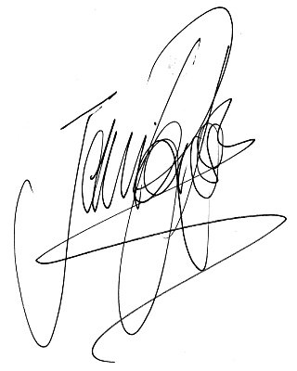Jennifer Ross

Director

[jennifer.ross@tibbalds.co.uk](mailto:jennifer.ross@tibbalds.co.uk)

Direct dial: 020 7089 2131

enc

cc