

**Design and Heritage Statement**

**34 Park Village East**

**Application for Listed Building Consent for Noise Insulation**

Document no: 1EW02-CSJ-EV-APP-SS01-000001

|  |  |  |  |  |  |
| --- | --- | --- | --- | --- | --- |
| Revision | Date | Author | Checked by | Approved by | Revision Details |
| P02 | 31/07/2017 | Simon Williams  Town Planning Advisor | Elliott Dennett  S2/S4 Consents Manager | Linda Bennett  Consents Manager | Issued for Submission |
| Signature | |  | C:\Users\swilliams\Desktop\Elliott.png | **C:\Users\swilliams\Desktop\untitled.png** |  |

**Contents**

1 Introduction 1

1.1 The application 1

1.2 The applicant 1

1.3 Background to HS2 1

1.4 Consultation in advance of the application 1

1.5 Purpose and scope of this statement 2

1.6 Structure of this statement 2

2 Need and justification for the application 3

3 Description of the proposals 5

3.1 Description of the site 5

3.2 Statement of significance 5

3.3 Description of site context and setting 7

3.4 The proposed works subject of this application 8

3.5 Design 9

4 Heritage assessment 13

4.1 Policy tests 13

4.2 Assessment of the impact of the proposals on significance 13

5 Compliance with national and local planning policy 16

5.2 NPPF and other national guidance 16

5.3 Statutory development plan and local guidance 17

6 Conclusions 19

Appendix A: Schedule of Works 21

Appendix B: Floorplans 24

Appendix C: External photographs 29

Appendix D: Internal photographs 31

Appendix E: Illustrations of standard secondary glazing and ventilation 39

**List of figures**

Figure 1: Examples of Internal Secondary Glazing installed in a Grade 1 listed Nash building. 40

Figure 2: Examples of Internal Acoustic Ventilation system. 41

1. Introduction
   1. The application

This statement has been prepared on behalf of High Speed Two Ltd (‘HS2 Ltd’). It is being submitted by HS2 Ltd, as the applicant, in support of an application seeking listed building consent for the installation of internal secondary glazing and supplementary ventilation at 34 Park Village East, NW1 7PZ.

The property is a Grade II* listed building, located within the Regents Park Conservation Area, within the London Borough of Camden (LB Camden).

* 1. The applicant

HS2 Ltd is an executive non-departmental public body, sponsored by the Department for Transport. It is responsible for developing and promoting the Government’s proposal for a new high speed north-south railway, High Speed Two (HS2).

Following Royal Assent, HS2 Ltd has been appointed the nominated undertaker, responsible for delivering the Proposed Scheme under the powers granted by the High Speed Rail (London – West Midlands) Act 2017 (‘the Act’).

* 1. Background to HS2

HS2 is being taken forward in two phases: Phase One, which will connect London with Birmingham and the West Midlands; and Phase Two which will extend the route to Manchester, Leeds and beyond.

Powers to construct Phase One of HS2 have now been secured through the High Speed Rail (London - West Midlands) Act 2017, which received Royal Assent on 23 February 2017. The Act contains provision for the disapplication or modification of various controls relating to listed buildings. This provision does not apply for works to listed buildings for the purposes of noise mitigation, such as the installation of secondary glazing in listed buildings close to construction works, such as 34 Park Village East.

* 1. Consultation in advance of the application

Throughout the passage of the Hybrid Bill, HS2 Ltd has continued to engage with LB Camden to secure arrangements for the mitigation of permanent and construction impacts.

As part of this process, as identified in the SES2 and AP3 ES, a commitment was made to mitigate any exceedance of construction noise thresholds. HS2 Ltd sought to consult with all affected properties by publishing a guide to noise insulation and delivering this to all affected properties in the Euston vicinity, offering appropriate noise insulation measures for those who qualified. HS2 Ltd’s Information papers E20 and E23 which set out HS2 policy with regard to noise insulation and rehousing policy were also published.

In relation to this and other listed building consent applications, a pre-application meeting was held with LB Camden officers, HS2 Ltd representatives and consultants on 18 October 2016.

Further meetings were held with LB Camden officers and Historic England on 1 December 2016 and 7 April 2017, where discussion focussed on the Grade II* listed buildings on Park Village East and the need for the sympathetic design of glazing specifications and ventilation solutions.

In order to progress this application, a survey was undertaken at 34 Park Village East on 17 February 2017. The building is currently owned by the Department for Transport and was vacant and undergoing internal painting and decorating work at the time.

* 1. Purpose and scope of this statement

The purpose of this statement is to clearly set out the information necessary to meet national and local requirements, and demonstrate the acceptability of the proposed works in order to allow LB Camden, in consultation with Historic England, to make a considered and informed decision in determining the listed building consent application.

The scope of this statement includes:

* consideration of the principles of and justification for the proposed works;
* an assessment of the significance of the listed building and its setting, with a focus on the elements potentially affected by the proposed works;
* a statement on design and access;
* an assessment of the impact of the proposed works on the significance of a heritage asset and the extent to which the proposals cause substantial harm or loss of significance; and
* a schedule of works.
  1. Structure of this statement

This statement comprises the following sections :

* Section 2 sets out the need and justification for the proposed works;
* Section 3 describes the site, including the special architectural, historic and other interest of the listed building and its setting. Section 3 also provides a description of the proposed works for 34 Park Village East, including details of the design and materials to be used;
* Section 4 contains an assessment of the proposed works on the significance of a heritage asset and the extent to which the proposals cause substantial harm or loss of significance;
* Section 5 outlines the planning guidance and policies that are relevant to the consideration of this application; and
* Section 6 provides conclusions on the impact of the proposed works on 34 Park Village East.

1. Need and justification for the application

HS2 is an infrastructure project of national importance being taken forward in two phases. Phase One will connect London with Birmingham and the West Midlands. In November 2013, HS2 Ltd deposited a hybrid Bill (High Speed Rail (London – West Midlands) Bill) with Parliament to seek powers for the construction and operation of Phase One of HS2.

The primary benefit of the HS2 project is the creation and enhancement of essential infrastructure at a national level that will generate economic benefits for many of the UK’s cities. As outlined in the strategic case for HS2[1], it is stated that demand for train travel is increasing rapidly and is predicted to increase substantially in the future, and this demand cannot be met through upgrades to existing track. Without HS2, there are likely to be severe constraints on the capacity of the railway network, both in terms of intercity passenger services and freight. HS2 offers a long-term solution to this national transport problem by providing sufficient capacity to meet long term demand and to improve resilience and reliability across the network, and improving connectivity by delivering better journey times and making travel easier.

There are a number of secondary social, economic and environmental benefits of the project including the creation of jobs through its supply chain; creation of training opportunities through a dedicated college; and being a catalyst for economic growth and delivery of low carbon journeys. The full economic case for constructing HS2 was extensively set out in the strategic business and economic case before Parliament.

An Environmental Statement (ES) setting out the potential significant environmental effects of the proposed development was submitted alongside the Bill. The SES2 and AP3ES, which assessed the environmental impacts of a revised scheme at Euston, were submitted in September 2015.

HS2 Ltd is committed to managing potential impacts and reducing disruption to communities, businesses and the environment in ways that reflect the best practice used by the construction industry. The Environmental Minimum Requirements (EMRs) that accompany the Act set out the environmental and sustainability commitments that will be observed in the construction of the HS2 works. This suite of documents includes the Heritage Memorandum and the Code of Construction Practice (CoCP) among others

The Heritage Memorandum sets out how the historic environment (including heritage assets and their setting) will be addressed during the design and construction of the Proposed Scheme. The CoCP sets out means of mitigating impacts during construction, ranging from matters such as noise, dust, lighting, traffic, disturbance to wildlife and disruption to buried archaeology. There will also be Local Environmental Management Plans (LEMPs) to set out how, at a local level, impacts during construction will be managed.

HS2 Ltd has committed to taking all reasonable steps to design and construct the railway in ways that reduce noise, as much as it reasonably can.

Where noise from the construction of HS2 is still likely to impact residents within their home, HS2 Ltd will offer to install a package of noise insulation. HS2 Ltd has produced two information papers which outline the eligibility and scale of noise insulation offered based on the level of noise and vibration at these residential properties. HS2 Information Paper E20 outlines the aim of providing noise insulation on properties affected by the Lowest Observed Adverse Effect Level. HS2 Information Paper E23: Control of construction noise and vibration sets out the HS2 Construction Noise and Vibration Policy in Appendix A and the HS2 Noise insulation and temporary re-housing Policy in Appendix B. HS2 Ltd has identified in the SES2 and AP3 Environmental Statement (ES), September 2015, which covers Euston station and approach, residential and other properties around Euston that will be eligible for noise insulation, to mitigate construction noise effects.

The standard noise insulation package which is being offered comprises:

* secondary glazing to eligible windows;
* acoustic ventilators in eligible rooms; and
* blinds to treated windows in eligible rooms (where there is a need to control solar gain).

This package reflects statutory noise insulation set out in the Noise Insulation Regulations 1996.

Assurances were given to LB Camden during the passage of the HS2 Bill, around the advance installation of noise insulation in some 1,300 residential properties in the vicinity of Euston. A programme for installing that noise insulation is being progressed by HS2 Ltd in consultation with LB Camden, Historic England and property owners. The programme includes a number of Grade II and Grade II* listed buildings which have been identified as eligible for noise insulation. The proposed works which are the subject of this application delivers on HS2 Ltd’s commitment to provide noise insulation in respect of 34 Park Village East.

The installation of this secondary glazing is essential to allow the continued reasonably comfortable occupation of these important listed buildings during the construction of HS2 and will ensure that these buildings can be ‘viably’ occupied and continue to be conserved during this period.

1. Description of the proposals
   1. Description of the site

34 Park Village East is a Grade II* listed three storey semi-detached dwelling located on the west side of Park Village East as shown on the site location plan. The listed building consent application boundary is shown on the site layout plan. The building is listed under the Planning (Listed Buildings and Conservation Areas) Act 1990 for its special architectural and historic interest. As a Grade II* listed building it is considered a particularly important building of more than special interest.

The listed building forms part of a row of semi-detached houses and detached villas on Park Village East, which are listed as ‘Numbers 2-16, 22-34, 36A and 36B and attached railings.’ The residences were built c. 1825-36 as part of John Nash’s prestigious Regent’s Park development. The semi-detached property is part symmetrical pair with the adjoining 32 Park Village East, designed in a Tudor-Gothic or castellated Tudor style.

List entry 1322056 includes ‘*numbers 2-16, 22-34, 36A and 36B and attached railings’* along Park Village East. The date of listing was 14-May-1974. Collectively Park Village East and its original houses are described as a:

*‘Street of 12 semi-detached and 4 detached, related villas. 1825-36. Designed and laid out by John Nash and his assistants. For the Commissioners of Woods, Forests and Land Revenues. Picturesque series of 2 and 3 storey stucco detached villas of varying styles.’*

Number 34 is then further described with Number 32, as together they form a pair.

*‘Nos 32 & 34: stucco with pitched slated roofs with projecting eaves. Centrally positioned slab chimney-stack. Double fronted pair with gabled 4 window centre and recessed 1 window wings with entrances. 3 storey centre. Architraved doorways with bracketed cornices; fanlights and wooden panelled doors. Plain stucco 1st floor sill band. Architraved casements; 2nd floor, round-arched.’*

The listing includes a description of the exterior of the building, covering the windows, architectural features and overall style. The listing also includes the cast-iron railing the low wall dividing the property from the public pavement. The list does not include a description of the interior of the building nor identify which elements, if any, specifically contribute to or detract from the significance of the asset.

* 1. Statement of significance

National Planning Policy Framework (NPPF) paragraph 128 requires applicants to describe the significance of any heritage assets affected by a proposal, including any contribution made by their setting. An assessment of the special interest and significance of the heritage asset affected by the application proposals is set out in this section.

34 Park Village East is designated within the Grade II* listing for Park Village East and as such is considered ‘*particularly important… [With] more than special interest’*.[2]

34 Park Village East, along with 32 Park Village East, form a pair of properties forming a semi-detached villa. It forms part of the plan for the Park Village development in 1823, but was built between 1829 and 1834. 34 Park Village East is one of a pair of semi-detached villas that forms part of the wider redevelopment of the Crown Estate by nationally important architect John Nash and his practice.

The idealised and sometimes playful architecture of the Park Villages is a significant aesthetic consideration where a variety of styles were employed and no two buildings were the same. 34 Park Village East and 32 Park Village East are a pair of houses are combined to form the appearance of a classically styled villa with symmetrical elevations and plan. This is based around a central, double pile block, four bays wide and three storeys in height. The central block has a gabled front set forward from two single bay wings on either side. The broad roofline and overhanging eaves to create the impression of a pediment. This is repeated on both east and west elevations, the west elevation facing onto the garden and having a balcony on the ground floor level, looking out onto the landscaped garden to the rear. Full length windows access the balcony from each property, is covered by a veranda. At basement level there are a further four, small square-headed windows in the central block and a back door in each of the side wings, exiting into the garden.

The exterior of the brick walls is covered in rusticated stucco, giving the appearance of ashlar masonry. There is a plain stuccoed band at first floor level. The roof is slate and topped with a centrally positioned chimney stack and a further chimney stack on the end walls of 32 Park Village East and 34 Park Village East. The south recessed wing encases the entrance hall and staircase to 34 Park Village East. The entrance consists of an architraved doorway, with bracketed cornices, fanlights and a wooden panelled door. The fenestration expresses the classical appearance through its symmetrical design and proportions. Across the whole east façade are four square-headed architraved windows on the ground and first floors, with an extra window in each of the side wings at first floor level. On the second floor there are two semi-circular, arched windows in the gable.

Internally the building broadly retains its original plan. In some cases fixtures and fittings have been modernised but where the windows retain their original joinery, including shutters and surrounds, it makes a significant contribution to the architectural and aesthetic value of the building.

The architectural features of each building add value. Features of note that have been considered in the development of the proposed works include the:

* internal joinery;
* painted stucco exterior (Crown Cream paint);
* stucco string course;
* architraves to windows and door;
* cornice detailing to main building at eaves level;
* cornice and console to door; and
* ashlar detailing to the stucco.
  1. Description of site context and setting

34 Park Village East is situated just outside the north east corner of Regent’s Park to the west of the West Coast Main Line (train line) out of Euston Station. There are seventeen buildings on the west side of the street that are listed Grade II* within a single list entry. These face onto an early twentieth century parapet wall and planter that separate Park Village East from the railway cutting. The houses on the east side of the street and island, formed by the former Serpentine Road, were demolished when the railway cutting was widened in 1883, and again in 1900-1905, removing over half of the original fifty houses from the street. Numbers 18-20 were also badly damaged by bombing in WWII, resulting in them being demolished and replaced by a purpose built apartment block, known as Nash House.

Originally, Park Village East was part of a larger development designed by John Nash, the renowned architect to the Crown. This involved the complete redevelopment and planning of the former Marylebone Park into what is now known as Regent’s Park and its surrounding suburban area. Towards the end of the development, Nash (aged 72) acquired land alongside the Regent’s Canal with the intention to design a larger scale version of his development in Blaise, Bristol. It was recorded that Nash said this project was “for amusement rather than profit”[3]. The development was constructed either side of the Regent’s Canal, separating it into west and east and was collectively known as The Villages. Park Village East was designed and then built in stages between 1824 and 1832.

Although Nash started the project, it is thought to have been completed by his adopted son, chief assistant, and successor James Pennethorne. Furthermore, while many of the architectural features suggest Nash’s involvement, it is thought that his assistants in his office were involved in the design, including Pennethorne and Charles James Matthews. However, none of the original designs for the houses exist and the attribution of design remains a speculation.

The houses of Park Village East are all substantial properties with large private gardens, mainly to the rear, containing the former canal cutting. They exhibit many different styles, including classical, gothic, Tudor, Swiss and emerging Italianate, which Nash combined in the ‘picturesque’ fashion. The Park Village development is considered highly influential in the introduction of the semi-detached house, where the pair were combined to externally appear as a large single dwelling. Their design established the tradition of the suburban villa, which was relatively new and subsequently became a universally used idea. His design responded to a new middling class by providing a rural setting in an urban location. The landscape included meadows, ornamental waters, curvilinear paths, green space and scattered plantings which all formed part of Nash’s intended design.

34 Park Village East is located within Park Village East Regents Park Conservation Area, which covers the eastern segment of Nash’s Regent’s Park development in LB Camden. The Regent’s Park Conservation Area Appraisal and Management Strategy identifies Park Village East and West as a character zone within the conservation area. In a definition of special character, the appraisal states *‘Park Village East and Park Village West are picturesque precedents for the small suburban villa, closely set in a variety of styles that were to become so popular with the Victorians.’* It also identifies ‘Mornington Street to Park Village East’ as a key view when approaching the conservation area.[4]

The intended setting of the buildings was changed substantially when the railway cutting was widened, resulting in the loss of similar buildings on the eastern side and the infill of the Regents Canal to the rear. From the street, the houses are now more exposed and open where they were originally intended to be enclosed. The context has also changed as the city and rail network has developed, resulting in some increase in road traffic and background urban noise. However, the particular character of this part of the conservation area endures and depends in part on the picturesque diversity of the facades of the houses and front garden features as a group. The value of the setting largely remains in this grouping with the other Park Village houses, landscaping, and association with the wider Nash development of the Crown estate, including Regent’s Park itself.

* 1. The proposed works subject of this application
     + 1. Proposed works

The listed building consent application proposes an internal glazing solution to a total of seven windows within the property, all on the front (east) elevation.

The proposed works also includes the installation of 1 no. internal ventilation unit and 1 no. external ventilator cowl on the (south) side elevation. There are no proposals to install new blinds as part of this application.

The Schedule of Works in Appendix A sets out a description of each of the proposed glazing and ventilation units and references relevant photographs and drawings. The locations of the proposed secondary glazing and ventilation unit are indicated on annotated floor plans (Appendix B) and photographs (Appendix C). The specifications are detailed in Planning Drawings which show the secondary glazing’s opening arrangements, locations within the frame and locations of the glazing bars. The Planning Drawings also show a section of each window showing the relationship of the secondary glazing to the original window.

Further design details are set out in section 3.5.

* + - 1. Duration of proposed works

The proposed works are designed to be reversible. They will remain in place for the duration of the construction period that affects the occupants of the property, which is likely to be for a number of years until the end of Stage A in 2026. HS2 Ltd will offer to remove the installation where requested or required to do so.

* + - 1. Restoration post works

The glazing and ventilation installation has been designed to be reversible as far as possible so that once the proposed work has been removed there would be no lasting visible impact on the listed building fabric.

The fixing holes can be carefully filled with conservation grade materials and redecorated, leaving no visible damage to the areas where the fixings were located. Any mastic would be carefully removed and the affected areas redecorated.

Upon removal of the ventilator unit, the hole would be filled, a suitable finish applied internally and externally and decorated appropriately. External decoration will also be in line with Crown Estate guidelines and specifications.

* 1. Design

The following section addresses the requirements set out in Paragraph 9 of Part 3 of the Planning (Development Management Procedure (England) (Order) 2015 for a Design and Access Statement. It has been prepared taking account of Government Guidance on Design and Access Statements as set out in the Planning Policy Guidance (PPG) on Making an Application (paragraph: 032). The guidance notes that a discussion regarding access is not necessary if the majority of the proposals are internal as is the case with this listed building consent application.

* + - 1. Design considerations

The use of internal secondary glazing, with the retention of the existing windows, is the preferred means of achieving the levels of noise attenuation required from construction works. It is also, in most instances, a preferable solution to achieve improved noise and thermal insulation in listed buildings, rather than the use of replacement double glazed windows. Historic England guidance[5] recognises that secondary glazing is a better sound insulator than double glazing and is generally the preferred solution in the case of listed buildings and other historic buildings to enable original windows to remain in place.

The design considerations seek to balance the need to deliver noise insulation that fulfils the commitment of HS2 Ltd with the need to respect the fabric and character of the listed building. In the case of 34 Park Village East, there will be a bespoke solution to respect the detail, form, and material of the existing windows. The design solution is for discreet glazing units that can be installed so that the existing windows, shutters, and joinery are kept in situ and not removed. The installation involves minimal impact to existing fabric where it is fixed into place. Upon removal of the glazing unit, surfaces would be made good and decorated appropriately to ensure there would be no lasting impact on the significance of the listed building fabric.

The design of the secondary glazing has been developed to fit around the existing internal shutters whilst achieving the necessary noise insulation performance.  Several glazing options for buildings on Park Village East with shutters were considered during pre-application and guidance was received from Historic England. Whilst the specific designs proposed in this application were not discussed with Historic England and LB Camden, the proposed glazing reflects the advice given for similar window arrangements in Park Village East.

Accordingly, the glazing designs proposed are an internal solution comprising of a secondary pane fixed to the shutter box in a way that is reversible as this is considered the least harmful solution for this building.

Given the sensitive nature of the listed buildings (and the surrounding conservation area), the internal glazing has been designed in order to avoid any substantial harm to the listed building. The solutions proposed have been carefully considered in the context of the listed features of the building and the wider setting. They have been designed, in line with the relevant national and local planning policies, to minimise the impact of the installation on the historic features of the building while providing the required noise attenuation. The proposed noise insulation in the form of secondary glazing has been designed to be sympathetic to the host listed building.

The location of the internal ventilation unit and external ventilator cowl has been determined by the proximity to the relevant sound insulated window. The external cowl is proposed to be located on the side elevation to minimise any interruption on the principle façade in views from Park Village East, where it is concealed by the projecting front elevation and away from design features such as string courses. In terms of the internal ventilation unit, consideration has been given to the use and appearance of the room.

The ventilation unit has been designed to minimise the impact on the building fabric and character. The secondary glazing, ventilation unit and external cowl can be reversed at the conclusion of construction, with no permanent harm to the building or its significance.

The building was surveyed to inspect and measure the windows to develop an appropriate and sympathetic design for each window in each room, as illustrated in the Planning Drawings.

* + - 1. Design and materials
      2. Secondary glazing

The use of secondary glazing is proposed as it protects the existing character of the host listed building and the surrounding conservation area as recognised in Historic England’s guidance. Secondary glazing is the proposed method of reducing noise ingress through a glazed opening, due to the ability to reduce the noise levels sufficiently without materially damaging any interiors.

In total, an internal glazing solution will be applied to seven windows within the property. The location of each is indicated in the Schedule of Works (Appendix A), and shown on annotated floor plans (Appendix B) and photographs (Appendix C) with further details provided on the Planning Drawings. Illustrations of standard secondary glazing units are provided in Appendix D.

The design is for a bespoke glazing solution which is discreet and installed so that the existing windows, shutters, and joinery are preserved and there is minimal intrusion into the internal space. Each original window differs slightly from the other, therefore, the secondary glazing will be bespoke for each window to ensure that the glazing bars of the original and secondary glazing are aligned. The glazing bars of the secondary glazing will be aligned with the glazing bars of the existing windows, to minimise both the visual impact from the interior, and the visual impact on the external appearance of the listed building within the conservation area.

The specifications are detailed in the Planning Drawings which show the secondary glazing’s opening arrangements, locations within the frame and locations of the glazing bars. The Planning Drawings show a section of each window with the proposed location of the secondary glazing in relation to the original window.

The secondary glazing units proposed will have slim line aluminium frames that will align with the position of the original frames and primary window sight-lines and match the colour of the original sashes to operate as illustrated in the Planning Drawings.

The secondary glazing creates airspace between the primary and secondary glazing. Ideally this should be at least 100mm in depth to achieve a high level of noise insulation. Whilst the designs are intended to provide the optimal airspace for sound insulation, the secondary glazing will be positioned as close to the existing glazing as practicable to reduce the visual impact that the secondary glazing has on the internal appearance of the listed building. The cavity widths expected in this case are illustrated on the Planning Drawings.

The secondary glazing will normally have a glass thickness of 6mm, but this may be increased slightly as laminated glass, to increase acoustic performance in cases where the preferred airspace depth cannot be accommodated. Installing secondary glazing involves drilling a series of screw holes and use of mastic to fix the secondary glazing unit to existing window surrounds and sills.  This is an easily reversible means of installation. Upon removal, the screw hole (s) would be filled, a suitable finish in terms of painting, sanding or waxing applied, and the surrounds and sills decorated appropriately.

To ensure good acoustic performance secondary glazing provides well sealed windows. Whilst in all cases the secondary glazing will be openable for cleaning and to provide the option for rapid ventilation as required, windows can be kept closed for the majority of the time during noisy works.

Some of the windows where secondary glazing is to be installed may have curtains and blinds once the decoration work is complete. Where the secondary glazing will interrupt their operation, these will usually be refitted to clear the installed secondary glazing. As part of the noise insulation package, the owner or occupiers will, at the time of the contractor’s pre-installation survey, be asked if they would like new or additional venetian blinds or curtains to help offset the possible build-up of heat while keeping the windows closed during the HS2 noisy works. In this instance, it is expected that the existing curtains will be replaced after installation of the secondary glazing, although details will need to be agreed with the owner during the pre-installation survey.

* + - 1. Ventilation unit with external cowl

In many rooms, particularly in listed buildings, additional ventilation is not needed when secondary glazing is installed, for example where other windows in the same room are not treated acoustically, or where a chimney or some other means of ventilation exists (e.g. an extractor fan), or where it is reasonable for a suitably sized door to remain open to an adjacent well ventilated room.

In this case, there are two rooms where an additional ventilator is required. The installation of additional ventilation is essential to allow reasonably comfortable occupation of the building and to ensure that the conservation of the fabric of the building will be continued. These rooms are bedroo0ms found to the front of the house at first and second floor levels.

Installation of the ventilation unit can be secured without disruption to the internal wall of the bedroom at first floor level, and such that it will correspond with the side facing exterior of the building. However, it is not possible to revert to the same solution for the bedroom at 2nd floor level due to the presence of a radiator on the wall which corresponds with the side facing exterior of the building. In this instance, it is proposed to include a trickle vent solution within the secondary glazing proposed for the bedroom window. This is shown on the submitted planning drawings.

The proposed ventilation unit comprises a small box (typically 440mm high, 310mm wide by 135mm deep) to be installed close to the relevant sound insulated window. The ventilation unit houses a small fan with acoustic baffling that draws fresh air in from outside through the duct and into the room through a dust filter. Variable speed controls will allow the user to vary the volume of fresh air supplied. These units are powered by mains electricity (typically drawing 10-40 watts) via a flexible cable to a standard domestic power socket.

Illustrations of standard ventilation units are provided in Appendix D.

The installation of the duct and external cowl requires drilling of a hole approximately 100mm in diameter, normally from inside to out. A duct is installed together with a discreet external weather proof cowl, in a colour to match the external stucco wall finish. The location of the ventilator cowl is shown on the annotated first floor plan (Appendix B) and photographs (Appendix C).

Upon removal of the unit, the hole would be filled, a suitable finish applied internally and externally and decorated appropriately.

1. Heritage assessment
   1. Policy tests

Paragraph 132 of the NPPF notes that *‘any harm or loss [to heritage assets] should require clear and convincing justification’. ‘Substantial harm or loss of designated heritage assets of the highest significance, notably….grade II* listed buildings should be wholly exceptional’.*

Paragraph 134 concludes that *‘where a proposal will lead to less than substantial harm to the significance of a designated heritage asset, this harm should be weighed against the public benefits of the proposal, including securing its optimum viable use’*.

These are the key tests which are considered within the heritage assessment.

* 1. Assessment of the impact of the proposals on significance

Whilst the installation has been designed to be reversible and could be removed after the period of construction for which it is required, Hs2 Ltd is reliant on securing the agreement of the property owner to do so. Accordingly, a worst-case assessment which considers permanent impact and harm has been undertaken, alongside temporary.

The proposals considered for this application include the installation of secondary glazing in seven windows and the installation of a ventilator unit in one rooms together with an external ventilator cowl.

* + 1. Temporary impacts
       1. Secondary glazing

The proposals at 34 Park Village East involve bespoke solutions that respect the detail, form and material of the existing window. This is intended to preserve the elements which contribute to the significance of the building and minimise visual impact externally and internally. The glazing unit is set within the recess of the existing window surrounds and uses thin framed aluminium glazing bars that align with the existing joinery and match the colour of existing joinery. The designs are intended to provide the optimal airspace for sound insulation but will be positioned as close to the existing glazing to reduce the impact upon the internal appearance of the building. The secondary glazing units are installed so that the existing windows, shutters, and joinery are preserved in situ and will not require removal to achieve the required reduction in noise levels.

The impacts of the proposed secondary glazing, as described in the Schedule of Works in Appendix A, on the interior of the building is assessed below, taking each window in turn:

* PVE34_-01_01 and PVE34_-01_02 (Kitchen/Dining room at basement level): The visual impact has been minimised by the alignment of the secondary glazing and the windows will remain accessible. Please see photograph PVE34_OUT_01[6] and Planning Drawing P229-PVE34-B-01/02P
* PVE34_00_01 and PVE34_00_02 (Sitting room at ground floor level): Access to the shutters will be restricted for the duration of the glazing but the windows will remain accessible. There will be a noticeable change to the historic appearance of the window, although the impact has been minimised by the alignment of the secondary glazing. Please see photograph PVE34_OUT_01 and Planning Drawing P2229-PVE34-00-01/02P.
* PVE34_01_01 and PVE34_01_02 (Front bedroom at first floor level): The visual impact has been minimised by the alignment of the secondary glazing and the windows will remain accessible. Please see photograph PVE34_OUT_01 and Planning Drawing P2229-PVE34-01-01/02P.
* PVE34_02_01 (Bedroom at second floor level): The visual impact has been minimised by the alignment of the secondary glazing and the windows will remain accessible. Please see photograph PVE34_OUT_01 and Planning Drawing P2229-PVE34-02-01-P.

Internally the discrete design minimises the visual impact of the insertion. There will be an impact resulting from the restricted access to the shutters in the ground floor sitting room restricting their use for the duration of the installation (PVE34_00_01 and PVE34_00_02). The shutters are an original fixture of the grade II* listed building and consequentially the effect should be considered a moderate significant negative effect, albeit temporary. The temporary nature of the effect means that the impact should be considered as less than substantial harm to the building.

Visually there will be some minor impact on the internal appearance of the windows. This will be most apparent in the two sitting room windows (PVE34_00_01 and PVE34_00_02) and two of the front bedroom windows (PVE34_01_01 and PVE34_01_02). These are focal points in these rooms, embellished with period joinery and can be considered to contribute to the aesthetic value of the building’s interior. The appearance of the window will be affected to a noticeable degree by the insertion of contemporary glazing when viewed from the inside. Internally the proposed works are reversible and if agreement can be obtained to remove the works at the end of the construction period and effect restoration the temporary nature of the proposals, would result in an effect on significance that is considered minor and is certainly less than substantial.

Externally the installation of the secondary glazing will have no discernible visual impact, when viewed from outside and, in consequence, is considered to have negligible impact on the external appearance of the listed building, its setting, or on the character and appearance of the conservation area.

* + - 1. Ventilator Unit and External Cowl

The ventilator unit will be in the first floor front bedroom (PVE34_01_01v), on the south facing wall. There will be a physical impact created when the duct is inserted through the wall at this location (the hole will be approximately 100mm in diameter). If agreement is obtained to remove the ventilator at the end of the construction period, all fixings will be carefully removed and the damage made good with lime plaster and internal decoration to match the existing texture and appearance.

Internally the proposals for ventilator installation will result in an appreciable change to the internal appearance of rooms due to the modern design and materials, particularly where period fixtures and fittings remain. This will be the case in the first floor front bedroom (PVE34_01_01v), where the design of the ventilators is at odds with the period fixtures and fittings. If agreement can be obtained to remove the works at the end of the construction period, and effect restoration, the ventilator can be considered temporary. The effect on significance is therefore considered minor and is certainly less than substantial.

Externally, a ventilator cowl will cover the hole. The ventilator cowl will be chosen in a pale colour to blend in as far as possible with the surrounding render and in line with Crown Estate guidelines and specifications. The side elevation, where it will be installed, is visible from the road and from the pavement, but only from vantage points to the south of the front elevation. It is considered to make a small change to the building’s external appearance. However, the ventilator cowl will form a very small percentage of the façade, and will be pale in colour to blend as far as possible to the adjacent render. The ventilator and associated external cowl will be removed once the secondary glazing for noise insulation is no longer needed upon agreement of the property owners. In this circumstance the effect on the significance of the building can be deemed to be temporary. The installation of the ventilator cowl externally will cause a minor negative impact on the external appearance of the listed building and its setting within the conservation area during the construction period.

* + 1. Permanent impacts
       1. Secondary glazing

There will be a minor impact from the installation on the existing fabric where it is fixed into place. It has been designed so it can be removed after the construction works with agreement of the property owners. Upon removal of the secondary glazing units, surfaces will be made good and decorated with materials to match the existing to ensure there is no lasting impact on the significance of the listed building.

* + - 1. Ventilator and External Cowl

Upon removal of the external ventilator cowl, the hole will be filled and a suitable finish (i.e. lime render to match the existing colour and texture of the existing render) will be applied so that the long-term effect on the significance of the building will be minor and certainly cause less than substantial harm. With removal of the cowl the long-term impact on the conservation area and setting will be negligible.

Should HS2 Ltd be unable to get agreement to remove the ventilator and cowl, in conjunction with the secondary glazing removal, the effect would be considered to cause minor harm but still certainly be less than substantial.

1. Compliance with national and local planning policy

Listed buildings are buildings or structures that have been identified as being of special architectural or historic interest and placed on a list of such buildings in accordance with the designation regime set out in the Planning (Listed Buildings and Conservation Areas) Act 1990. Listed building consent is required for all works of demolition, alteration or extension to a listed building that affect its character as a building of special architectural or historic interest.

Under Section 16 of the 1990 Act, when determining applications for listed building consent, the local planning authority or the Secretary of State, ‘*shall have special regard to the desirability of preserving the building or its setting of any features of special architectural or historic interest which it possesses*.’

The Planning and Compulsory Purchase Act 2004, states in section 38(6) that planning applications should be determined against the provisions of the local adopted statutory Development Plan. Strictly speaking, the installation of secondary glazing is not development and, as such, does not require the grant of planning permission as covered by section 38(6). However, given that LB Camden’s Local Area Requirements for listed building consent applications refers to both national and local policy drivers this section sets out relevant national and local policy context.

This listed building consent application has been considered against the provisions of the NPPF and the local adopted statutory Development Plan which in this case comprises:

* The London Plan 2016;
* Camden Core Strategy 2010; and
* Camden Development Policies 2010.
  1. NPPF and other national guidance

The NPPF sets out the Government’s approach to planning matters, and is a material consideration in relevant planning applications and in relation to listed building consents.

According to Paragraph 6 of the NPPF, *‘the purpose of the planning system is to contribute to the achievement of sustainable development’* and the policies set out in within it ‘*constitute the Government’s view of what sustainable development in England means in practice for the planning system.’* In particular the policy on Planning and the Historic Environment is provided in section 12 on conserving and enhancing the historic environment.

The overarching objective of the policies is to maintain and manage change to heritage assets in a way that sustains and, where appropriate, enhances its significance. Significance (for heritage policy) is defined in the NPPF glossary as: *‘the value of a heritage asset to this and future generations because of its heritage interest. That interest may be archaeological, architectural, artistic or historic. Significance derives not only from a heritage asset’s physical presence, but also from its setting’.*

The NPPF in paragraph 128 requires applicants to describe the significance of any heritage assets affected by a proposal, including any contribution made by their setting. An assessment of the special interest and significance of the heritage asset affected by the application proposals is has already been set out in section 3 of this statement, in accordance with policy.

Paragraph 132 of the NPPF notes that *‘any harm or loss [to heritage assets] should require clear and convincing justification’. ‘Substantial harm or loss of designated heritage assets of the highest significance, notably….grade II* listed buildings should be wholly exceptional’.*

Paragraph 134 concludes that *‘where a proposal will lead to less than substantial harm to the significance of a designated heritage asset, this harm should be weighed against the public benefits of the proposal, including securing its optimum viable use’*.

These are the tests which have been considered in the heritage assessment in section 4. The installation of this secondary glazing is essential to allow the continued reasonably comfortable occupation of these important listed buildings during the construction of HS2 and will ensure that these buildings can be ‘viably’ occupied and continue the conservation of the building during this period. These public benefits should be given substantial weight, which outweighs the moderate to minor, less than substantial harm of the proposed works.

The NPPF is supported by the National Planning Policy Guidance (NPPG) 2014 which is a web-based resource. The relevant paragraphs to this application include Paragraph 3 of the guidance which states that ‘conservation is an active process of maintenance and managing change.’ Furthermore paragraph 9 states the importance of understanding the significance in decision making: ‘*Heritage assets may be affected by direct physical change or by change in their setting. Being able to properly assess the nature, extent and importance of the significance of a heritage asset, and the contribution of its setting, is very important to understanding the potential impact and acceptability of development proposals’.*

Historic England has published a guidance note titled ‘Energy Efficiency and Historic Buildings: Secondary Glazing for windows’[7] which advocates the use of secondary glazing on historic listed buildings such as 34 Park Village East as a means to improve the thermal and acoustic performance of historic buildings where required. According to that guidance *‘Secondary glazing when carefully designed and installed allows the original windows to be retained unaltered’.* The use of secondary glazing is supported by Historic England as a means of noise insulation on listed properties.

* 1. Statutory development plan and local guidance
     1. London Plan 2016

The London Plan 2016 sets out the Mayor’s spatial development strategy (SDS) for London and legally forms part of the local statutory development plan for LB Camden.

London Plan Policy 7.8 (Heritage Assets and Archaeology), Part D asserts that *‘development with an effect on heritage assets and their settings should conserve their significance, by being sympathetic to their form, scale, materials and architectural detail’*.

The historical significance of the property and its contribution to the surrounding Conservation Area has been fully assessed in section 3. HS2 Ltd’s approach to noise insulation through secondary glazing is in full accordance with this policy aspiration.

* + 1. Camden Core Strategy 2010

The Camden Core Strategy 2010 Policy CS14 (Promoting high quality places and conserving our heritage) is a wide ranging policy which seeks to conserve the borough’s heritage assets which includes conservation areas and listed buildings. The policy seeks development of the highest standard of design that respects local context and character. The proposed works promote a bespoke solution designed specifically to respect the context of the listed features of 34 Park Village East and the wider setting and minimise the impact of the installation on the listed features of building.

* + 1. Camden Development Policies 2010

Policy, DP24 states that ‘*The Council will require all developments, including alterations and extensions to existing buildings, to be of the highest standard of design and will expect developments to consider: a) character, setting, context and the form and scale of neighbouring buildings; b) the character and proportions of the existing building, where alterations and extensions are proposed; c) the quality of materials to be used; d) the provision of visually interesting frontages at street level; e) the appropriate location for building services equipment; f) existing natural features, such as topography and trees; g) the provision of appropriate hard and soft landscaping including boundary treatments; h) the provision of appropriate amenity space; and i) accessibility*’.

Policy DP25 also states’ *to preserve or enhance the borough’s listed buildings the Council will: f) only grant consent for a change of use or alterations and extensions to a listed building where it considers this would not cause harm to the special interest of the building*’. This has been demonstrated through the heritage assessment in section 4.

Camden Planning Guidance provides advice and information on how the planning policies will be applied in the Borough. The most relevant to this application for listed building consent is CPG1 (Design) in particular chapter 3 which deals with Heritage. According to the heritage section in CPG1 ‘*the council will only permit development within conservation areas that preserves and enhances the character and appearance of the area’*. The approach taken to protection of the heritage assets is fully discussed in section 4.

1. Conclusions

HS2 is an infrastructure project of national importance being taken forward in two phases. Phase one will connect London with Birmingham and the West Midlands. HS2 Ltd has made a commitment to design and construct Phase One of the HS2 scheme in ways that reduces noise and vibration as much as reasonably practicable. In order to achieve this aim, HS2 Ltd is offering a standard package of noise insulation measures to residential occupiers, in line with statutory noise insulation in the Noise Insulation Regulations 1996.

The proposed works which are the subject of this application delivers on HS2 Ltd’s commitment to provide noise insulation in respect of 34 Park Village East.

The proposed works, subject of this application, are to install internal secondary glazing and supplementary ventilation at 34 Park Village East. This is a Grade II* listed three storey semi-detached dwelling with basement located on the west side of Park Village East and as such is considered a particularly important building that is of more than special interest. In addition, the property is located within the Regent’s Park Conservation Area (Camden) that covers the wider redevelopment of the Crown Estate by John Nash. The setting of Park Village East has been altered to some degree most particularly by the loss of the facing houses on Park Village East.

Whilst Hs2 Ltd is committed to the removal of the proposed works after the period of construction for which it is required, HS2 Ltd is reliant on securing the agreement of the property owners to do so. Accordingly, a worst-case assessment that includes consideration of both temporary and permanent impact and harm has been undertaken.

The proposed works will be designed and installed in such a way as to minimise harm to the fabric of the sensitive listed building. This assessment takes account of all proposed works as a whole and acknowledges any harm to the significance of the listed building and surrounding conservation area.

There will be no discernible visual impact, from external views, as a result of the installation of secondary glazing. Its installation will have a negligible impact on the significance of the building, its setting, or the character of the surrounding conservation area. The external ventilator cowl will have a minor temporary negative effect on the exterior appearance of the building, its setting and the character of the surrounding conservation area.

Any permanent harm associated with the proposed works with regard to the exterior will be minor.

The temporary impacts of the secondary glazing and ventilator unit will cause less than substantial harm to the interior of the building. Should HS2 Ltd be unable to attain agreement to remove the ventilator and cowl, in conjunction with the secondary glazing, the impact would be to cause moderate to minor harm, certainly less than substantial harm contained in the tests in the NPPF.

In the NPPF, it is clearly stated in paragraph 134 that, where a proposal will lead to a low risk of harm to the significance of the heritage asset, this less than substantial harm should be weighed against the public benefits of the proposal.

In the case of 34 Park Village East, the installation of this secondary glazing is essential to allow the continued reasonably comfortable occupation of this important listed buildings during the construction of HS2 and will ensure that this building can be ‘viably’ occupied and its continued conservation during this period, in accordance with paragraph 134 of the NPPF.

Should this listed building become unoccupied due to an increase in construction noise during the building of HS2, as a result of proposed noise insulation proposed as part of this application not being granted consent, this could lead to the deterioration of the listed building and a potential effect on the appearance of the conservation area would be a public detriment. Although the installation of secondary glazing would normally be considered a private rather than public benefit, the greater public benefits both of retaining the present appearance of the conservation area, the continued conservation of this Grade II* building and of the long-term public benefits of HS2 should be considered in this context. These public benefits should be given substantial weight and outweighs the minor, less than substantial harm in accordance with paragraph 134 of the NPPF.

Appendix A: Schedule of Works

|  |  |  |  |  |  |  |  |
| --- | --- | --- | --- | --- | --- | --- | --- |
| 34 Park Village East |  |  |  |  |  |  |  |
|  |  |  |  |  |  |  |  |
| Schedule of Works |  |  |  |  |  |  |  |
|  |  |  |  |  |  |  |  |
| Window/Ventilator Reference | Item | Location | Floor | Elevation | Elevation Photo Ref | Description of Proposed Works | Drawing Ref. |
| PV34_-01_01 | Secondary Glazing | Kitchen/Dining Room | Basement | East | PVE34_OUT_01 | Secondary glazing will consist of a two light horizontally sliding window with glazing bar aligned to the timber mullions. | P229-PVE34-B-01/02P |
| PVE34_-01_02 | Secondary Glazing | Kitchen/Dining Room | Basement | East | PVE34_OUT_01 | Secondary glazing will consist of a two light horizontally sliding window with glazing bar aligned to the timber mullions. | P229-PVE34-B-01/02P |
| PVE34_00_01 | Secondary Glazing | Sitting Room | Ground Floor | East | PVE34_OUT_01 | Secondary glazing will consist of a three light window with two horizontally sliding lights with glazing bar aligned to the timber mullions. | P229-PVE34-00-01/02P |
| PVE34_00_02 | Secondary Glazing | Sitting Room | Ground Floor | East | PVE34_OUT_01 | Secondary glazing will consist of a three light window with two horizontally sliding lights with glazing bar aligned to the timber mullions. | P229-PVE34-00-01/02P |

|  |  |  |  |  |  |  |  |
| --- | --- | --- | --- | --- | --- | --- | --- |
| 34 Park Village East |  |  |  |  |  |  |  |
|  |  |  |  |  |  |  |  |
| Schedule of Works |  |  |  |  |  |  |  |
|  |  |  |  |  |  |  |  |
| Window/Ventilator Reference | Item | Location | Floor | Elevation | Elevation Photo Ref | Description of Proposed Works | Drawing Ref. |
| PV34_01_01 | Secondary Glazing | Front Bedroom | First Floor | East | PVE34_OUT_01 | Secondary glazing will consist of a three light window with two horizontally sliding lights with glazing bar aligned to the timber mullions. | P229-PVE34-01-01/02P |
| PVE34_01_01v | Acoustic Ventilator and External Cowl | Front Bedroom | First Floor | East | PVE34_OUT_01 | Installation of a wall-mounted ventilator unit, creation of a circular hole in the external south-facing wall, insertion of a wall tube and external grille/cowl. | GS/ESVD, Sonair Mounting Detail Plan, Sonair Specification Details |
| PVE34_01_02 | Secondary Glazing | Front Bedroom | First Floor | East | PVE34_OUT_01 | Secondary glazing will consist of a three light window with two horizontally sliding lights with glazing bar aligned to the timber mullions. | P229-PVE34-01-01/02P |
| PVE34_02_01 | Secondary Glazing | Front Bedroom | Second Floor | East | PVE34_OUT_01 | Secondary glazing will consist of a three light window with two horizontally sliding lights with glazing bar aligned to the timber mullions. | P229-PVE34-02-01P |

Appendix B: Floorplans

Floorplans showing location of windows where secondary glazing is to be installed and position of external ventilator cowls.

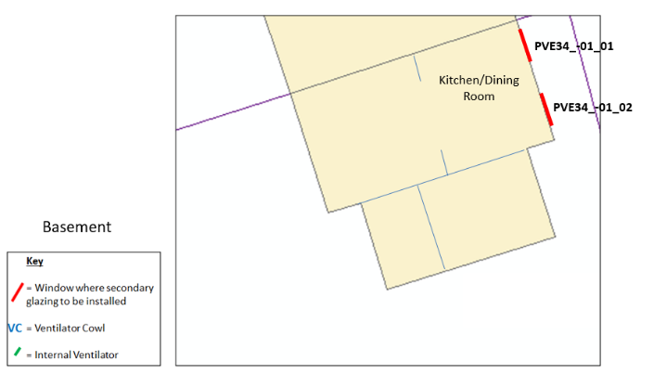

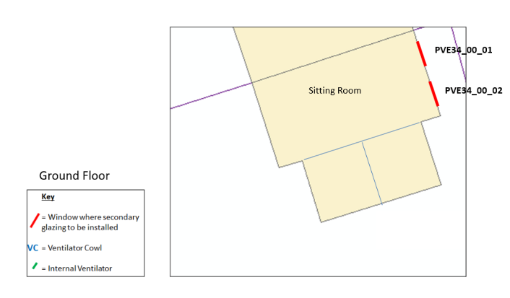

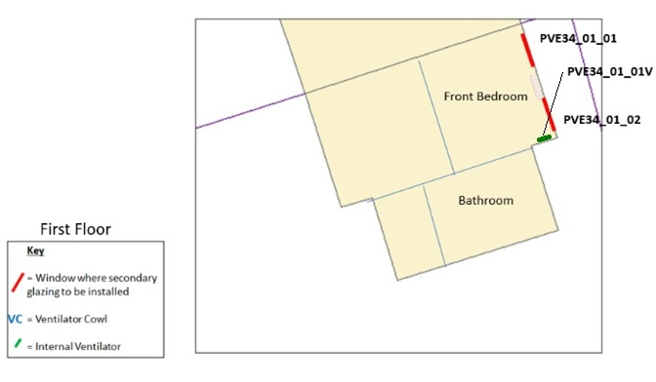

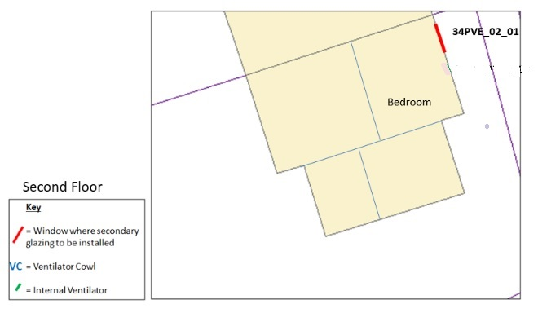

Appendix C: External photographs

External photograph of the existing facades showing the location of windows where secondary glazing is to be installed and the position of the external ventilator cowl.

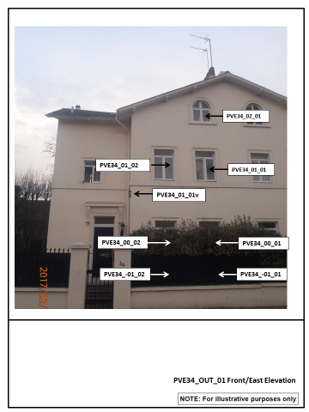

Appendix D: Internal photographs

Internal photographs of existing windows where secondary glazing is to be installed.

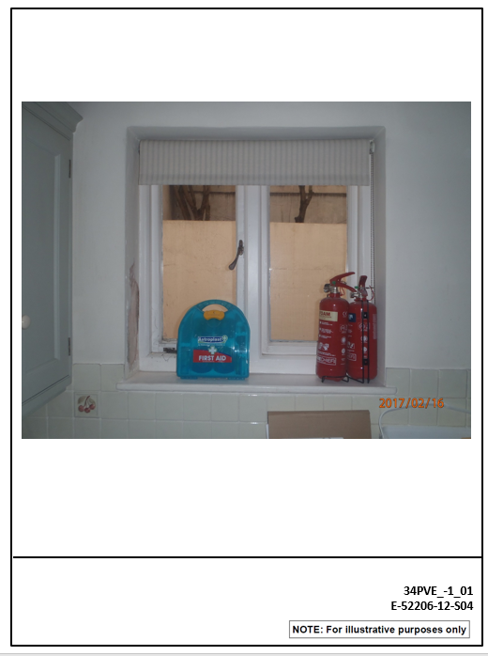

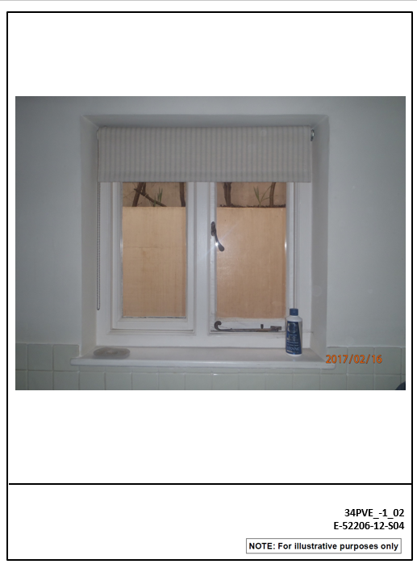

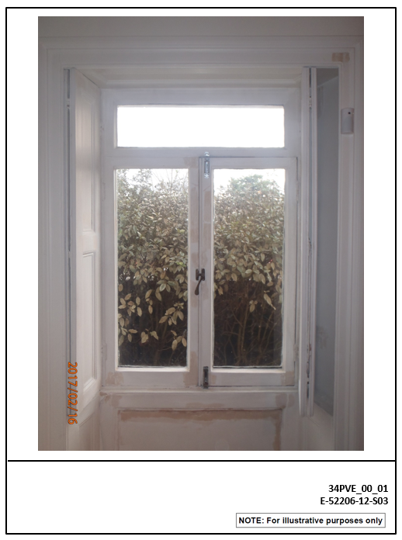

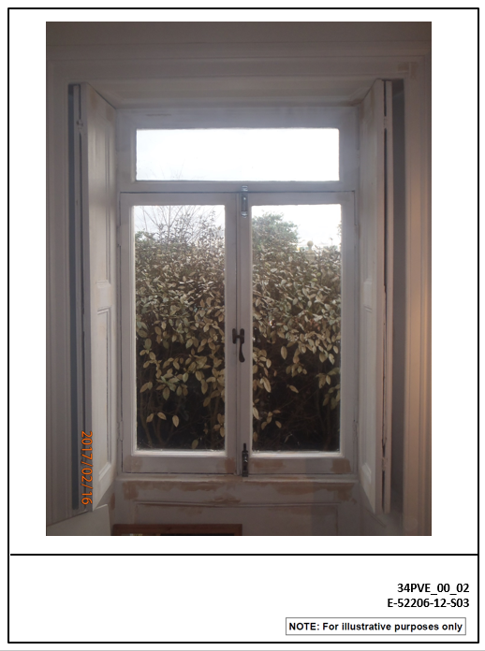

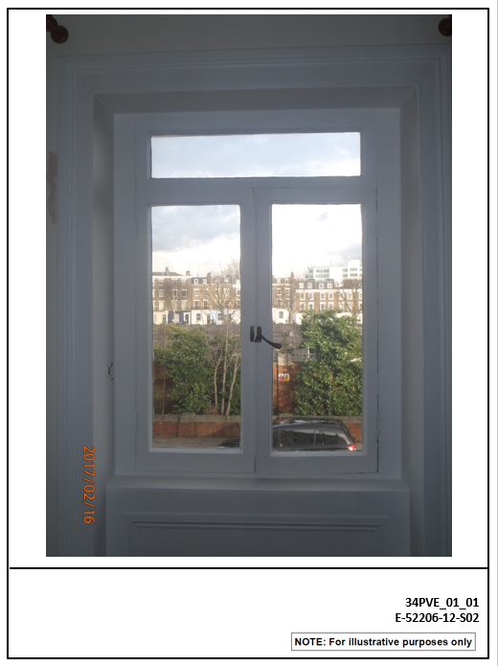

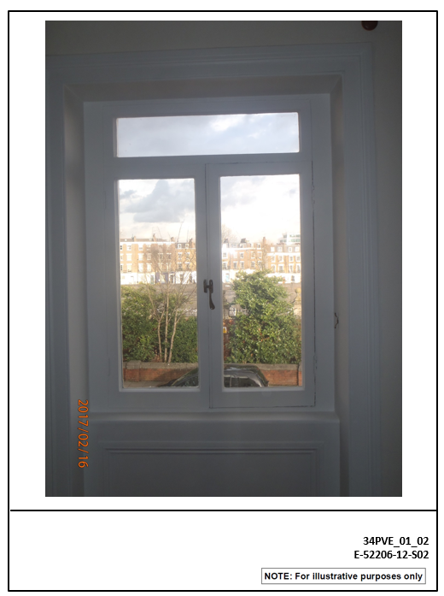

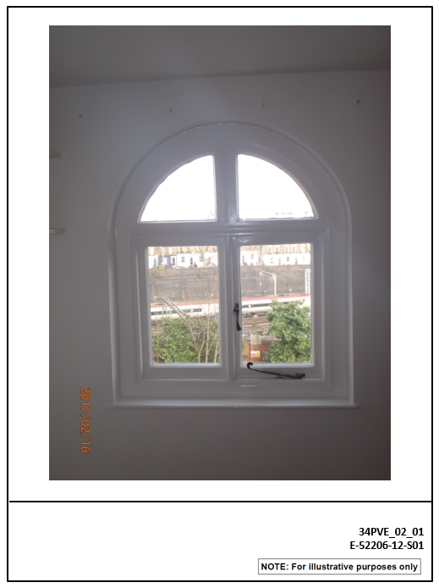

Appendix E: Illustrations of standard secondary glazing and ventilation

This appendix gives examples of noise insulation, in the form of secondary glazing and acoustic ventilators. These are provided to illustrate the general appearance of these items and does not form part of the listed building consent application.

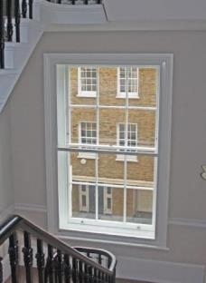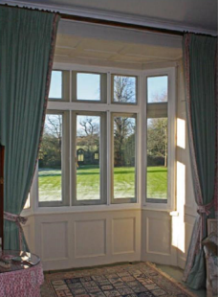

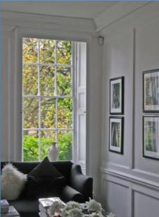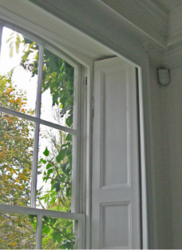

Figure : Examples of Internal Secondary Glazing installed in a Grade 1 listed Nash building.

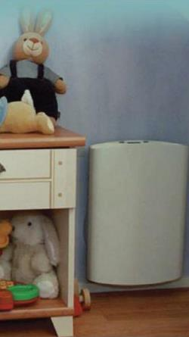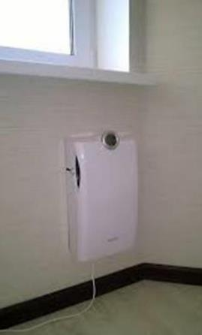

Figure : Examples of Internal Acoustic Ventilation system.

1. https://www.gov.uk/government/collections/the-strategic-case-for-hs2
2. DCMS, 2010, Principles of Selection for Listing Buildings.
3. Tyack, G. 1993. John Nash and the Park Village. The Georgian Group Journal, III, p. 68
4. LB Camden 2011. Regent’s Park Conservation Area Appraisal and Management Strategy.
5. Historic England; ‘Energy Efficiency and Historic Buildings: Secondary Glazing for windows’, 2012, https://historicengland.org.uk/images-books/publications/eehb-secondary-glazing-windows/
6. Window is obscured from photograph as location is inaccessible to provide clear photograph.
7. Historic England; ‘Energy Efficiency and Historic Buildings: Secondary Glazing for windows’, 2012, https://historicengland.org.uk/images-books/publications/eehb-secondary-glazing-windows/