**NUMBER 22 AND ATTACHED RAILINGS**

**List Entry Summary**

This building is listed under the Planning (Listed Buildings and Conservation Areas) Act 1990 as amended for its special architectural or historic interest.

Name: NUMBER 22 AND ATTACHED RAILINGS

List entry Number: 1271915

**Location**

NUMBER 22 AND ATTACHED RAILINGS, 22, CHURCH ROW

The building may lie within the boundary of more than one authority.

County: Greater London Authority

District: Camden

District Type: London Borough

Parish:

National Park: Not applicable to this List entry.

Grade: II*

Date first listed: 11-Aug-1950

Date of most recent amendment: Not applicable to this List entry.

**Legacy System Information**

The contents of this record have been generated from a legacy data system.

Legacy System: LBS

UID: 476949

**Asset Groupings**

This list entry does not comprise part of an Asset Grouping. Asset Groupings are not part of the official record but are added later for information.

**List entry Description**

**Summary of Building**

Legacy Record - This information may be included in the List Entry Details.

**Reasons for Designation**

Legacy Record - This information may be included in the List Entry Details.

**History**

Legacy Record - This information may be included in the List Entry Details.

**Details**

CAMDEN  
  
TQ2685NW CHURCH ROW 798-1/26/233 (South side) 11/08/50 No.22 and attached railings   
  
GV II*  
  
Terraced house. c1720, refaced late C19 in Georgian style. Brown brick with red brick dressings and floor bands. Slightly projecting brick pilaster strips at angles. Slated mansard roof with pedimented dormers. 3 storeys, attic and basement. 3 windows. Late C19 doorcase with fluted pilasters and cornice; doorway with panelled reveals, radial patterned fanlight and panelled door with wrought-iron lamp bracket over. Gauged red brick segmental arches to slightly recessed sashes with exposed boxes and glazing bars to top half of sashes only; 1st floor with cast-iron balconies. Parapet. INTERIOR: not inspected. SUBSIDIARY FEATURES: attached cast-iron railings with torch flambe finials to areas.   
  
  
  
  
  
Listing NGR: TQ2631785624

**Selected Sources**

Legacy Record - This information may be included in the List Entry Details

National Grid Reference: TQ 26317 85626

**Map**

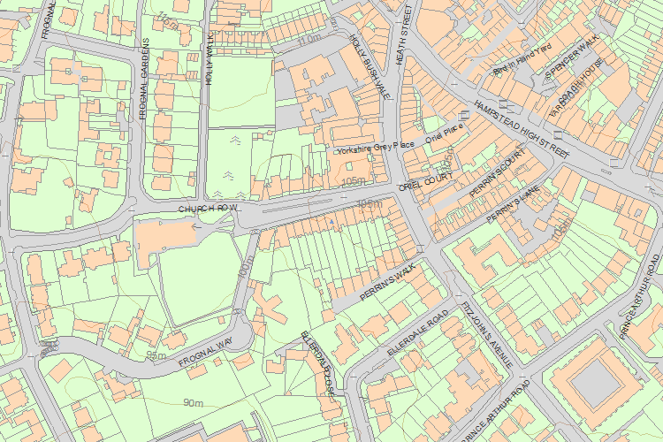© Crown Copyright and database right 2017. All rights reserved. Ordnance Survey Licence number 100024900.  
© British Crown and SeaZone Solutions Limited 2017. All rights reserved. Licence number 102006.006.  
Use of this data is subject to [Terms and Conditions](https://historicengland.org.uk/terms/website-terms-conditions/).

The above map is for quick reference purposes only and may not be to scale. For a copy of the full scale map, please see the attached PDF - [1271915 .pdf](http://mapservices.historicengland.org.uk/printwebservicehle/StatutoryPrint.svc/248279/HLE_A4L_Grade%7CHLE_A3L_Grade.pdf)

The PDF will be generated from our live systems and may take a few minutes to download depending on how busy our servers are. We apologise for this delay.

This copy shows the entry on 03-Aug-2017 at 03:07:22.

End of official listing