REDINGTON FROGNAL ASSOCIATION

Umbrella body for residents groups in the Redington Frognal Conservation Area

1 May, 2017

Dear Ms Smith,

2017/1229/P: 5 Templewood Avenue – objection

Redington Frognal Association is greatly concerned by this proposal, which would cause considerable harm to this important building and its setting. The house, dating from 1910-11, is an outstanding example of the work of the renowned architect, Charles Henry Bourne Quennell.

**5 Templewood Avenue, by CHB Quennell (1910-11)**

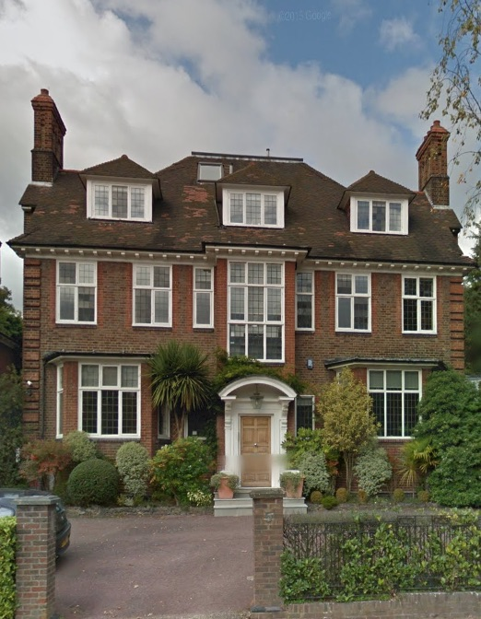

In particular, we object to the removal of the original rear bay window and its replacement with a double-height extension with excessive glazing, causing light

pollution to the rear garden bat and wildlife corridor (contrary to Local Plan Policies 6.7, 6.44). The arboricultural report additionally notes the possible presence of a bat roost in one of the oak trees and research by Redington Frognal confirms the presence of bats throughout the area.

Many other aspects of this application also give cause for concern in relation to the 2017 Local Plan; notably:

* the threat to a number of important trees, including two veteran oak trees at the front of numbers 5 and 5A
* the construction of a building specifically to house air conditioning plant. This is contrary to Policies 6.20, 8.40
* the increased height of the infill extension, thereby further obscuring the gap between numbers 5 and 5A, which is contrary to Policies 6.38, 7.39, 7.45 and Conservation Area guideline RF 33)
* potential flooding issues arising from the construction of such a large basement (Policies 6.124, 6.132, 6.133, 6.136 and RF 2)
* the loss of three flats and their replacement by a mega mansion with seven bedrooms (plus a one-bed)
* loss of light to and overshadowing of the neighbouring property at 5A: contrary to Policies 6.3, 6.4, 6.5.
* overlooking from the windows in the side extension (Policy 6.4)
* the first-floor terrace. These are not a feature of the conservation area (Policy 6.19 and RF 30).
* the inclusion of light wells to the front of the house (Policy 6.139).

We also note that the absence of any provisions to mitigate some of the harmful consequences of the proposal under Policy 6.44, such as:

* biodiversity enhancing measures.
* biodiverse-rich landscaping
* sustainable urban drainage systems (Policy 6.133)
* tree planting (Policy 8.37)

We are additionally concerned by the use of the front garden for car parking, the noise impacts of the proposed car lift and the destruction of the existing hedge as the front boundary treatment (contrary to Policy 10.21 and RF 8)).

We consider that the development should be car-free (Policies 8.76, 8.78, 8.88, 10.15, 10.17, 10.18), that the front garden should be returned to soft surface, in order to improve biodiversity and enhance the character and attractiveness of the conservation area (RF 9).

Yours sincerely,

Nancy Mayo

Secretary

Redington Frognal Association

http://www.redfroghampstead.org