**NUMBERS 63-68 AND ATTACHED RAILINGS**

**List Entry Summary**

This building is listed under the Planning (Listed Buildings and Conservation Areas) Act 1990 as amended for its special architectural or historic interest.

Name: NUMBERS 63-68 AND ATTACHED RAILINGS

List entry Number: 1379126

**Location**

NUMBERS 63-68 AND ATTACHED RAILINGS, 63-68, WARREN STREET

The building may lie within the boundary of more than one authority.

County: Greater London Authority

District: Camden

District Type: London Borough

Parish:

National Park: Not applicable to this List entry.

Grade: II

Date first listed: 14-May-1974

Date of most recent amendment: Not applicable to this List entry.

**Legacy System Information**

The contents of this record have been generated from a legacy data system.

Legacy System: LBS

UID: 478492

**Asset Groupings**

This list entry does not comprise part of an Asset Grouping. Asset Groupings are not part of the official record but are added later for information.

**List entry Description**

**Summary of Building**

Legacy Record - This information may be included in the List Entry Details.

**Reasons for Designation**

Legacy Record - This information may be included in the List Entry Details.

**History**

Legacy Record - This information may be included in the List Entry Details.

**Details**

CAMDEN  
  
TQ2982SW WARREN STREET 798-1/93/1680 (North side) 14/05/74 Nos.63-68 (Consecutive) and attached railings   
  
GV II  
  
Terrace of 6 houses. c1792, restored c1985, No.64 refronted. Darkened stock brick with later patching. Plain stucco band at 1st floor sill level. No.68 with slate mansard roof and dormers. 4 storeys and basement, except No.68, 3 storeys, attic and basement. Nos 63 and 64 with round-arched ground floor openings with keystones and linked by impost bands; plain stucco band at 1st floor level. All with round-arched doorways, radial patterned fanlights and panelled doors. Gauged brick flat arches to recessed sash windows. Parapets. INTERIORS: not inspected. SUBSIDIARY FEATURES: attached cast-iron railings with urn finials to areas. (Survey of London: Vol. XXI, Tottenham Court Road and Neighbourhood, St Pancras III: London: -1949: 65).   
  
  
  
  
  
Listing NGR: TQ2918882242

**Selected Sources**

Books and journals  
'Survey of London' in Survey of London - Tottenham Court Road and Neighbourhood St Pancras Part 3: Volume 21, (1949), 65

National Grid Reference: TQ 29188 82242

**Map**

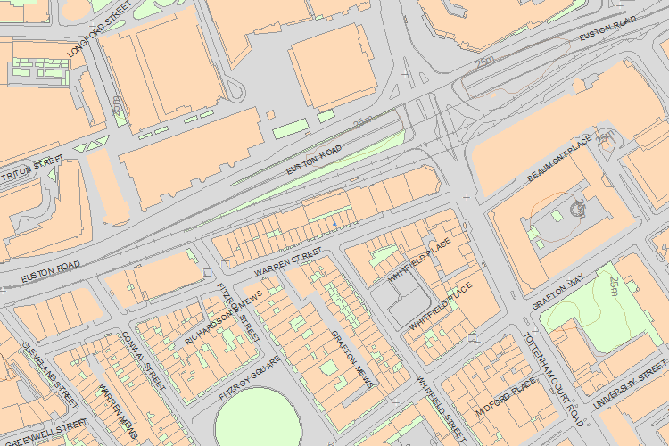© Crown Copyright and database right 2017. All rights reserved. Ordnance Survey Licence number 100024900.  
© British Crown and SeaZone Solutions Limited 2017. All rights reserved. Licence number 102006.006.  
Use of this data is subject to [Terms and Conditions](https://historicengland.org.uk/terms/website-terms-conditions/).

The above map is for quick reference purposes only and may not be to scale. For a copy of the full scale map, please see the attached PDF - [1379126 .pdf](http://mapservices.historicengland.org.uk/printwebservicehle/StatutoryPrint.svc/342076/HLE_A4L_Grade%7CHLE_A3L_Grade.pdf)

The PDF will be generated from our live systems and may take a few minutes to download depending on how busy our servers are. We apologise for this delay.

This copy shows the entry on 18-Jul-2017 at 11:11:57.

End of official listing