DESIGN AND ACCESS STATEMENT

34 DELANCEY STREET
LONDON NW1 7NH

DESIGN AND ACCESS STATEMENT
by
LIVARCH
15 COLOMBO ROAD
ILFORD, ESSEX
IG1 4RH

TEL: 079-0386-5705
EMAIL: INFO@LIVARCH.CO.UK
WWW.LIVARCH.CO.UK

INTRODUCTION:

This Design & Access Statement provides supporting information on the proposed works at 34 Delancey Street, NW1 7NH. The information contained in this report aims to explain the reasoning between necessary works, details of the proposed works and the impact on the property. The proposal of the application is as under
1-EXTEND EXISTING BASEMENT BED ROOM TO THE REAR INSTALLATION OF LIGHTWELL WITH STAIRCASE.
2-SINGLE STOREY GROUND FLOOR REAR EXTENSION.
3-PART SIGLE STOREY FIRST FLOOR REAR EXTENSION.
4-MANSORD ROOF WITH TWO DORMER WINDOWS AT THIRD FLOOR LEVEL.

EXISTING SITE CONTEXT:

The site is located in Camden Council. The surrounding of the application site is a well establish area .
Ordnance Survey (Not to scale)

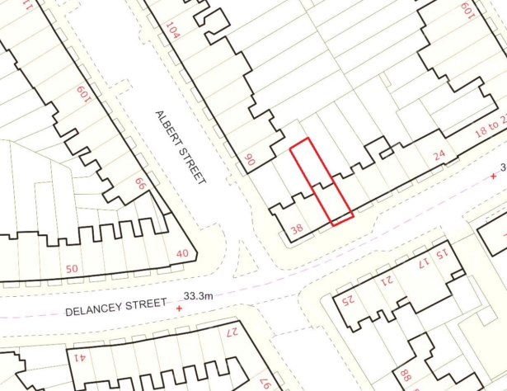

SCALE:
The scale of the existing buildings will not be affected as a result of the proposed works. The works do not alter the scale, size or height of the building.

USE:
It is not proposed to change the use of the buildings, the existing uses will remain.

ACCESS:
No access changes are proposed as part of this development. Access to the property will remain as existing from the street.

APPREARENCE:

At front only Mansard roof will be added at Third Floor level .

