* + [Search the List](https://www.historicengland.org.uk/listing/the-list/)
  + [Enrich the List](https://www.historicengland.org.uk/listing/enrich-the-list/)
  + [Apply for Listing](https://www.historicengland.org.uk/listing/apply-for-listing/)
  + [What is Listing?](https://www.historicengland.org.uk/listing/what-is-designation/)
  + [Listing Guidance](https://www.historicengland.org.uk/listing/selection-criteria/)
* [Advice](https://www.historicengland.org.uk/advice/)
  + [Your Home](https://www.historicengland.org.uk/advice/your-home/)
  + [Planning](https://www.historicengland.org.uk/advice/planning/)
  + [Latest Advice & Guidance](https://www.historicengland.org.uk/advice/latest-guidance/)
  + [Caring for Heritage](https://www.historicengland.org.uk/advice/caring-for-heritage/)
  + [Technical Guidance](https://www.historicengland.org.uk/advice/technical-advice/)
  + [Heritage at Risk](https://www.historicengland.org.uk/advice/heritage-at-risk/)
  + [Constructive Conservation](https://www.historicengland.org.uk/advice/constructive-conservation/)
  + [Heritage Protection Guide](https://www.historicengland.org.uk/advice/hpg/)
* [Research](https://www.historicengland.org.uk/research/)
  + [Our Research Strategy and Agenda](https://www.historicengland.org.uk/research/agenda/)
  + [Research Methods](https://www.historicengland.org.uk/research/methods/)
  + [Current Research](https://www.historicengland.org.uk/research/current/)
  + [Research Results](https://www.historicengland.org.uk/research/research-results/)
  + [Support & Collaboration](https://www.historicengland.org.uk/research/support-and-collaboration/)
  + [Inclusive Heritage](https://www.historicengland.org.uk/research/inclusive-heritage/)
  + [Heritage Counts](https://www.historicengland.org.uk/research/heritage-counts/)
* [Images & Books](https://www.historicengland.org.uk/images-books/)
  + [Find Photos](https://www.historicengland.org.uk/images-books/photos/)
  + [Search All Publications](https://www.historicengland.org.uk/images-books/publications/)
  + [Buy Books](https://www.historicengland.org.uk/images-books/books/)
  + [The Historic England Archive](https://www.historicengland.org.uk/images-books/archive/)
  + [Be an Archive Detective](https://www.historicengland.org.uk/images-books/archive-mysteries/)
* [Services & Skills](https://www.historicengland.org.uk/services-skills/)
  + [Education](https://www.historicengland.org.uk/services-skills/education/)
  + [Grants](https://www.historicengland.org.uk/services-skills/grants/)
  + [Our Planning Services](https://www.historicengland.org.uk/services-skills/our-planning-services/)
  + [Training & Skills](https://www.historicengland.org.uk/services-skills/training-skills/)
  + [Archive Services](https://www.historicengland.org.uk/services-skills/archive-services/)
  + [Heritage Action Zones](https://www.historicengland.org.uk/services-skills/heritage-action-zones/)
* [Get Involved](https://www.historicengland.org.uk/get-involved/)
  + [100 Places](https://www.historicengland.org.uk/get-involved/100-places/)
  + [Be a Volunteer](https://www.historicengland.org.uk/get-involved/volunteer/)
  + [Visit Your Heritage](https://www.historicengland.org.uk/get-involved/visit/)
  + [Protect Your Heritage](https://www.historicengland.org.uk/get-involved/protect/)
  + [Help Write History](https://www.historicengland.org.uk/get-involved/help-write-history/)
  + [Angel Awards](https://www.historicengland.org.uk/get-involved/angel-awards/)
* [What's New](https://www.historicengland.org.uk/whats-new/)
  + [News](https://www.historicengland.org.uk/whats-new/news/)
  + [In Your Area](https://www.historicengland.org.uk/whats-new/in-your-area/)
  + [Latest Listings](https://www.historicengland.org.uk/whats-new/listing/)
  + [Latest Research](https://www.historicengland.org.uk/whats-new/research/)
  + [Heritage Online Debate](https://www.historicengland.org.uk/whats-new/debate/)
  + [Statements](https://www.historicengland.org.uk/whats-new/statements/)
  + [Stay Up To Date](https://www.historicengland.org.uk/whats-new/stay-up-to-date/)
  + [50 Years of Conservation Areas](https://www.historicengland.org.uk/whats-new/conservation-areas-50-years/)
  + [First World War Centenary](https://www.historicengland.org.uk/whats-new/first-world-war-home-front/)
  + [What We Do](https://www.historicengland.org.uk/about/what-we-do/)
  + [Who We Are](https://www.historicengland.org.uk/about/who-we-are/)
  + [Jobs](https://www.historicengland.org.uk/about/jobs/)
  + [Contact Us](https://www.historicengland.org.uk/about/contact-us/)
  + [Volunteer with Historic England](https://www.historicengland.org.uk/about/volunteering/)
  + [Website Terms and Conditions](https://www.historicengland.org.uk/terms/website-terms-conditions/)
  + [Data Protection](https://www.historicengland.org.uk/terms/data-protection-information-charter/)
  + [Privacy and Cookies](https://www.historicengland.org.uk/terms/privacy-cookies/)
  + [Links Policy](https://www.historicengland.org.uk/terms/links-policy/)
  + [Historic England Blog: House Rules](https://www.historicengland.org.uk/terms/blog-house-rules/)
  + [Listed Property Owner Survey Competition Terms and Conditions](https://www.historicengland.org.uk/terms/lpos-competition-terms-conditions/)
  + [Survey of Property Owners Living in Conservation Areas Competition Terms and Conditions](https://www.historicengland.org.uk/terms/survey-poca-competition-terms-conditions/)
  + [Photo Competition Terms and Conditions](https://www.historicengland.org.uk/terms/photo-competition-terms-conditions/)
* [Home](https://www.historicengland.org.uk/)
* [...](https://www.historicengland.org.uk/listing/the-list/list-entry/1139086)
* [Listing](https://www.historicengland.org.uk/listing/)
* [Search the List](https://www.historicengland.org.uk/listing/the-list/)
* List Entry

[This browser is not fully supported](https://www.historicengland.org.uk/access/) by Historic England. Please update your browser to the latest version so that you get the best from our website.

We use cookies to give you the best possible experience online. By using this website, you consent to cookies being used in accordance with our [Cookie Policy](https://www.historicengland.org.uk/terms/).

* [Section Navigation](https://www.historicengland.org.uk/listing/the-list/list-entry/1139086)
  + [Map Search](https://www.historicengland.org.uk/listing/the-list/map/)
  + [Advanced Search](https://www.historicengland.org.uk/listing/the-list/advanced/)
  + [Minor Amendments](https://www.historicengland.org.uk/listing/the-list/minor-amendments/)
  + [Download Listing Data](https://www.historicengland.org.uk/listing/the-list/data-downloads/)
  + [Non-Listed Sites](https://www.historicengland.org.uk/listing/the-list/non-listed-sites/)
  + [About The List](https://www.historicengland.org.uk/listing/the-list/about-the-list/)
  + [Enrich the List](https://www.historicengland.org.uk/listing/the-list/enrich/)
  + [Understanding List Entries](https://www.historicengland.org.uk/listing/the-list/understanding-list-entries/)

**1-14, PROVOST ROAD**

**List Entry Summary**

This building is listed under the Planning (Listed Buildings and Conservation Areas) Act 1990 as amended for its special architectural or historic interest.

Name: 1-14, PROVOST ROAD

List entry Number: 1139086

**Location**

1-14, PROVOST ROAD

The building may lie within the boundary of more than one authority.

County: Greater London Authority

District: Camden

District Type: London Borough

Parish:

National Park: Not applicable to this List entry.

Grade: II

Date first listed: 14-May-1974

Date of most recent amendment: Not applicable to this List entry.

**Legacy System Information**

The contents of this record have been generated from a legacy data system.

Legacy System: LBS

UID: 477816

**Asset Groupings**

This list entry does not comprise part of an Asset Grouping. Asset Groupings are not part of the official record but are added later for information.

**List entry Description**

**Summary of Building**

Legacy Record - This information may be included in the List Entry Details.

**Reasons for Designation**

Legacy Record - This information may be included in the List Entry Details.

**History**

Legacy Record - This information may be included in the List Entry Details.

**Details**

CAMDEN  
  
TQ2784SE PROVOST ROAD 798-1/63/1355 (South side) 14/05/74 Nos.1-14 (Consecutive)   
  
GV II  
  
7 pairs of semi-detached villas. c1844. By John Shaw. Painted stucco. Slated gabled roofs with dormers, central long slab chimney-stacks and overhanging eaves, bracketed on angle return and having plain bargeboards to gables. 2 storeys, attics and semi-basements. 1 window each plus 1 window recessed entrance bays. Architraved entrances to recessed doorways with pilaster jambs and part-glazed doors approached by steps. Architraved sashes, ground floor windows with pilasters and cornice. Nos 3 & 4 have 3-light canted bays rising from semi-basement through 2nd floor with pilasters. All have architraved 3-light attic windows, central window blind, in apex of gable. INTERIORS: not inspected.   
  
  
  
  
  
Listing NGR: TQ2789684459

**Selected Sources**

Legacy Record - This information may be included in the List Entry Details

National Grid Reference: TQ 27896 84459

**Map**

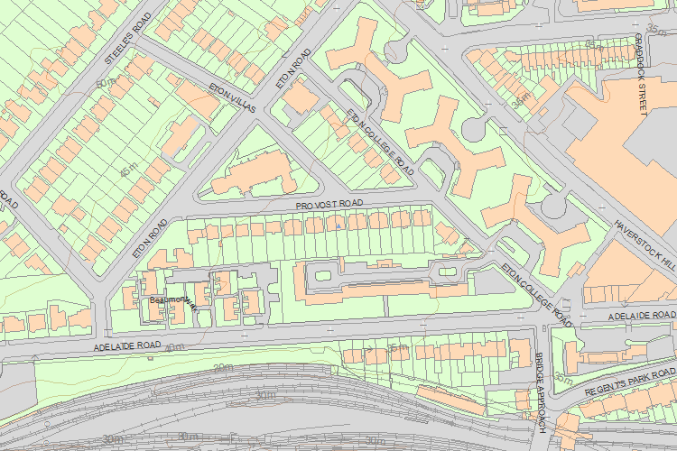© Crown Copyright and database right 2017. All rights reserved. Ordnance Survey Licence number 100024900.  
© British Crown and SeaZone Solutions Limited 2017. All rights reserved. Licence number 102006.006.  
Use of this data is subject to [Terms and Conditions](https://historicengland.org.uk/terms/website-terms-conditions/).

The above map is for quick reference purposes only and may not be to scale. For a copy of the full scale map, please see the attached PDF - [1139086 .pdf](http://mapservices.historicengland.org.uk/printwebservicehle/StatutoryPrint.svc/132177/HLE_A4L_Grade%7CHLE_A3L_Grade.pdf)

The PDF will be generated from our live systems and may take a few minutes to download depending on how busy our servers are. We apologise for this delay.

This copy shows the entry on 06-Jul-2017 at 01:47:47.

End of official listing