**NUMBERS 1-22 AND ATTACHED RAILINGS**

**List Entry Summary**

This building is listed under the Planning (Listed Buildings and Conservation Areas) Act 1990 as amended for its special architectural or historic interest.

Name: NUMBERS 1-22 AND ATTACHED RAILINGS

List entry Number: 1330368

**Location**

NUMBERS 1-22 AND ATTACHED RAILINGS, 1-22, REGENTS PARK TERRACE

The building may lie within the boundary of more than one authority.

County: Greater London Authority

District: Camden

District Type: London Borough

Parish:

National Park: Not applicable to this List entry.

Grade: II

Date first listed: 14-May-1974

Date of most recent amendment: Not applicable to this List entry.

**Legacy System Information**

The contents of this record have been generated from a legacy data system.

Legacy System: LBS

UID: 477854

**Asset Groupings**

This list entry does not comprise part of an Asset Grouping. Asset Groupings are not part of the official record but are added later for information.

**List entry Description**

**Summary of Building**

Legacy Record - This information may be included in the List Entry Details.

**Reasons for Designation**

Legacy Record - This information may be included in the List Entry Details.

**History**

Legacy Record - This information may be included in the List Entry Details.

**Details**

CAMDEN  
  
TQ2883NE REGENT'S PARK TERRACE 798-1/76/1385 Nos.1-22 (Consecutive) 14/05/74 and attached railings   
  
GV II  
  
Terrace of 22 houses. c1840-50. Yellow stock brick with rusticated stucco ground floors. Nos 1-21 form a symmetrical facade with slightly projecting end houses. 4 storeys and basements. 2 windows each. Square-headed doorways with cornice-heads, fanlights and panelled doors. Entrance to No.1 on right hand return with stucco portico having pilasters, cornice and parapet; round-arched door way. Architraved sashes; 1st floor with cornices and continuous cast-iron balconies, 2nd floor with cornices. Plain stucco sill bands to 2nd and 3rd floors. Stucco modillion cornice and blocking course. No.22: rusticated stucco. 2 storeys and basement. 1 window. Projecting stucco portico with balustraded parapet. Cornice with balustraded parapet. INTERIORS: not inspected. SUBSIDIARY FEATURES: attached cast-iron railings with foliated finials to areas.   
  
  
  
  
  
Listing NGR: TQ2862883819

**Selected Sources**

Legacy Record - This information may be included in the List Entry Details

National Grid Reference: TQ 28628 83819

**Map**

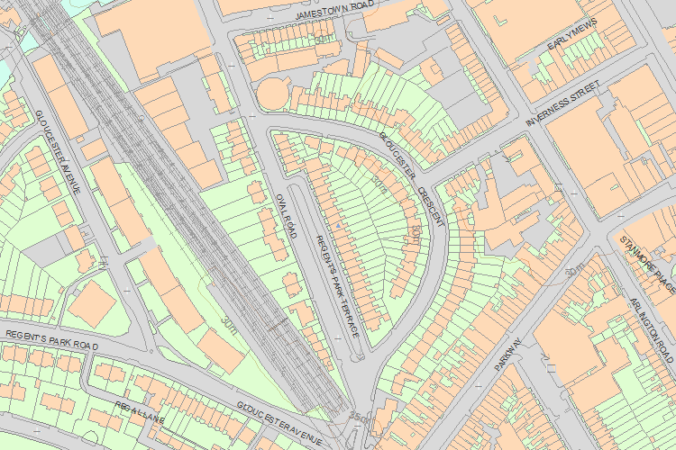© Crown Copyright and database right 2017. All rights reserved. Ordnance Survey Licence number 100024900.  
© British Crown and SeaZone Solutions Limited 2017. All rights reserved. Licence number 102006.006.  
Use of this data is subject to [Terms and Conditions](https://historicengland.org.uk/terms/website-terms-conditions/).

The above map is for quick reference purposes only and may not be to scale. For a copy of the full scale map, please see the attached PDF - [1330368 .pdf](http://mapservices.historicengland.org.uk/printwebservicehle/StatutoryPrint.svc/299446/HLE_A4L_Grade%7CHLE_A3L_Grade.pdf)

The PDF will be generated from our live systems and may take a few minutes to download depending on how busy our servers are. We apologise for this delay.

This copy shows the entry on 04-Jul-2017 at 02:13:15.

End of official listing

Your Contributions