[Historic England](https://www.historicengland.org.uk/)

* [Menu](https://www.historicengland.org.uk/listing/the-list/list-entry/1379293)
* [Search](https://www.historicengland.org.uk/sitesearch)

Top of Form

What are you looking for?



Searching...

Click anywhere to close (ESC)

Bottom of Form

* [Listing](https://www.historicengland.org.uk/listing/)
  + [Search the List](https://www.historicengland.org.uk/listing/the-list/)
  + [Enrich the List](https://www.historicengland.org.uk/listing/enrich-the-list/)
  + [Apply for Listing](https://www.historicengland.org.uk/listing/apply-for-listing/)
  + [What is Listing?](https://www.historicengland.org.uk/listing/what-is-designation/)
  + [Listing Guidance](https://www.historicengland.org.uk/listing/selection-criteria/)
* [Advice](https://www.historicengland.org.uk/advice/)
  + [Your Home](https://www.historicengland.org.uk/advice/your-home/)
  + [Planning](https://www.historicengland.org.uk/advice/planning/)
  + [Latest Advice & Guidance](https://www.historicengland.org.uk/advice/latest-guidance/)
  + [Caring for Heritage](https://www.historicengland.org.uk/advice/caring-for-heritage/)
  + [Technical Guidance](https://www.historicengland.org.uk/advice/technical-advice/)
  + [Heritage at Risk](https://www.historicengland.org.uk/advice/heritage-at-risk/)
  + [Constructive Conservation](https://www.historicengland.org.uk/advice/constructive-conservation/)
  + [Heritage Protection Guide](https://www.historicengland.org.uk/advice/hpg/)
* [Research](https://www.historicengland.org.uk/research/)
  + [Our Research Strategy and Agenda](https://www.historicengland.org.uk/research/agenda/)
  + [Research Methods](https://www.historicengland.org.uk/research/methods/)
  + [Current Research](https://www.historicengland.org.uk/research/current/)
  + [Research Results](https://www.historicengland.org.uk/research/research-results/)
  + [Support & Collaboration](https://www.historicengland.org.uk/research/support-and-collaboration/)
  + [Inclusive Heritage](https://www.historicengland.org.uk/research/inclusive-heritage/)
  + [Heritage Counts](https://www.historicengland.org.uk/research/heritage-counts/)
* [Images & Books](https://www.historicengland.org.uk/images-books/)
  + [Find Photos](https://www.historicengland.org.uk/images-books/photos/)
  + [Search All Publications](https://www.historicengland.org.uk/images-books/publications/)
  + [Buy Books](https://www.historicengland.org.uk/images-books/books/)
  + [The Historic England Archive](https://www.historicengland.org.uk/images-books/archive/)
  + [Be an Archive Detective](https://www.historicengland.org.uk/images-books/archive-mysteries/)
* [Services & Skills](https://www.historicengland.org.uk/services-skills/)
  + [Education](https://www.historicengland.org.uk/services-skills/education/)
  + [Grants](https://www.historicengland.org.uk/services-skills/grants/)
  + [Our Planning Services](https://www.historicengland.org.uk/services-skills/our-planning-services/)
  + [Training & Skills](https://www.historicengland.org.uk/services-skills/training-skills/)
  + [Archive Services](https://www.historicengland.org.uk/services-skills/archive-services/)
  + [Heritage Action Zones](https://www.historicengland.org.uk/services-skills/heritage-action-zones/)
* [Get Involved](https://www.historicengland.org.uk/get-involved/)
  + [100 Places](https://www.historicengland.org.uk/get-involved/100-places/)
  + [Be a Volunteer](https://www.historicengland.org.uk/get-involved/volunteer/)
  + [Visit Your Heritage](https://www.historicengland.org.uk/get-involved/visit/)
  + [Protect Your Heritage](https://www.historicengland.org.uk/get-involved/protect/)
  + [Help Write History](https://www.historicengland.org.uk/get-involved/help-write-history/)
  + [Angel Awards](https://www.historicengland.org.uk/get-involved/angel-awards/)
* [What's New](https://www.historicengland.org.uk/whats-new/)
  + [News](https://www.historicengland.org.uk/whats-new/news/)
  + [In Your Area](https://www.historicengland.org.uk/whats-new/in-your-area/)
  + [Latest Listings](https://www.historicengland.org.uk/whats-new/listing/)
  + [Latest Research](https://www.historicengland.org.uk/whats-new/research/)
  + [Heritage Online Debate](https://www.historicengland.org.uk/whats-new/debate/)
  + [Statements](https://www.historicengland.org.uk/whats-new/statements/)
  + [Stay Up To Date](https://www.historicengland.org.uk/whats-new/stay-up-to-date/)
  + [50 Years of Conservation Areas](https://www.historicengland.org.uk/whats-new/conservation-areas-50-years/)
  + [First World War Centenary](https://www.historicengland.org.uk/whats-new/first-world-war-home-front/)
  + [What We Do](https://www.historicengland.org.uk/about/what-we-do/)
  + [Who We Are](https://www.historicengland.org.uk/about/who-we-are/)
  + [Jobs](https://www.historicengland.org.uk/about/jobs/)
  + [Contact Us](https://www.historicengland.org.uk/about/contact-us/)
  + [Volunteer with Historic England](https://www.historicengland.org.uk/about/volunteering/)
  + [Website Terms and Conditions](https://www.historicengland.org.uk/terms/website-terms-conditions/)
  + [Data Protection](https://www.historicengland.org.uk/terms/data-protection-information-charter/)
  + [Privacy and Cookies](https://www.historicengland.org.uk/terms/privacy-cookies/)
  + [Links Policy](https://www.historicengland.org.uk/terms/links-policy/)
  + [Historic England Blog: House Rules](https://www.historicengland.org.uk/terms/blog-house-rules/)
  + [Listed Property Owner Survey Competition Terms and Conditions](https://www.historicengland.org.uk/terms/lpos-competition-terms-conditions/)
  + [Survey of Property Owners Living in Conservation Areas Competition Terms and Conditions](https://www.historicengland.org.uk/terms/survey-poca-competition-terms-conditions/)
  + [Photo Competition Terms and Conditions](https://www.historicengland.org.uk/terms/photo-competition-terms-conditions/)
* [Home](https://www.historicengland.org.uk/)
* [...](https://www.historicengland.org.uk/listing/the-list/list-entry/1379293)
* [Listing](https://www.historicengland.org.uk/listing/)
* [Search the List](https://www.historicengland.org.uk/listing/the-list/)
* List Entry

[This browser is not fully supported](https://www.historicengland.org.uk/access/) by Historic England. Please update your browser to the latest version so that you get the best from our website.

We use cookies to give you the best possible experience online. By using this website, you consent to cookies being used in accordance with our [Cookie Policy](https://www.historicengland.org.uk/terms/).

* [Section Navigation](https://www.historicengland.org.uk/listing/the-list/list-entry/1379293)
  + [Map Search](https://www.historicengland.org.uk/listing/the-list/map/)
  + [Advanced Search](https://www.historicengland.org.uk/listing/the-list/advanced/)
  + [Minor Amendments](https://www.historicengland.org.uk/listing/the-list/minor-amendments/)
  + [Download Listing Data](https://www.historicengland.org.uk/listing/the-list/data-downloads/)
  + [Non-Listed Sites](https://www.historicengland.org.uk/listing/the-list/non-listed-sites/)
  + [About The List](https://www.historicengland.org.uk/listing/the-list/about-the-list/)
  + [Enrich the List](https://www.historicengland.org.uk/listing/the-list/enrich/)
  + [Understanding List Entries](https://www.historicengland.org.uk/listing/the-list/understanding-list-entries/)

**NUMBERS 66, 68 AND 70 AND AREA RAILINGS TO NUMBERS 68 AND 70**

**List Entry Summary**

This building is listed under the Planning (Listed Buildings and Conservation Areas) Act 1990 as amended for its special architectural or historic interest.

Name: NUMBERS 66, 68 AND 70 AND AREA RAILINGS TO NUMBERS 68 AND 70

List entry Number: 1379293

**Location**

NUMBERS 66, 68 AND 70 AND AREA RAILINGS TO NUMBERS 68 AND 70, 66, 68 AND 70, LEIGHTON ROAD

The building may lie within the boundary of more than one authority.

County: Greater London Authority

District: Camden

District Type: London Borough

Parish:

National Park: Not applicable to this List entry.

Grade: II

Date first listed: 11-Jan-1999

Date of most recent amendment: Not applicable to this List entry.

**Legacy System Information**

The contents of this record have been generated from a legacy data system.

Legacy System: LBS

UID: 478662

**Asset Groupings**

This list entry does not comprise part of an Asset Grouping. Asset Groupings are not part of the official record but are added later for information.

**List entry Description**

**Summary of Building**

Legacy Record - This information may be included in the List Entry Details.

**Reasons for Designation**

Legacy Record - This information may be included in the List Entry Details.

**History**

Legacy Record - This information may be included in the List Entry Details.

**Details**

CAMDEN  
  
TQ2985SW LEIGHTON ROAD 798-1/43/1833 (South side) Nos.66, 68 AND 70 and area railings to Nos.68 and 70  
  
GV II  
  
3 terraced houses. c1840. Rendered brick, roof not seen. 3 storeys and basement, No.70 two windows wide, Nos 66 and 68 with a single window to front with doors to side. All with bands at first and second floor levels, No.66 with moulded cornice. Nos 68 and 70 with 16-light sashes, No.66 with tripartite sash windows to upper storeys, the narrower side panels with pointed tracery. Panelled doors under round-arched top lights. INTERIORS not inspected. SUBSIDIARY FEATURES: spear finial railings to areas of Nos 68 and 70. Leighton Road contains a variety of early C19 houses; this terrace with No.64 (qv) are the best preserved and most characterful group along the southern side.   
  
  
  
Listing NGR: TQ2927685179

**Selected Sources**

Legacy Record - This information may be included in the List Entry Details

National Grid Reference: TQ 29276 85179

**Map**

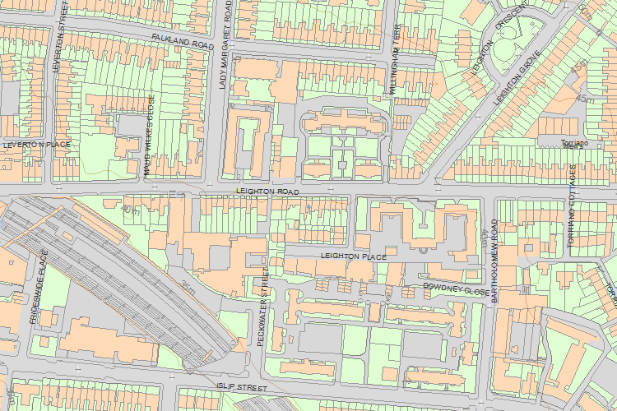© Crown Copyright and database right 2017. All rights reserved. Ordnance Survey Licence number 100024900.  
© British Crown and SeaZone Solutions Limited 2017. All rights reserved. Licence number 102006.006.  
Use of this data is subject to [Terms and Conditions](https://historicengland.org.uk/terms/website-terms-conditions/).

The above map is for quick reference purposes only and may not be to scale. For a copy of the full scale map, please see the attached PDF - [1379293 .pdf](http://mapservices.historicengland.org.uk/printwebservicehle/StatutoryPrint.svc/342225/HLE_A4L_Grade%7CHLE_A3L_Grade.pdf)

The PDF will be generated from our live systems and may take a few minutes to download depending on how busy our servers are. We apologise for this delay.

This copy shows the entry on 28-Jun-2017 at 11:16:56.

End of official listing