**64, LEIGHTON ROAD**

**List Entry Summary**

This building is listed under the Planning (Listed Buildings and Conservation Areas) Act 1990 as amended for its special architectural or historic interest.

Name: 64, LEIGHTON ROAD

List entry Number: 1379292

**Location**

64, LEIGHTON ROAD

The building may lie within the boundary of more than one authority.

County: Greater London Authority

District: Camden

District Type: London Borough

Parish:

National Park: Not applicable to this List entry.

Grade: II

Date first listed: 11-Jan-1999

Date of most recent amendment: Not applicable to this List entry.

**Legacy System Information**

The contents of this record have been generated from a legacy data system.

Legacy System: LBS

UID: 478661

**Asset Groupings**

This list entry does not comprise part of an Asset Grouping. Asset Groupings are not part of the official record but are added later for information.

**List entry Description**

**Summary of Building**

Legacy Record - This information may be included in the List Entry Details.

**Reasons for Designation**

Legacy Record - This information may be included in the List Entry Details.

**History**

Legacy Record - This information may be included in the List Entry Details.

**Details**

CAMDEN  
  
TQ2985SW LEIGHTON ROAD 798-1/43/1832 (South side) No.64   
  
GV II  
  
House. c1820-35. Brown brick, roof not seen behind parapet and may have been lowered. 3 windows wide, 2 storeys high, with central door and 16-light sash windows under splayed gauged brick heads. Door in fluted surround has had some panels replaced by glazing, fanlight over blind. INTERIOR: projecting painted central bay at rear contains stick baluster staircase. Other interiors not inspected.   
  
  
  
Listing NGR: TQ2926385183

**Selected Sources**

Legacy Record - This information may be included in the List Entry Details

National Grid Reference: TQ 29263 85183

**Map**

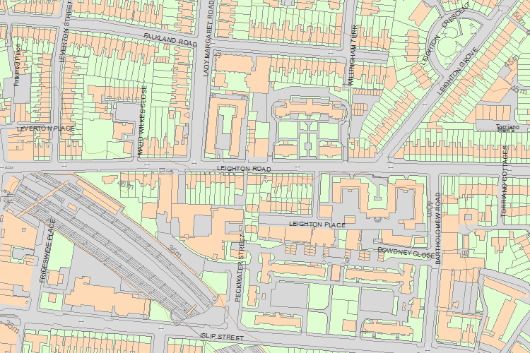© Crown Copyright and database right 2017. All rights reserved. Ordnance Survey Licence number 100024900.  
© British Crown and SeaZone Solutions Limited 2017. All rights reserved. Licence number 102006.006.  
Use of this data is subject to [Terms and Conditions](https://historicengland.org.uk/terms/website-terms-conditions/).

The above map is for quick reference purposes only and may not be to scale. For a copy of the full scale map, please see the attached PDF - [1379292 .pdf](http://mapservices.historicengland.org.uk/printwebservicehle/StatutoryPrint.svc/342224/HLE_A4L_Grade%7CHLE_A3L_Grade.pdf)

The PDF will be generated from our live systems and may take a few minutes to download depending on how busy our servers are. We apologise for this delay.

This copy shows the entry on 28-Jun-2017 at 11:14:21.

End of official listing

Your Contributions

Do you know more about this entry?

The following information has been contributed by users volunteering for our [Enriching The List project](http://historicengland.org.uk/listing/enrich-the-list/). For small corrections to the List Entry please see our [Minor Amendments procedure](http://historicengland.org.uk/listing/the-list/minor-amendments/).

The information and images below are the opinion of the contributor, are not part of the official entry and do not represent the official position of Historic England. We have not checked that the contributions below are factually accurate. Please see our [terms and conditions](http://historicengland.org.uk/terms/website-terms-conditions/enriching-the-list-contribution-terms/). If you wish to report an issue with a contribution or have a question please email [EnrichingTheList@HistoricEngland.org.uk](mailto:enrichingthelist@HistoricEngland.org.uk).

Top of Form



Email

Password

[Forgotten your password?](https://services.historicengland.org.uk/passportserver/RecoverPassword.aspx)

Log in

Don't have an account? [Sign up](https://services.historicengland.org.uk/passportserver/registration.aspx?app_id=1f8fb93f-56a7-4c10-91e4-6e9d04cbf7aa)

Bottom of Form

There aren't currently any contributions

Share