LDC (Proposed) Report |  | Application number | 2017/1708/P
Officer |  | Expiry date
Anna Roe |  | 31/05/2017
Application Address |  | Authorised Officer Signature
25 Hillfield Road
London
NW6 1QD
Conservation Area |  | Article 4
N/A |  | No

Proposal
Erection of single storey rear extension.
Recommendation: | Grant Certificate of Lawfulness

Class A
The enlargement, improvement or other alteration of a dwellinghouse.

If yes to any of the questions below the proposal is not permitted development |  | Yes/no
A.1(a) | Permission to use the dwellinghouse as a dwellinghouse has been granted only by virtue of Class M, N, P or Q of Part 3 of this Schedule (changes of use). | No
A.1(b) | As a result of the works, the total area of ground covered by buildings within the curtilage of the dwellinghouse (other than the original dwellinghouse) would exceed 50% of the total area of the curtilage (excluding the ground area of the original dwellinghouse). | No
A.1(c) | The height of the part of the dwellinghouse enlarged, improved or altered would exceed the height of the highest part of the roof of the existing dwellinghouse; | No
A.1(d) | The height of the eaves of the part of the dwellinghouse enlarged, improved or altered would exceed the height of the eaves of the existing dwellinghouse. | No
A.1(e) | The enlarged part of the dwellinghouse would extend beyond a wall which forms the principal elevation of the original dwellinghouse; or fronts a highway and forms a side elevation of the original dwellinghouse. | No
A.1(f) | Subject to paragraph g, the enlarged part of the dwellinghouse would have a single storey and extend beyond the rear wall of the original dwellinghouse by more than 4 metres in the case of a detached dwellinghouse, or 3 metres in the case of any other dwellinghouse, or exceed 4 metres in height. | Yes
A.1(g) | Until 30th May 2019, for a dwellinghouse not on article 2(3) land nor on a site of special scientific interest, the enlarged part of the dwellinghouse would have a single storey and extend beyond the rear wall of the original dwellinghouse by more than 8 metres in the case of a detached dwellinghouse, or 6 metres in the case of any other dwellinghouse or exceed 4 metres in height. | N/A
A.1(h) | The enlarged part of the dwellinghouse would have more than a single storey and extend beyond the rear wall of the original dwellinghouse by more than 3 metres, or be within 7 metres of any boundary of the curtilage of the dwellinghouse opposite the rear wall of the dwellinghouse. | No
A.1(i) | The enlarged part of the dwellinghouse would be within 2 metres of the boundary of the curtilage of the dwellinghouse, and the height of the eaves of the enlarged part would exceed 3 metres. | No
A.1(j) | The enlarged part of the dwellinghouse would extend beyond a wall forming a side elevation of the original dwellinghouse, and would—  (i) exceed 4 metres in height,  (ii) have more than a single storey, or  (iii) have a width greater than half the width of the original dwellinghouse; or | Yes
A.1(k) | It would consist of or include-  (i) the construction or provision of a verandah, balcony or raised platform,  (ii) the installation, alteration or replacement of a microwave antenna,  (iii) the installation, alteration or replacement of a chimney, flue or soil and vent pipe, or  (iv) an alteration to any part of the roof of the dwellinghouse. | No
Condition. If yes to the question below then the proposal is not permitted development.

A.2(a) | In the case of a dwellinghouse on article 2(3) land, development is not permitted by Class A if—  (a) it would consist of or include the cladding of any part of the exterior of the dwellinghouse with stone, artificial stone, pebble dash, render, timber, plastic or tiles;  (b) the enlarged part of the dwellinghouse would extend beyond a wall forming a side elevation of the original dwellinghouse; or  (c) the enlarged part of the dwellinghouse would have more than a single storey and extend beyond the rear wall of the original dwellinghouse. | N/A
Conclusion

The proposed extension is considered to exceed the depth limit in sub-paragraph (f) and the width limit in sub-paragraph (j).

To avoid exceeding the depth limit the full width lean-to would have to be considered as part of the original dwellinghouse. In fact historic maps suggest that the lean-to was only part of the width of the rear outrigger as the property stood in the 1948. This is further supported by differences in the age of the brickwork and masonry detailing, illustrated by the photographs below.

The official guidance on the interpretation of the Order is provided in the published Technical Guidance. That Guidance, at page 4, states that original means a building as it existed on 1 July 1948 where it was built before that date, and as it was built when built after that date. The full width lean-to cannot clearly be identified as part of the original dwellinghouse in the absence of any evidence to demonstrate that it was constructed prior to the 1 July 1948, has not been treated as the original rear wall. As such, when considered as a whole, the proposed development is judged to extend beyond the rear wall of the original dwellinghouse by more than 3 metres.

To avoid exceeding the width limit the entire lean-to structure would have to be considered as part of the original dwellinghouse. As discussed above the architect has supplied no concrete evidence to support their assumption. The official guidance, page 21, states that any wall that cannot be identified as being a front or rear wall should be considered to form part of the side elevation. This is supported by a diagram on the same page, which illustrates an example with subsidiary walls which are said to form part of the side elevation. That being so, the limitation as to width, contained in paragraph A.1, subparagraph (j), becomes relevant. In the present case, the ‘enlarged part’ of the dwelling would be the whole of the proposed extension. That part would span 3.8m and so would clearly exceed half the width of the original building (6m). The proposed development thus falls outside the limits provided for by sub-paragraph (j).

The agent was asked to supply more information to support their assumption that the rear projection formed part of the original building, but the aerial image from Bing/Google maps was not considered sufficient.

Supporting Evidence

OS Extract dated 1952-54

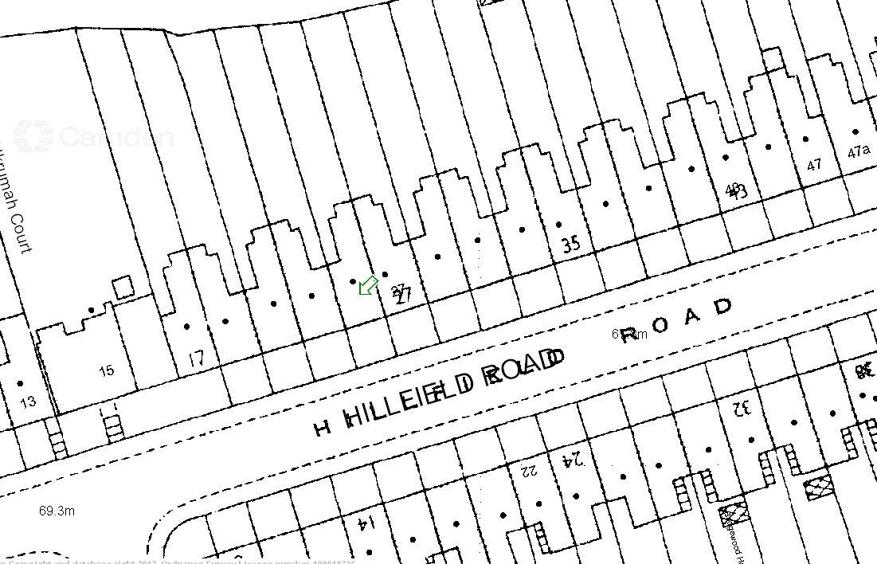

No. 25 Hillfield Road, Rear Elevation

Non original brickwork at lower ground floor level.

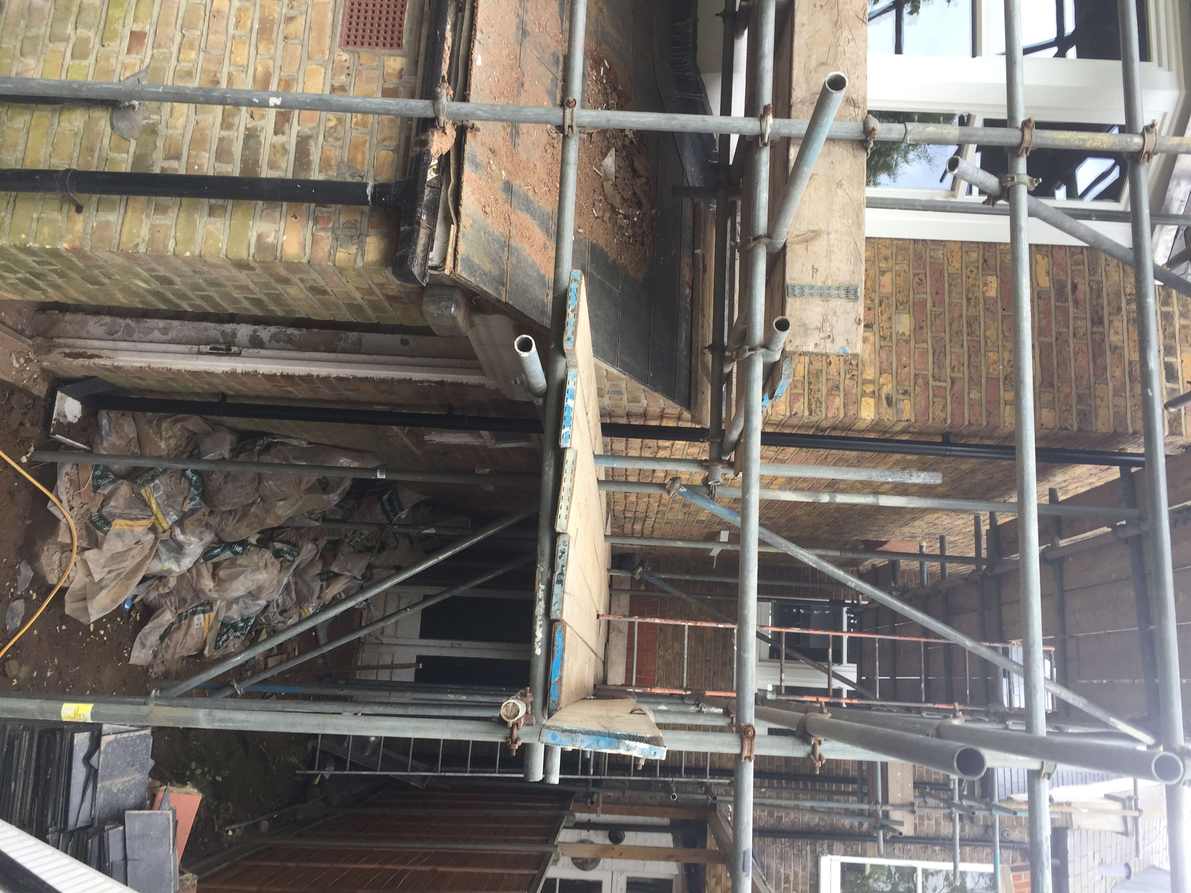

No. 25 Hillfield Road, Rear Elevation

Structure of double height bay.

