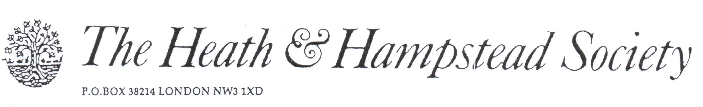
The Society examines all Planning Applications relating to Hampstead, and assesses them for their impact on conservation and on the local environment.

To London Borough of Camden, Development Control Team

Planning Ref: 2017/1499/P
Address: 3 Greenaway Gardens NW3
Description: Car lift in garden
Case Officer: Kate Henry Date: 31 May 2017

We must object to this application, on these grounds:

1. Extent of on-site car parking
Whichever of the proposed alternative designs is considered, the total amount of on-site car parking proposed is grossly excessive (either 4 or 5 spaces). The LDF Parking Standard for residential sites is one space per dwelling. Acceptance of any higher standard of provision would conflict with Camden’s policies on discouragement of car use, air pollution and control of air quality generally.

There appear at present to be about 2 spaces in the garden, although the existing site layout is ambiguously drawn, with no differentation shown between hardstanding and garden space. This is already in excess of Camden standards, and harms the front garden character, with considerable loss of green space. Any addition to the existing provision would be harmful to the character of the Conservation Area.

2. Car lift
The addition of a car lift in front of the house would be greatly intrusive to its appearance and character. Little is shown of the actual details, but there appear to be glazed screens, possibly retractable, and there must be a control panel. The material of the lift floor is not specified, nor its structure.

3. Noise
The Noise Report indicates that little external noise would be generated. We are dubious, and are particularly concerned about night-time use, and the possibility of poor future maintenance.

4. Design and Access Statement
There is none

A most unacceptable proposal; please refuse.

