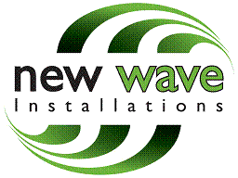
Camden Council
Planning - Development Control
Camden Council
Camden Town Hall
London
WC1H 8ND

New Wave Installations, Hope Street
Rotherham, S60 1LH
Tel: 01709 821 757

31st May 2017

Dear Sir / Madam

Address: The Dry Cleaning Company, 57 Red Lion Street, London, WC1R 4PD
Our Ref: E020699 Planning Portal Ref: PP-06112282

We wish to apply for planning permission for the retention of an ATM & ILLUMINATED SIGN at the above address.

The payment of £305.00 for the FULL PLANNING and ADVERTISEMENT CONSENT will be paid via cheque and posted soon.

We look forward to receiving written confirmation of the registration of this application together with a receipt for the statutory fee.

I trust the above is satisfactory, however if you require any further information please do not hesitate to contact me.

Yours sincerely,

Natalie Gaunt
Planning Coordinator
NewWave Installations Ltd

