Design & Access Statement
E020699 - The Dry Cleaning Company, 57 Red Lion Street, London, WC1R 4PD

This Design and Access Statement has been prepared on behalf of Cashzone in support of an application submitted for:

The retention of an Automated Teller Machine and Installation of Illuminated signage

We have consulted Circular 01/2006.
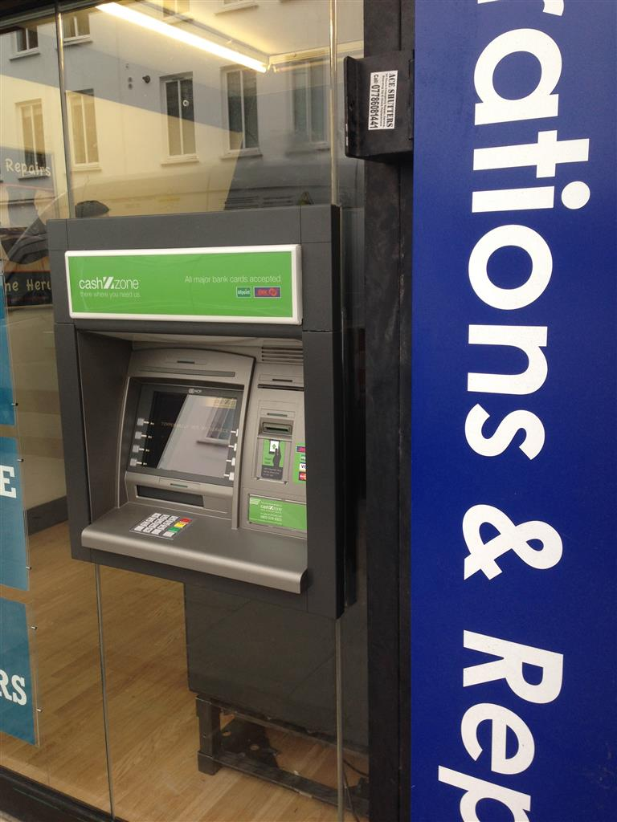

Appearance

We have installed an ATM to the right hand side of the glazed shopfront. We have replaced an existing glazing panel with silicone jointed glazing. The window of the store where the ATM has been installed has no special architectural or historic features.

The immediate area is both commercial and residential however we consider that the installation of an ATM in this location would not be detrimental to them.

The site is located within the Bloomsbury conservation area however I do not believe that it is a listed building.

Use

The purpose of the installation of this Automated Teller Machine is to provide a 24 hour banking facility for the local community and visitors to the area.

Scale

N/A

Layout

The installation of the ATM has not altered the basic design of the building. We have removed an existing glazing panel. In the remaining void we have installed silicone jointed glazing with an aperture for the ATM face. We consider that this would not be detrimental to the existing street scene.

Amount

This is not a new structure, but the installation of an ATM in an existing shop.

Landscaping

Due to the nature of the proposal, we feel the application will not benefit from any landscaping.

Design Principals

The ATM is of standard design as located in many areas throughout the UK and is accepted as a necessary facility. There are a number of mandatory standards which apply, relating to the position of the ATM, it’s visibility, ambient lighting, building structure, building security features, ATM anchoring, safe strength.

Designing out Crime

We install and anchor the ATMs in accordance with National Guidelines.

Site approval by the Cash In Transit Company has been obtained. They have considered routes to and from the ATM, ensuring there is protection of their staff and of any staff or customers at the site. Paramount in their review has been the welfare of their staff and the persons they come into contact with.

The area where the ATM has been installed is a well-lit open area in full view of pedestrians aiding natural surveillance.

Access

The access to the site and other properties has not been affected. In designing this application, we have taken into account the needs of able and disabled users. The ATM is set at a height that makes it accessible for all users and has space to the front for a wheel chair. Key 5 has raised markings for blind persons to identify the centre key.

