Heritage Statement& Design and Access Statement

SITE ADDRESS: Ground Floor Flat 28 Steeles Road London NW3 4RE

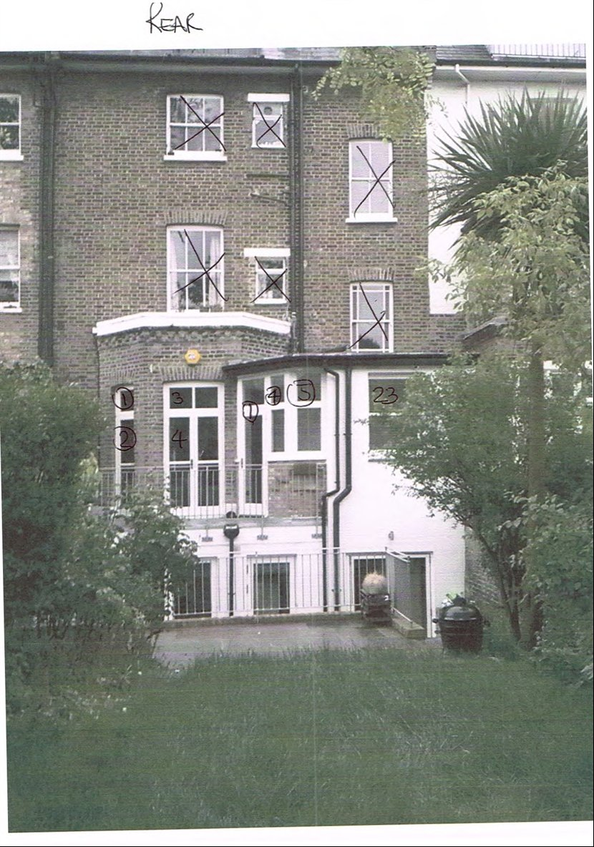

Use: Anglian Home Improvements have been contracted to replace the existing
windows and doors at the above site address.

Surrounding Area: The north side of Steeles Road is lined with mature trees and partly comprised of grade II listed dwellings. 23-29 are terraced properties with lower ground and three main floors. They match the southern terraces no’s 15-22. Many of the properties have been converted into flats.

We do not believe the replacement windows proposed will have a detrimental impact on the surrounding area.

Heritage/History

The property lies within the Eton Conservation Area, sub area 1 and was designated 01/02/1988

Constraints: The property is located in the Eton Conservation Area and is a flat and therefore does not benefit from permitted development rights hence the requirement of the application.

Design Principles/Justification: Our applicant has chosen our white timber replacement windows and doors, with double glazing. It is proposed to replace the existing windows and doors. The new windows and doors are to be made slightly larger as shown on the proposed CAD plans in the same styling as the existing. The new windows will provide better weather proofing and thermal efficiency and therefore will protect the internal and external fabric of the property. In addition draught proofing, sound insulation and security measures will all be improved upon to the benefit of the quality of the life of the homeowners.

As the replacements are to the rear of the property any impact the impact to the conservation area would be minimal.

.

Access: No change to the property to the existing access.

Landscaping: N/A

To conclude with the above in mind we trust the windows proposed will be considered favourably by the council as we do not believe they will have any detrimental impact on the conservation area. We look forward to your reply and positive co-operation.

