- Listing
- Search the List
- List Entry
This browser is not fully supported by Historic England. Please update your browser to the latest version so that you get the best from our website.
We use cookies to give you the best possible experience online. By using this website, you consent to cookies being used in accordance with our Cookie Policy.
- Section Navigation
  - Map Search
  - Advanced Search
  - Minor Amendments
  - Download Listing Data
  - Non-Listed Sites
  - About The List
  - Enrich the List
  - Understanding List Entries

29, HAMPSTEAD HIGH STREET

List Entry Summary
This building is listed under the Planning (Listed Buildings and Conservation Areas) Act 1990 as amended for its special architectural or historic interest.
Name: 29, HAMPSTEAD HIGH STREET
List entry Number: 1378687

Location
29, HAMPSTEAD HIGH STREET
The building may lie within the boundary of more than one authority.
County: Greater London Authority
District: Camden
District Type: London Borough
Parish:
National Park: Not applicable to this List entry.
Grade: II
Date first listed: 14-May-1974
Date of most recent amendment: Not applicable to this List entry.

Legacy System Information
The contents of this record have been generated from a legacy data system.
Legacy System: LBS
UID: 478021

Asset Groupings
This list entry does not comprise part of an Asset Grouping. Asset Groupings are not part of the official record but are added later for information.

List entry Description

Summary of Building
Legacy Record - This information may be included in the List Entry Details.

Reasons for Designation
Legacy Record - This information may be included in the List Entry Details.

History
Legacy Record - This information may be included in the List Entry Details.

Details
CAMDEN
TQ2685NW HAMPSTEAD HIGH STREET 798-1/26/750 (North side) 14/05/74 No.29
GV II
Terraced shop with accommodation over. c1870. Yellow stock brick with stone and stucco dressings. Slated mansard roof with lunette dormers. Shopfront with central entrance; panelled risers to plate glass windows with rounded top corners and slim colonnettes at angles. Fascia with projecting cornice flanked by enriched console bracketed stops which also flank the house doorway with overlight and panelled door. Upper floor sashes round-arched, with enriched architraves and blind boxes, linked by enriched impost bands. 2nd floor with continuous cornice sill band. Enriched scalloped frieze beneath bracketed cornice flanked by enriched double bracketed stops; blocking course. INTERIOR: not inspected.
Listing NGR: TQ2649485707

Selected Sources
Legacy Record - This information may be included in the List Entry Details
National Grid Reference: TQ 26491 85701

Map
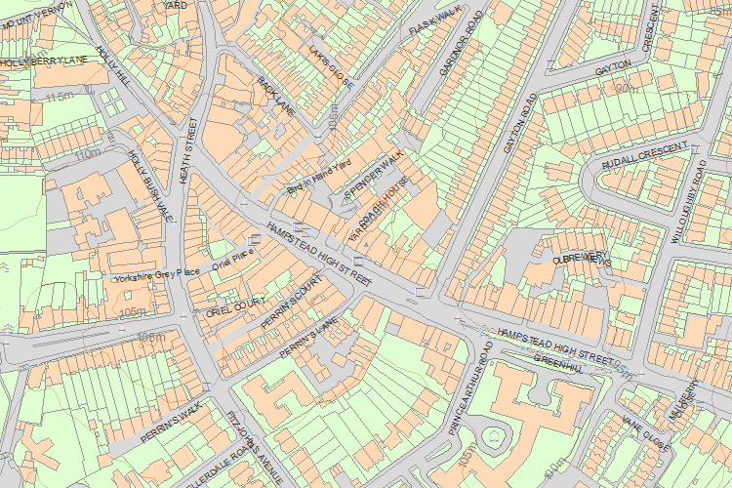© Crown Copyright and database right 2017. All rights reserved. Ordnance Survey Licence number 100024900.
© British Crown and SeaZone Solutions Limited 2017. All rights reserved. Licence number 102006.006.
Use of this data is subject to Terms and Conditions.
The above map is for quick reference purposes only and may not be to scale. For a copy of the full scale map, please see the attached PDF - 1378687 .pdf
The PDF will be generated from our live systems and may take a few minutes to download depending on how busy our servers are. We apologise for this delay.
This copy shows the entry on 10-May-2017 at 12:09:08.
End of official listing

Your Contributions

