THE HORSE AND GROOM PUBLIC HOUSE

List Entry Summary
This building is listed under the Planning (Listed Buildings and Conservation Areas) Act 1990 as amended for its special architectural or historic interest.
Name: THE HORSE AND GROOM PUBLIC HOUSE
List entry Number: 1378828

Location
THE HORSE AND GROOM PUBLIC HOUSE, 68, HEATH STREET
The building may lie within the boundary of more than one authority.
County: Greater London Authority
District: Camden
District Type: London Borough
Parish:
National Park: Not applicable to this List entry.
Grade: II
Date first listed: 11-Jan-1999
Date of most recent amendment: Not applicable to this List entry.

Legacy System Information
The contents of this record have been generated from a legacy data system.
Legacy System: LBS
UID: 478185

Asset Groupings
This list entry does not comprise part of an Asset Grouping. Asset Groupings are not part of the official record but are added later for information.

List entry Description

Summary of Building
Legacy Record - This information may be included in the List Entry Details.

Reasons for Designation
Legacy Record - This information may be included in the List Entry Details.

History
Legacy Record - This information may be included in the List Entry Details.

Details
CAMDEN
TQ2685NW HEATH STREET 798-1/26/799 (East side) No.68 The Horse and Groom Public House
GV II
Public house. 1898-1900. By Keith D Young. Red brick and Portland stone bands. Tiled gabled roof with chimney-stacks. Arts and Crafts style. EXTERIOR: 4 storeys, attic and cellars. Public house frontage of a central segmental-arched window, having engraved glass to top and bottom panes, flanked by segmental-arched entrances having large enriched keystones. 1st floor cornice with 2 large brackets to window below. Rising from the ground floor to full height are V-profile piers articulating the outer bays. Upper floor sashes with glazing bars to top of sashes only. 1st and 2nd floors with central slightly canted bays of 3 windows, flanked by single windows; entablature to each floor. 3rd floor of 4 single sashes and entablature, above which a 2-light attic window in the large gable with ball finial. INTERIOR: long narrow plan with bars to front and back, with archway between; entrance to back bar down long corridor with lincrusta decoration which gives on to flat baluster stair leading to first-floor lounge (not inspected). Ground floor front bar with counter, perhaps early C20, and some square panelling under moulded lincrusta frieze with lyre decoration and moulded cornice. Bar back typical of Mssrs Youngs houses of c1930. Rear bar simpler but retains c1900 fireplace and mirror, and dado. HISTORICAL NOTE: Young was a member of the brewing family, still based in Wandsworth, but is better-known as a hospital architect. He was working on New End Hospital at the same time as this public house was erected. (Greater London Record Office, Building Act case No. 14786).
Listing NGR: TQ2639385856

Selected Sources
Legacy Record - This information may be included in the List Entry Details
National Grid Reference: TQ 26393 85856

Map
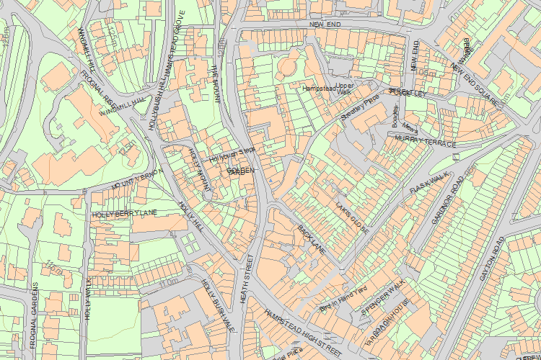© Crown Copyright and database right 2017. All rights reserved. Ordnance Survey Licence number 100024900.
© British Crown and SeaZone Solutions Limited 2017. All rights reserved. Licence number 102006.006.
Use of this data is subject to Terms and Conditions.
The above map is for quick reference purposes only and may not be to scale. For a copy of the full scale map, please see the attached PDF - 1378828 .pdf
The PDF will be generated from our live systems and may take a few minutes to download depending on how busy our servers are. We apologise for this delay.
This copy shows the entry on 10-May-2017 at 11:05:12.
End of official listing

Your Contributions

