66, HEATH STREET

List Entry Summary
This building is listed under the Planning (Listed Buildings and Conservation Areas) Act 1990 as amended for its special architectural or historic interest.
Name: 66, HEATH STREET
List entry Number: 1378827

Location
66, HEATH STREET
The building may lie within the boundary of more than one authority.
County: Greater London Authority
District: Camden
District Type: London Borough
Parish:
National Park: Not applicable to this List entry.
Grade: II
Date first listed: 14-May-1974
Date of most recent amendment: Not applicable to this List entry.

Legacy System Information
The contents of this record have been generated from a legacy data system.
Legacy System: LBS
UID: 478184

Asset Groupings
This list entry does not comprise part of an Asset Grouping. Asset Groupings are not part of the official record but are added later for information.

List entry Description

Summary of Building
Legacy Record - This information may be included in the List Entry Details.

Reasons for Designation
Legacy Record - This information may be included in the List Entry Details.

History
Legacy Record - This information may be included in the List Entry Details.

Details
CAMDEN
TQ2685NW HEATH STREET 798-1/26/798 (East side) 14/05/74 No.66
GV II
End of terrace house with later restaurant. Early C18, refaced early C19. Painted brick. Slated mansard roof with dormer. 3 storeys and attic. 1 window. Ground floor with C20 restaurant front but retains original fascia brackets. Upper floors with gauged brick flat arches to recessed sashes. Parapet. Rear facade of brown brick with floor bands and segmental-arched flush framed sash windows. INTERIOR: not inspected.
Listing NGR: TQ2639885853

Selected Sources
Legacy Record - This information may be included in the List Entry Details
National Grid Reference: TQ 26396 85852

Map
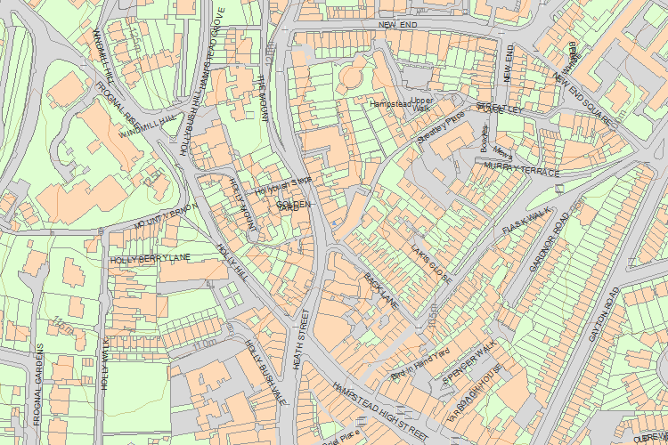© Crown Copyright and database right 2017. All rights reserved. Ordnance Survey Licence number 100024900.
© British Crown and SeaZone Solutions Limited 2017. All rights reserved. Licence number 102006.006.
Use of this data is subject to Terms and Conditions.
The above map is for quick reference purposes only and may not be to scale. For a copy of the full scale map, please see the attached PDF - 1378827 .pdf
The PDF will be generated from our live systems and may take a few minutes to download depending on how busy our servers are. We apologise for this delay.
This copy shows the entry on 10-May-2017 at 11:01:50.
End of official listing

Your

