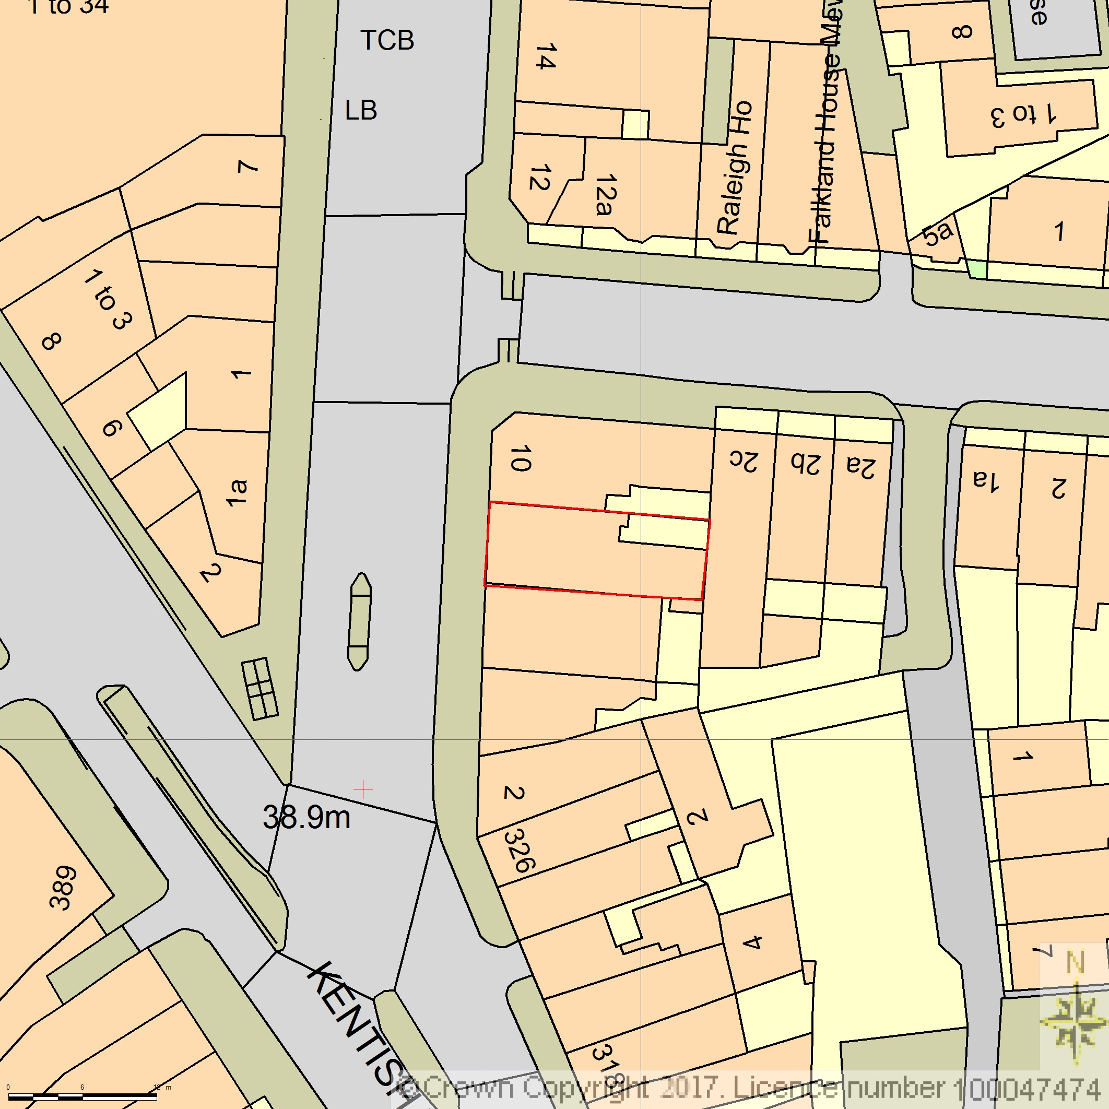
BLOCK/SITE PLAN
AREA 90m x 90m
SCALE 1:500 on A4
CENTRE COORDINATES: 528993, 185315



Supplied by Streetwise Maps Ltd
www.streetwise.net
Licence No: 100047474
28/07/2026 08:01:03

