2 AND 4, FLASK WALK

List Entry Summary
This building is listed under the Planning (Listed Buildings and Conservation Areas) Act 1990 as amended for its special architectural or historic interest.
Name: 2 AND 4, FLASK WALK
List entry Number: 1322187

Location
2 AND 4, FLASK WALK
The building may lie within the boundary of more than one authority.
County: Greater London Authority
District: Camden
District Type: London Borough
Parish:
National Park: Not applicable to this List entry.
Grade: II
Date first listed: 14-May-1974
Date of most recent amendment: Not applicable to this List entry.

Legacy System Information
The contents of this record have been generated from a legacy data system.
Legacy System: LBS
UID: 477313

Asset Groupings
This list entry does not comprise part of an Asset Grouping. Asset Groupings are not part of the official record but are added later for information.

List entry Description

Summary of Building
Legacy Record - This information may be included in the List Entry Details.

Reasons for Designation
Legacy Record - This information may be included in the List Entry Details.

History
Legacy Record - This information may be included in the List Entry Details.

Details
CAMDEN
TQ2685NW FLASK WALK 798-1/26/460 (South side) 14/05/74 Nos.2 AND 4
GV II
Pair of terraced shops with accommodation over. Early C19. Yellow stock brick. No.2: 3 storeys 2 windows. Reproduction C19 shopfront with small panes and panelled risers; fascia flanked by later C19 enriched consoles. Upper floors with gauged brick cambered arches to recessed hornless sashes. V-shaped parapet. No.4: 2 storeys 1 window. Wooden shopfront with pilasters supporting a C20 fascia with one (right hand) enriched console. Plate glass windows with continuous top strip of small rectangular panes. Upper floors with gauged brick cambered arches to recessed hornless sashes. Parapet. INTERIORS: not inspected.
Listing NGR: TQ2643185742

Selected Sources
Legacy Record - This information may be included in the List Entry Details
National Grid Reference: TQ 26432 85744

Map
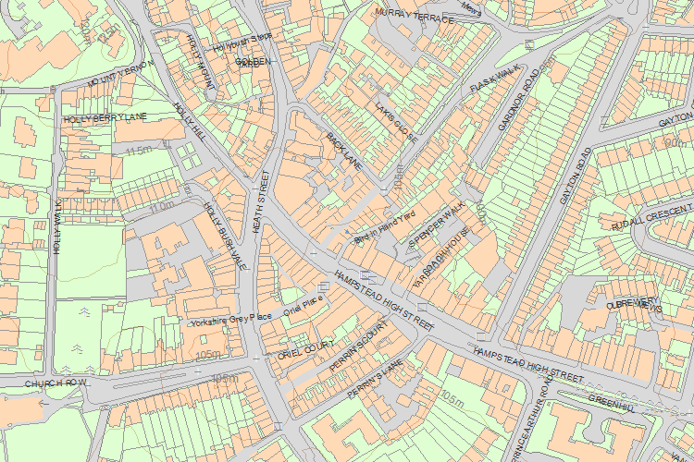© Crown Copyright and database right 2017. All rights reserved. Ordnance Survey Licence number 100024900.
© British Crown and SeaZone Solutions Limited 2017. All rights reserved. Licence number 102006.006.
Use of this data is subject to Terms and Conditions.
The above map is for quick reference purposes only and may not be to scale. For a copy of the full scale map, please see the attached PDF - 1322187 .pdf
The PDF will be generated from our live systems and may take a few minutes to download depending on how busy our servers are. We apologise for this delay.
This copy shows the entry on 04-May-2017 at 11:07:50.
End of official listing

