Construction
Management Plan
pro forma v2.0
Rev 1 – 20.3.17 (new text added in blue)

Contents

Internal review sheet 3
Introduction 4
Timeframe 5
Contact 6
Site 8
Community liaison 15
Transport 19
Environment 35
Agreement 45
Supporting Information – issued as separate file
Review

For Internal use only

Please initial and date in the relevant section of the table.

The highlighted areas of the Draft table will be deleted by their respective teams during pre app review if these sections are no longer applicable.

Pre app

Community liaison
CLOCS
Transport
Highways
Parking
Environmental health
Sustainability | (attach appendix if necessary)
Sign off

Draft

Community liaison
CLOCS
Transport
Highways
Parking
Environmental health
Sustainability
Sign off

INDICATES INPUT REQUIREMENT FROM MULTIPLE TEAMS THROUGHOUT DOCUMENT

Introduction
The purpose of the Construction Management Plan (CMP) is to help developers to minimise construction impacts, and relates to both on site activity and the transport arrangements for vehicles servicing the site.
It is intended to be a live document whereby different stages will be completed and submitted for application as the development progresses.
The completed and signed CMP must address the way in which any impacts associated with the proposed works, and any cumulative impacts of other nearby construction sites, will be mitigated and managed. The level of detail required in a CMP will depend on the scale and kind of development. Further policy guidance is set out in Camden Planning Guidance (CPG) 6: Amenity and (CPG) 8: Planning Obligations.

This CMP follows the best practice guidelines as described in Tr an sp ort f or Londo n ’s (TfL’s Standard for Construction Logistics and Cyclist Safety (CLOCS) scheme) and Camd en ’s Minimum Requirements for Building Construction (CMRBC).

The approved contents of this CMP must be complied with unless otherwise agreed with the Council in writing. The project manager shall work with the Council to review this CMP if problems arise in relation to the construction of the development. Any future revised plan must also be approved by the Council and complied with thereafter.
It should be noted that any agreed CMP does not prejudice or override the need to obtain any separate consents or approvals such as for road closures or hoarding licences.
If your scheme involves any demolition, you need to make an application to the Council’s Building Control Service. Please complete the “Demolition Notice”

Please complete the questions below with additional sheets, drawings and plans as required. The boxes will expand to accommodate the information provided, so please provide as much information as is necessary. It is preferable if this document is completed electronically and submitted as a Word file to allow comments to be easily documented.
(Note the term 'vehicles' used in this document refers to all vehicles associated with the implementation of the development, e.g. demolition, site clearance, delivery of plant & materials, construction, etc.)
Revisions to this document may take place periodically.

Timeframe
Work can commence if draft CMP is approved
INDICATIVE TIMEFRAME (MONTHS)


COUNCIL ACTIONS DEVELOPER ACTIONS
0
Requirement to submit CMP
1
2
Council response to draft
3
Council response to second
draft
4


Post app submission

Appoint principal contractor


Begin community liaison

Submit draft CMP


Resubmission of CMP if first draft refused
Contact
- Please provide the full postal address of the site and the planning reference relating to the construction works.

Address: 21-22 King’s Mews, London, WC1N 2JB
Planning ref: 2016/1093/P
Planning has been granted subject to section 106 legal agreement, ref: 2016/1093/P
Type of CMP: Section 106 planning obligation / Major sites framework

- Please provide contact details for the person responsible for submitting the CMP.

Name: Liz King, DDC Ltd
Address: 77 Elmers End Road, London SE20 7UU
Email: lking@ddclimited.com
Phone: 020 8778 6111

- Please provide full contact details of the site project manager responsible for day-to-day management of the works and dealing with any complaints from local residents and businesses.

Name: Project Manager - Liz King & Site Manager – Graham Bold
Address: 77 Elmers End Road, London SE20 7UU
Email: lking@ddclimited.com
Phone: 020 8778 6111 / 07494 459125

- Please provide full contact details of the person responsible for community liaison and dealing with any complaints from local residents and businesses if different from question 3.

Name: As Q3
Address:
Email:
Phone:

Email: Phone:

- Please provide full contact details of the person responsible for community liaison/dealing with any complaints from local residents and businesses if different from question 3. In the case of Community Investment Programme (CIP), please provide contact details of the responsible Camden officer.

Name: As Q3
Address:
Email:
Phone:

- Please provide full contact details including the address where the main contractor accepts receipt of legal documents for the person responsible for the implementation of the CMP.

Name: Liz King, DDC Ltd
Address: 77 Elmers End Road, London SE20 7UU
Email: lking@ddclimited.com
Phone: 020 8778 6111

Site
- Please provide a site location plan and a brief description of the site, surrounding area and development proposals for which the CMP applies.

The site is located on the eastern side of King’s Mews within the London Borough of Camden, just north of the A401 Theobalds Road. The site is located approximately 500 metres north of Chancery Lane Underground Station. The site operates currently as a garage and as such, two points of vehicle access to the site are provided from King’s Mews.
The land use in the vicinity of the site comprises of a mixture of commercial and residential uses. The development proposals comprise the demolition of the existing garage and the construction of a new 4 storey property including a new basement level.
The location of the site in relation to the surrounding area is shown below:
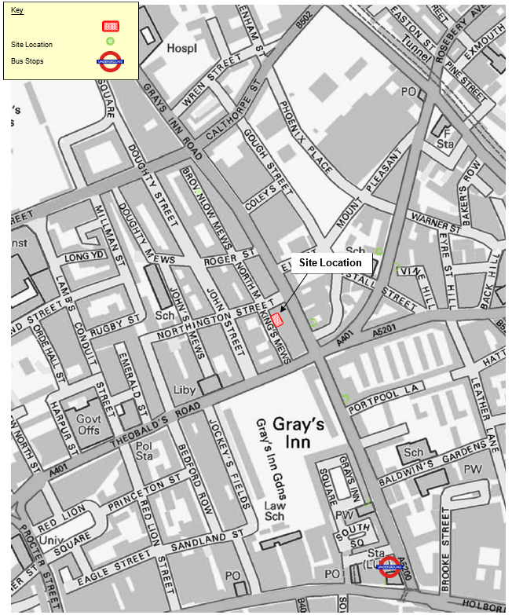

- Please provide a very brief description of the construction works including the size and nature of the development and details of the main issues and challenges (e.g. narrow streets, close proximity to residential dwellings).

The development proposals comprise the demolition of the existing garage and the construction of a new 4 storey property including a new basement level. The development creates 7no new apartments.
The property is fronted to the west by King’s Mews which is a two-way single lane carriageway road and is subject to a 20mph speed restriction. King’s Mews is 7.6 metres wide outside the frontage of the property and narrows at its southern end where it joins the A401. Single yellow lines run along both sides of King’s Mew in the vicinity of the site and a footway is provided along the western side of the road. The existing highway layout is shown in Drawing 160134-01, appended to this pro- forma.
The site is bound to the north, east and south by adjacent residential and commercial properties and is bound to the west by King’s Mews. There is footway is provided along the eastern side of King’s Mews. No garden or outside space is available on site.
NOTE – this plan deals with the demolition phase also so a separate DMP is not being produced.
The main issues and challenges we envisage with this project are as follows:
- Working adjacent to party wall boundaries on 3 sides – following party wall award, we will then be making every effort (through initial consultation and ongoing good communication) to keep those most affected by the work up to speed as to progress, any major events that may affect them (eg craneage) etc
Deliveries to the site could be an issue but our current plan, subject to a meeting with highways and to their agreement, would be to apply for a full road closure, maintaining the pavement opposite the site and allowing vehicular access in either end of the road for those living or working there. This would allow us to safely hoard the section of road outside of the site, with drive through access via gates in the hoarding meaning we can safely offload within the site compound. We would look to have a gantry above this section for site welfare and storage etc. Highways have now advised that a full road closure will not be permitted as the other end of Kings Mews is closed. Please see updated swept path diagrams (in supporting info) showing how vehicles will enter and leave via Northington St. We are waiting on Highways confirmation that we can still have full width gantry maintaining drive through for those needing access beyond our site. A delivery schedule will be drawn up with the other project managers (No’s 27, 28 & 29-30) to ensure that the public highway is not obstructed during delivery times and that there are no delivery clashes.
- Priority will be given to maintaining good and safe access for pedestrians using the road

- Please identify the nearest potential receptors (dwellings, business, etc.) likely to be affected by the activities on site (i.e. noise, vibration, dust, fumes, lighting, etc.).
Activity | Impact | Affecting
- Deconstruction of internal atrium floor levels | Noise  Vibration  Dust  Fumes | 7-8,13-14 &22 King Mews WC1N 2JB and rear Buildings  at John Street 1-6 WC1N 2ES and 37-47 WC1X 8PP Grays Inn Road.
- Site Access and entry | Vehicles Loading / Unloading  Movement of materials | Pedestrians, Vehicles Northington Street
- Full property refurbishment | Noise  Dust  Vibration  Fumes | 7-8,13-14 &22 King Mews WC1N 2JB and rear Buildings  at John Street 1-6 WC1N 2ES and 37-47 WC1X 8PP Grays Inn Road.
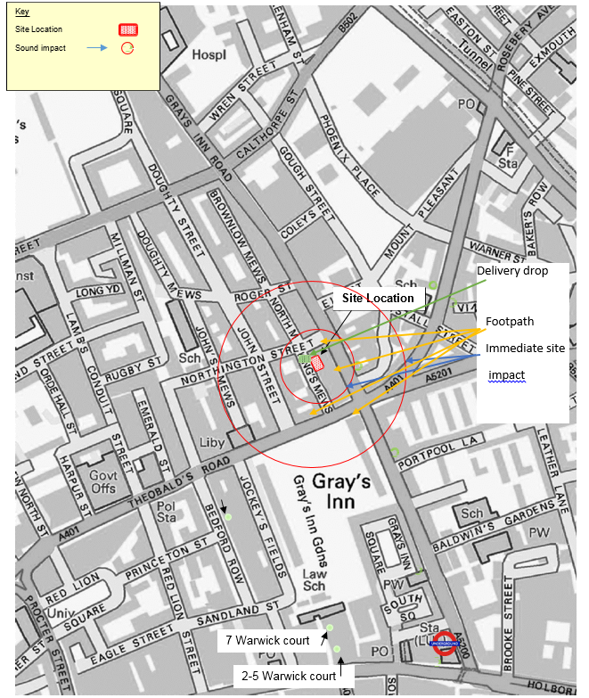

- Please provide a scaled plan detailing the local highway network layout in the vicinity of the site. This should include details of on-street parking bay locations, cycle lanes, footway extents and proposed site access locations.

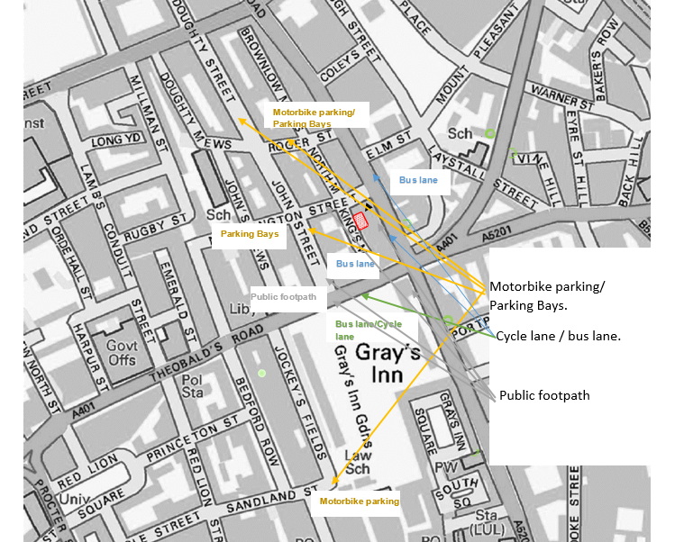

- Please provide the proposed start and end dates for each phase of construction as well as an overall programme timescale. (A Gantt chart with key tasks, durations and milestones would be ideal).
The programme appended to this document provides an indication of the duration of each phase of the works. The programme will be updated with the correct dates envisaged for each phase of the works once CMP has been reviewed and agreed / highways have confirmed road closure etc and the date for works to start on site has been determined. (Please ignore the current start date shown – we are hoping to commence late April / May ’17 and programme will updated once firm start date is known).

- Please confirm the standard working hours for this site, noting that the standard working hours for construction sites in Camden are as follows:
  - 8.00am to 6pm on Monday to Friday
  - 8.00am to 1.00pm on Saturdays
  - No working on Sundays or Public Holiday

The provisional working hours for the site will be 08:00 to 18:00 Monday to Friday and 08:00- 13:00 on Saturdays. No work will be permitted on Sundays or public holidays.

- Please indicate if any changes to services are proposed to be carried out that would be linked to the site during the works (i.e. connections to public utilities and/or statutory undertakers’ plant). Larger developments may require new utility services. If so, a strategy and programme for coordinating the connection of services will be required. If new utility services are required, please confirm which utility companies have been contacted (e.g. Thames Water, National Grid, EDF Energy, BT. etc.) You must explore options for the utility companies to share the same excavations and traffic management proposals. Please supply details of your discussions.

Service | Details | Contact
Water | Update to supply with new water meters | Thames Water Utilities Limited, Clearwater Court, Vastern Road, Reading RG1 8DB
Electric | Update to 3 phase supply  200amp per min | Uk Power 237 Southwark Bridge Rd, London SE1 6NP
Gas | Update to supply with new Gas meters | British Gas  PO Box 227  ROTHERHAM  S98 1P

Community Liaison

A neighbourhood consultation process must have been undertaken prior to submission of the CMP first draft.
Significant time savings can be made by running an effective neighbourhood consultation process. This must be undertaken in the spirit of cooperation rather than one that is dictatorial and unsympathetic to the wellbeing of local residents and businesses.
These are most effective when initiated as early as possible and conducted in a manner that involves the local community. Involving locals in the discussion and decision making process helps with their understanding of what is being proposed in terms of the development process. The consultation and discussion process should have already started, with the results incorporated into the CMP first draft submitted to the Council for discussion and sign off. This communication should then be ongoing during the works, with neighbours and any community liaison groups being regularly updated with programmed works and any changes that may occur due to unforeseen circumstances through newsletters, emails and meetings.
Please note that for larger sites, details of a construction working group may be required as a separate S106 obligation. If this is necessary, it will be set out in the S106 Agreement as a separate requirement on the developer.

Cumulative impact

Sites located within high concentrations of construction activity that will attract large numbers of vehicle movements should consider establishing contact with other sites in the vicinity in order to manage traffic routeing and volumes. Developers in the Tottenham Court Road area have done this to great effect.

The Council can advise on this if necessary.

- Consultation

The Council expects meaningful consultation. For large sites, this may mean two or more meetings with local residents prior to submission of the first draft CMP.
Evidence of who was consulted, how the consultation was conducted and a summary of the comments received in response to the consultation. Details of meetings including minutes, lists of attendees etc. must be included.
In response to the comments received, the CMP should then be amended where appropriate and, where not appropriate, a reason should be given. The revised CMP should also include a list of all the comments received. Developers are advised to check proposed approaches to consultation with the Council before carrying them out. If your site is on the boundary between boroughs then we would recommend contacting the relevant neighbouring planning authority.
Please provide details of consultation of draft CMP with local residents, businesses, local groups (e.g. residents/tenants and business associations) and Ward Councillors.

A pre-consultation letter will be issued following this issue of this CMP to Camden Planning.
(See copy attached in the supporting information file).
DDC Ltd through its company procedures initiates consultation with occupants affected by works to limit disturbance and provide communication routes to deal with concerns or complaints.
See question 2 for information on ways that consultation will take place.
Letter has now been issued to neighbours, with info on how to access the CMP & make comments. A copy of this is sent with this CMP revision. This letter also advises that due to the number of projects happening, all sites will be working closely to minimise the disruption and that there will be a shared newsletter update.
We have not to date received any responses from neighbours.
A separate discussion has been held with the contractors responsible for other developments
along the street and once we are on site (I believe later start than other projects) we will ensure that our foreman has daily communication with the other sites to agree delivery times , deal with any community issues etc

- Construction Working Group

Please provide details of community liaison proposals including any Construction Working Group that will be set up, addressing the concerns of the community affected by the works, the way in which the contact details of the person responsible for community liaison will be advertised to the local community, and how the community will be updated on the upcoming works i.e. in the form of a newsletter/letter drop, or weekly drop in sessions for residents.

Community liaison will be formed by the following:
- Neighbourhood consultation letter including site contact details

- Weekly email updates to all interested parties This is now going to be done collectively with the projects at 27, 28 & 29-30

- We will seek to keep any close neighbors advised of any large scale operations but any works that may impact the site hours or restriction to vehicular access would be dealt with via the appropriate channels.
- Monitor works and establish log book for complaints and incidents to remediate.

- Details of site contact person will also be posted on the contact board on the outside of our site entrance area so anyone else in the vicinity who has any issues / queries can contact the site direct.
Contact board will contain the following information:
a) The title ‘Contact Board’
b) Name of the main contractor, address and person to whom correspondence should be addressed.
c) Name of the site manager.
d) Month and year of completion of works.
e) Names and telephone numbers of staff who can take immediate action, so that contact can be made at any time.
- All feedback from local occupants and further concerns are recorded on site to ensure any complaints are dealt with within a professional and courteous timescale.
- See following page detailing further info regarding complaints procedure

Complaints
Any complaints made direct to the site will be recorded and advised to both the contracts manager and our head office. They will be investigated by the site manager and if necessary, the contracts manager will follow any complaint up within 24 hours and again, a record will be kept of the outcome.
Should a complaint be received regarding works that are taking place, those works will be put on hold temporarily until agreement can be reached with regards any noisy works restrictions etc. If agreement cannot be reached, we would seek to involve a representative from Camden council to agree a way forward.

- Schemes

Please provide details of any schemes such as the ‘Considerate Constructors Scheme’, such details should form part of the consultation and be notified to the Council. Contractors will also be required to follow the “Guide for Contractors Working in Camden” also referred to as “Camd en ’s Con sider ate Con t ractor s M anu al ”.

The site has now been registered with the ‘Considerate Constructors Scheme’ (copy of email verifying this is attached with this resubmission) and we are aware of the code of considerate contractor standards contained within your manual (Table 1.1) and will endeavor to work within all 8 of these standards. A copy of these standards will be displayed in the site welfare area and site office.

- Neighbouring sites

Please provide a plan of existing or anticipated construction sites in the local area and please state how your CMP takes into consideration and mitigates the cumulative impacts of construction in the vicinity of the site. The council can advise on this if necessary.

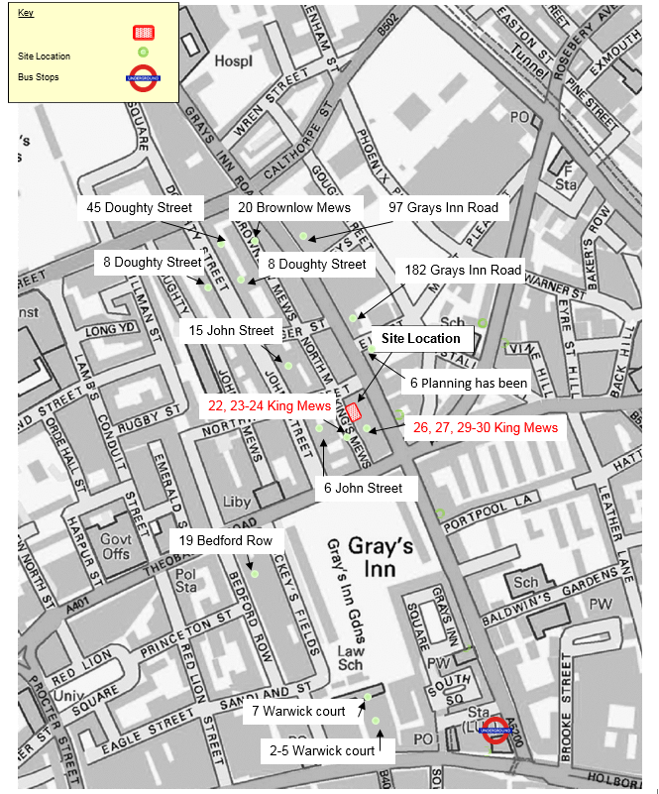
The map above provides information on current jobs in operation.
22, 23-24, 26, 27, 29-30 Kings Mews, we are aware that the following properties have been granted planning consent and will liaise with them to manage the construction process
This plan is now slightly out of date but we are aware of, and in contact with the other planned sites in Kings Mews

Transport

This section must be completed in conjunction with your principal contractor. If one is not yet assigned, please leave the relevant sections blank until such time when one has been appointed.
Camden is a CLOCS Champion, and is committed to maximising road safety for Vulnerable Road Users (VRUs) as well as minimising negative environmental impacts created by motorised road traffic. As such, all vehicles and their drivers servicing construction sites within the borough are bound by the conditions laid out in the CLOCS Standard.

This section requires details of the way in which you intend to manage traffic servicing your site, including your road safety obligations with regard to VRU safety. It is your responsibility to ensure that your principal contractor is fully compliant with the terms laid out in the CLOCS Standard. It is your principal contractor’s responsibility to ensure that all contractors and sub-contractors attending site are compliant with the terms laid out in the CLOCS Standard.
Checks of the proposed measures will be carried out by the council to ensure compliance. Please refer to the CLOCS Standard when completing this section. Guidance material which details CLOCS requirements can be accessed here, details of the monitoring process are available here.

Please contact CLOCS@camden.gov.uk for further advice or guidance on any aspect of this section.

Please refer to the CLOCS Overview and Monitoring Overview documents which give a breakdown of requirements.
CLOCS Considerations

- Name of Principal contractor:

Name: DDC Ltd

Address: 77 Elmers End Road, London, SE20 7UU Email: lking@ddclimited.com
Phone: 07983572641

- Please submit the proposed method for checking operational, vehicle and driver compliance with the CLOCS Standard throughout the duration of the contract (please refer to our CLOCS Overview document in the appendix and CLOCS Standard point 3.4.7).

All subcontractors and suppliers to the site will be advised at point of our placing orders of the requirement to comply with the council requirements as laid out in the CLOCS Overview document. We will put in writing at point of order / set up of supply contract that CLOCS requirements must be adhered to.
Our principle suppliers for the site will be Travis Perkins who are already signed up to the FORS scheme (Gold) plus Lawsons & T Brewer – both of whom have FORS Silver certification. Waste will be cleared by Metro Waste who are also registered (Bronze). The demolition contractors (Demo One,) are also accredited with FORS scheme (Bronze).
We will carry out office based checks on all new suppliers to check their compliance and if not signed up to the FORS scheme, then they will be asked to advise on driver training regime & vehicle equipment, such as blind spot minimisation.
Site based checks to ensure compliance will be carried out.
We would note that on another of our sites, A CLOCS inspection was carried out (via CCS) in January ‘ 17 and this was very positive, with just the site based checks of vehicles to be improved on, as proper records were not being kept. This is now being implemented.

Please contact CLOCS@camden.gov.uk for further advice or guidance on any aspect of this section.

- Please confirm that you as the client/developer and your principal contractor have read and understood the CLOCS Standard and included it in your contracts. Please sign-up to join the CLOCS Community to receive up to date information on the standard by expressing an interest online.

I confirm that we will include the requirement to abide by the CLOCS Standard in all contracts to my subcontractors and suppliers:

Site Traffic

Sections below shown in blue directly reference the CLOCS Standard requirements. The CLOCS Standard should be read in conjunction with this section.
- Traffic routing: “Clients shall ensure that a suitable, risk assessed vehicle route to the site is specified and that the route is communicated to all contractors and drivers. Clients shall make contractors and any other service suppliers aware that they are to use these routes at all times unless unavoidable diversions occur.” (P19, 3.4.5)

Routes should be carefully considered and risk assessed, taking into account the need to avoid where possible any major cycle routes and trip generators such as schools, offices, public buildings, museums etc. Where appropriate, on routes that use high risk junctions (ie. those that attract high volumes of cycling traffic) installing Trixi mirrors to aid driver visibility should be considered.

Consideration should also be given to weight restrictions, low bridges and cumulative impacts of construction (including neighbouring construction sites) on the public highway network. The route(s) to and from the site should be suitable for the size of vehicles that are to be used.

  - Please indicate routes on a drawing or diagram showing the public highway network in the vicinity of the site including details of links to the Transport for London Road Network (TLRN).

Please note that this section was all prepared in advance of the proposed plan to apply for a full road closure, so will be subject to review and update once we have met with Highways to agree our proposals.

For now we leave the text and diagrams as shown and will re-submit with updated text and swept path diagrams etc prior to commencement of the works.

A road closure has been granted for works to 29/30 Kings Mews so our proposal now is that our gantry will be at a height and width to allow access (inc site traffic for No’s 27 & 28, emergency vehicles & other occupants of Kings Mews) down the mews. We therefore request that we still be permitted a 5m high gantry but with maintained drive through access below. New swept path analysis drawings have been prepared and are submitted with this revision. (NB – we have not yet submitted the gantry application as Camden already have our cheque for road closure which needs to be cancelled)
It is anticipated that the construction vehicles will access the site from the A5200 (Grays Inn Road) tuning into Northington Street travelling westbound. Vehicles will pull past Kings Mews, reversing in to the Mews using banksmen, to access the site. Vehicles will leave the site in a forward gear, making a left turn onto Northington Street. See revised Swept Path Analysis showing a ready-mix concrete mixer (the largest vehicle expected to access the site).
It will be required that all deliveries call a minimum of 20 minutes prior to arrival at the site to ensure that the appropriate loading area is available. All vehicle movements to and from the loading areas will be managed by a minimum of two trained banksmen.
The potential risks to both cyclists and pedestrians have been considered and vehicles with appropriate safety equipment will be used. It will be required that all vehicles will be fitted with safety bars, additional mirrors and advisory signage. It will also be required that drivers must have undertaken a cyclist safety awareness course. Drivers will also be made aware prior to travelling to the site of the presence of a Sandander Cycle docking station on Northington Street.
The vehicle routeing plan will be reviewed and confirmed following any further discussions with officers at Camden Borough Council.
There will be no contractors vehicles parked on King’s Mews. Those requiring all day parking
will use the National Car Park on Farringdon Road. Those visiting the site by car for a short time will use the pay and display parking spaces within the surrounding CPZ.

  - Please confirm how contractors, delivery companies and visitors will be made aware of the route (to and from the site) and of any on-site restrictions, prior to undertaking journeys.

All contractors, delivery companies and visitors will be advised of and required to adhere to the specified route and all other measures detailed in this plan prior to journeys being undertaken. All contractors and visitors to the site will be advised to travel to the site by public transport or on foot or by cycle. The Construction Project Manager will provide all site personnel with details of local public transport services.

- Control of site traffic, particularly at peak hours: “Clients shall consider other options to plan and control vehicles and reduce peak hour deliveries” (P20, 3.4.6)

Construction vehicle movements are generally acceptable between 9.30am to 4.30pm on weekdays and between 8.00am and 1.00pm on Saturdays). If there is a school in the vicinity of the site or on the proposed access and/or egress routes, then deliveries must be restricted to between 9.30am and 3pm on weekdays during term time. (Refer to the Guide for Contractors Working in Camden).

A delivery plan should ensure that deliveries arrive at the correct part of site at the correct time. Instructions explaining such a plan should be sent to all suppliers and contractors. Consideration should be given to the location of any necessary holding areas for large sites with high volumes of traffic. Vehicles must not wait or circulate on the public highway. Whilst deliveries should be given set times to arrive, dwell and depart, no undue time pressures should be placed upon the driver at any time.

  - Please provide details of the typical sizes of all vehicles and the approximate frequency and times of day when they will need access to the site, for each phase of construction. You should estimate the average daily number of vehicles during each major phase of the work, including their dwell time at the site. High numbers of vehicles per day and/or long dwell times may require vehicle holding procedures.

The diagram previously shown here was incorrect. Please see attached drawing (SK01) in iour ‘supporting information pack’ which shows access and egress routes, taking into account the current road closure in place for planned works at 29-30 Kings Mews and also correcting the errror regards Northington Street being one way

Vehicles will load and unload outside the site, either directly onto the gantry or into the site
demise
A banksman will be provided when required for vehicles manouvering on Kings Mews.

Construction Vehicles

It is anticipated that the following vehicle types will be used throughout the construction period:

• 8m Concrete Mixer;
• 6.5m Tipper Truck; and
• 6m Skip Lorry

Largest anticipated vehicle sizes will be 18.5 tonne & 2.6 wide
Vehicle delivery times will be between 9.30am to 4.30pm on weekdays and between 8.00am and 1.00pm on Saturdays).
There is a school in Baldwin Gardens but we do not anticipate that our delivery routes will be in this vicinity or cause any issue with deliveries during school hours / pupils arriving & leaving.

  - Please provide details of other developments in the local area or on the route.

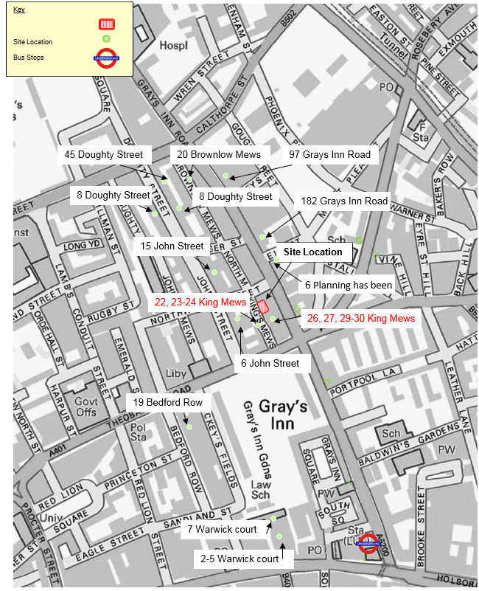
We are aware of consented development works near 20-21 King’s Mews. The Construction Project Manager will liaise with the Project Managers of the consented developments to ensure that deliveries are coordinated where possible. The contractor will continue to monitor the progress of planning applications in the area and will ensure that deliveries are coordinated with any consented schemes if appropriate.

  - Please outline the system that is to be used to ensure that the correct vehicle attends the correct part of site at the correct time.

The Construction Project Manager must be notified at least 24 hours before and all drivers will be informed of the vehicle route and location of the appropriate loading area prior to departure, ,confirming that the loading area is clear. If the loading area is not available, the vehicle shall not proceed to the site and will be given an alternative delivery time. Vehicles will not be permitted to wait, stack or circulate on the roads within the borough.

  - Please identify the locations of any off-site holding areas (an appropriate location outside the borough may need to be identified, particularly if a large number of delivery vehicles are expected) and any measures that will be taken to ensure the prompt admission of vehicles to site in light of time required for necessary compliance checks. Please refer to question 5 if any parking bay suspensions will be required for the holding area.
Following the query raised by yourselves, we confirm as follows:
We do not believe that bays will need to be suspended in the surrounding streets to provide holding areas.
The deliveries will be timed / co-ordinated to avoid vehicles waiting to offload and they will be offloaded directly outside the site in a timely and efficient manner.
Our site will co-ordinate with the other 3 sites to agree delivery slots to minimise disruption

  - Please provide details of any other measures designed to reduce the impact of associated traffic (such as the use of construction material consolidation centres).

N/A

- Site access and egress: “Clients shall ensure that access to and egress from the site is appropriately managed, clearly marked, understood and clear of obstacles.” (P18, 3.4.3)
Vehicles entering and leaving the site should be carefully managed, using gates that are clearly marked and free from obstacles. Traffic Marshalls must ensure the safe passage of pedestrians, cyclists and other traffic when vehicles are entering and leaving site, particularly if reversing.

  - Please detail the proposed access and egress routes to and from the site

The existing and proposed building occupies the entirety of the site and, as such, no vehicle access into the site is available. On this basis, it is proposed that all deliveries will take place from a temporary vehicle loading area on King’s Mews located adjacent to the frontage of the site, as shown in Motion drawing 160134-02.
As there is no vehicular access to the site, it is proposed that a skip is located on King’s Mews, adjacent to the site frontage. A temporary vehicle loading area will also be located on the single line space adjacent to the frontage of the property. A hoarding containing scaffolding will also be installed around the frontage of the property as shown in drawing 160134-02 which will not extend more than 0.5 metres from the site frontage.
Motion Drawing 160134-TK01 shows a skip lorry accessing the proposed vehicle loading area. The vehicle will reverse down Kings Mews toward the site and reverse onto the skip. Motion drawing 160134-TK02 shows a ready-mix concrete lorry (the largest vehicle expected to access the site) entering and leaving the proposed loading area. No skip will be located on the carriageway when a concrete delivery is scheduled.

  - Please describe how the access and egress arrangements for construction vehicles will be managed.

All vehicle manoeuvres to and from the proposed loading area will be supervised by trained banksmen in order to manage the interaction between pedestrians, cyclists and other road users.

  - Please provide swept path drawings for any tight manoeuvres on vehicle routes to and from the site including proposed access and egress arrangements at the site boundary (if necessary).

See revised Motion drawings in the supporting information

  - Provision of wheel washing facilities should be considered if necessary. If so, please provide details of how this will be managed and any run-off controlled.

Vehicles will not access the site and as such wheel washing facilities will not be required. Any material transferred to the footway will be cleared immediately.

- Vehicle loading and unloading: “Clients shall ensure that vehicles are loaded and unloaded on-site as far as is practicable.” (P19, 3.4.4)

If this is not possible, Traffic Marshalls must ensure the safe passage of pedestrians, cyclists and motor traffic in the street when vehicles are being loaded or unloaded.

Please provide details of the parking and loading arrangements for construction vehicles with regard to servicing and deliveries associated with the site (e.g. delivery of materials and plant, removal of excavated material). This is required as a scaled site plan, showing all points of access and where materials, skips and plant will be stored, and how vehicles will access and egress the site. If loading is to take place off site, please identify where this is due to take place and outline the measures you will take to ensure that loading/unloading is carried out safely. Please outline in question 8 if any parking bay suspensions will be required.

The strategy below provides an indicative parking and loading arrangement for construction vehicles associated with the site. Full details and the final strategy will be provided once discussed and agreed with Camden Borough Council prior to commencement.
As no vehicular access to the site is provided, it is considered that all loading activity will need to take place from the single yellow line space on King’s Mews, located immediately adjacent to the site frontage. It is proposed that a hoarded skip is placed on the carriageway adjacent to the site and spoil will be fed by conveyor into the spoil storage area. The proposed site set up is shown in Motion drawing 160134-02, attached. Skips will be collected up to twice per day during the demolition and excavation phases of the works.
Skip vehicles will pull past the site and reverse into the temporary loading area, as shown in Motion Drawing 160134-TK01. Motion drawing 160134-TK02 shows a ready-mix concrete vehicle (the largest vehicle expected to access the site) entering and leaving the proposed loading area. No skip will be located on the carriageway when a concrete delivery is scheduled.
Vehicular access along King’s Mews will be maintained and banksmen will be positioned outside the frontage of the site to guide vehicles around a vehicle when it is located within the temporary loading area.
A hoarding will be installed around the site and will have a lockable access. The hoarding will contain scaffolding and will not extend more than 0.5 metres from the site frontage. All materials and plan will be stored on site and deliveries will be on a ‘just-in-time’ bases so as to minimise the storage requirements on site. Welfare facilities will also be provided on site. Further details will be provided following the appointment of a contractor.

Highway interventions

- Parking bay suspensions and temporary traffic management orders

Please note that a parking bay suspension should only be requested where absolutely necessary. Parking bay suspensions are permitted for a maximum of 6 months, suspensions whose duration exceeds 6 months must apply for a Temporary Traffic Order (TTO). For parking bay suspensions of one year or longer, a Traffic Management Order (TMO) must be applied for.
Please provide details of any proposed parking bay suspensions and temporary traffic management orders which would be required to facilitate construction.
Information regarding parking suspensions can be found here.

N/A

- Scaled drawings of highway works

Please note that use of the public highway for storage, site accommodation or welfare facilities is at the discretion of the Council and is generally not permitted. If you propose such use you must supply full justification, setting out why it is impossible to allocate space on-site. You must submit a detailed (to-scale) plan showing the impact on the public highway that includes the extent of any hoarding, pedestrian routes, parking bay suspensions and remaining road width for vehicle movements. We prefer not to close footways but if this is unavoidable, you should submit a scaled plan of the proposed diversion route showing key dimensions.
  - Please provide accurate scaled drawings of any highway works necessary to enable construction to take place (e.g. construction of temporary vehicular accesses).

As no vehicular access to the site is provided, it is proposed that a temporary vehicle loading area will be located on the single yellow line space adjacent to the frontage of the property. In addition, it is proposed that a skip is also located on the single yellow line space adjacent to the frontage of the site for the storage of waste and spoil. A hoarding will be installed around the skip. The proposed site setup during construction is as per our sketch submitted to Niall Lambe of Camden Highways and subsequent email regards keeping open drive through access for the other sites and residents beyond our site. A secure and lockable hoarding will also be installed around the frontage of the property which will contain scaffolding. NB We are reviewing the feasibility of skips currently and may revert to wait & load if the gantry and requirements for access through do not allow space for a skip left on site.
Vehicular access along King’s Mews will be maintained at all times. All building materials and site accommodation will be accommodated on site. No footway diversion will be necessary as there is no footway along the eastern side of King’s Mews.

  - Please provide details of all safety signage, barriers and accessibility measures such as ramps and lighting etc.

Appropriate signage and lighting will be provided on the site hoarding and on the hoarding surrounding the skip. Further details will be provided following meeting with highways and prior to commencement.

- Diversions

Where applicable, please supply details of any diversion, disruption or other anticipated use of the public highway during the construction period (alternatively a plan may be submitted).

No diversions are currently proposed. Further details and confirmation of the delivery strategy will be provided by the contractor, once appointed and prior to commencement.

- VRU and pedestrian diversions, scaffolding and hoarding

Pedestrians and/or cyclist safety must be maintained if diversions are put in place. Vulnerable footway users should also be considered, these include wheelchair users, the elderly, those with walking difficulties, young children, those with prams, the blind and partially sighted. Appropriate ramping must be used if cables, hoses, etc. are run across the footway.
Any work above ground floor level may require a covered walkway adjacent to the site. A licence must be obtained for scaffolding and gantries. The adjoining public highway must be kept clean and free from obstructions. Lighting and signage should be used on temporary structures/skips/ hoardings, etc.
A secure hoarding will generally be required to the site boundary with a lockable access

  - Please provide details describing how pedestrian and cyclist safety will be maintained, including any proposed alternative routes (if necessary), and any Traffic Marshall arrangements.

The potential risks to both cyclists and pedestrians have been considered and vehicles with appropriate safety equipment will be used. It will be required that all vehicles will be fitted with safety bars, additional mirrors and advisory signage. It will also be required that drivers must have undertaken a cyclist safety awareness course. Drivers will also be made aware prior to travelling to the site of the presence of a Sandander Cycle docking station on Northington Street.
In addition, traffic marshals will be available on site at all times and will supervise all vehicle movements to and from the loading area and will also supervise all loading/unloading activity and the transferal of material into the site so as to manage the interaction of construction activity with pedestrians, cyclists and other vehicles.

  - Please provide details of any temporary structures which would overhang the public highway (e.g. scaffolding, gantries, cranes etc.) and details of hoarding requirements or any other occupation of the public highway.

A lockable site hoarding will be installed along the frontage of the site. The site hoarding and gantry will be erected in such a way as to maintain the width and height required for all vehicles, including larger emergency vehicles etc. We are still waiting on sign off by highways to confirm that our proposal is acceptable. All relevant licences for the hoarding, scaffolding and skip will be applied for by the Construction Project Manager and the requirements will be confirmed by the contractor prior to commencement.

Environment
To answer these sections please refer to the relevant sections of Camden’s Minimum Requirements for Building Construction (CMRBC).

- Please list all noisy operations and the construction method used, and provide details of the times that each of these are to be carried out.

- Demolition of existing structure
- Groundworks – current slab very thin so minimal noise for breaking out
- Construction of the new four storey (inc basement) structure – inc RC, steel & masonry. New timber roof and roof coverings, new windows and internal fit-out.
All works will be carried out within the previously stated site hours.
Full RAMS will be provided by Demo One prior to commencement and these will be incorporated into the CPP on site
CONTROLS
Allow for all considerations in complying with the Provision of the Control of Pollution Act
1974 particularly Sections 60 and 61 of part III which relates to noise on construction and
demolition sites.
The amount of noise made on the site is to be kept to a minimum at all times due to the
location of the site. No radios or other audio equipment to be utilised on site at any time. All
generators, compressors and other noisy mechanical plant to be muffled at all times by
means of silencers, screens etc. and in this respect the Contractor is to comply with the Noise
at Work Regulations 2005 (the Noise Regulations.) and BS 5228 Parts 1,2 and 4, Noise Control
on Construction and Open Sites.

ALL WORK TO BE CARRIED OUT BY HAND BY LABOUR USING HILTI GUNS POWERED.
We now understand that there will be on site power and no generator will be required.
It is anticipated that ready mix tubs of mortar will be used so no on site cement mixers are required and carpentry wise, a chop saw will be used but at this stage the building envelope will be completed and equipment will be used internally, thereby vastly reducing the noise outside of the façade.

We commit to use our best endeavours to ensure that the noise levels
produced by the works are kept as low as possible at all times, including early morning
arrivals of the workmen and staff, who will be instructed to restrict their noise, including
conversation, to a minimum before works commence at 8am or later.

We will strive to continually improve the attenuation of noise levels through the duration of the works; implementing lessons learnt as the works progress.

- Please confirm when the most recent noise survey was carried out (before any works were carried out) and provide a copy. If a noise survey has not taken place please indicate the date (before any works are being carried out) that the noise survey will be taking place, and agree to provide a copy.

Automated noise monitoring was undertaken on the proposed site (by KP acoustic).
The choice of these positions was based both on accessibility and on collecting representative noise data in relation to the nearest noise sensitive receivers relative to the proposed plant installation. The duration of the survey was between 09:30 on 04/02/2016 and
11:00 on 05/02/2016.
Initial inspection of the site revealed that the background noise profile at the monitoring location was dominated by road traffic noise from the surrounding roads.
The weather during the course of the survey was generally dry with wind speeds within acceptable tolerances and therefore suitable for the measurement of environmental noise. The measurement procedure generally complied with ISO 1996-2:2007 Acoustics “Description, measurement and assessment of environmental noise.
See copy of KP report in the supporting information.

- Please provide predictions for noise and vibration levels throughout the proposed works.

See attached Acoustic Report from KP Acoustics
The Best Practicable Means (BPM), as defined in Section 72 of the Control of Pollution Act 1974, shall be employed at all times to reduce noise (including vibration) to a minimum, with reference to the general principles contained in British Standard BS5228: 2009 ‘Noise and Vibration Control on Construction and Open Sites’.

- Please provide details describing mitigation measures to be incorporated during the construction/demolition works to prevent noise and vibration disturbances from the activities on the site, including the actions to be taken in cases where these exceed the predicted levels.

Where the measured noise levels are more than 3 dB above the predicted noise levels or in the event of a complaint of noise an investigation shall be carried out to ascertain the cause of the exceedance or the complaint and to check that Best Practicable Means are being used to control the noise in accordance with the steps set out in the application for ‘prior consent’. Noise levels shall be reduced further if it is reasonably practicable to do so.

Mitigation methods will include:

- Ensuring that the existing building envelope is retained intact and openings are kept closed during noisy and dusty works

- All demolition / cutting / breaking out works will be structurally isolated from adjacent structure, particularly Party Structures, to disrupt passage of vibration

- Temporary acoustic enclosures / screens with sufficient mass to be able to resist the passage of sound across the barrier, and to be free of significant holes or gaps which would undermine the acoustic properties

-‐ Where practicable, acoustic blankets shall be used round noisy plant

-‐ For structure ‐borne noise, if and where required, the contractor will incorporate a 2-‐hour on, 2-‐hour off respite period to reduce impact

-‐ Any scaffolding will be covered with Monarflex

For further information please refer to the KP Acoustic Report in the supporting info file

- Please provide evidence that staff have been trained on BS 5228:2009

All direct staff are trained internally in accordance with BS5228, COP for noise and vibration control on construction and open sites with direct reference to Regulation 8 of the Control of Vibration at Work Regulations 2005 for employee health.
All sub-contractors are to provide evidence of their own training in respect of CoVaWR, with particular attention to (HAV), (WBV), assessment and management of reducing exposure limits.
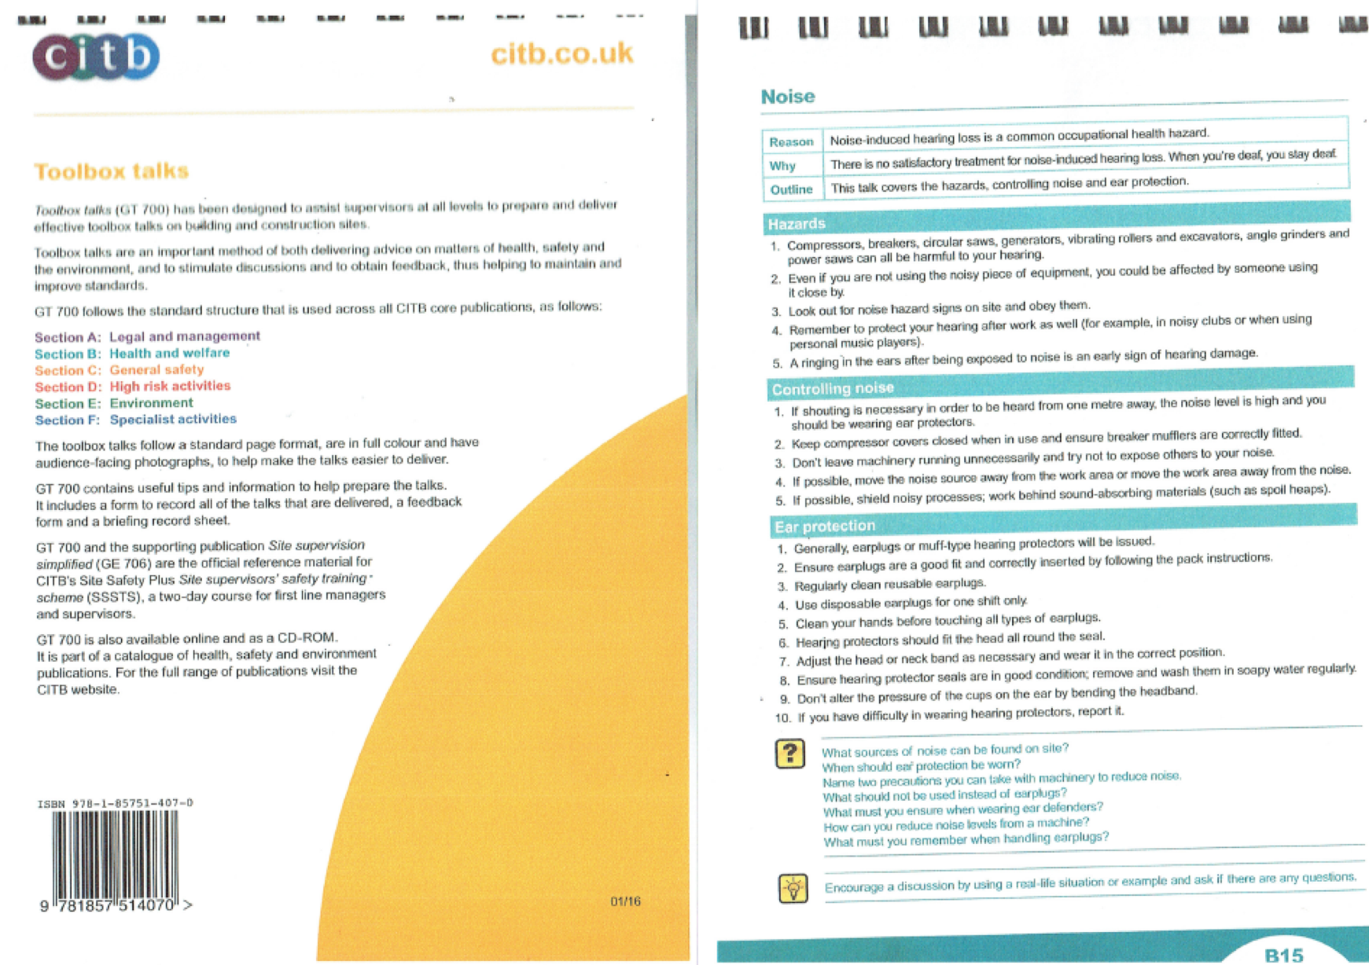
- Please provide details on how dust nuisance arising from dusty activities, on site, will be prevented.

General advice for all construction and demolition sites, as recommended within the Mayor’s SPG for Control of Dust and Emissions during Construction and Demolition (July 2014) include the following:
- Dust suppression and screening must be carried out to minimise the transfer of dust into neighbouring properties.
- Dust generated by the construction process will be suppressed via a fine directional spray jet of water aimed at the source, and any material to be transported to be wetted down prior to transit.
- Skips, chutes and conveyors should be completely covered and, if necessary, completely enclosed to ensure that dust does not escape.
- Drop heights should be minimised to control the fall of materials
- Material as cement, sand, and other aggregates are sealed after use and stored in enclosed or bunded containers or silos and not allowed to dry out, unless this is required for a particular process, in which case should additional control measures are taken in place.
- Cutting equipment to be used with water suppressant and/or suitable extract system
- No burning of waste wood or other materials on site
- The stockpiling of dust generating materials on site will be minimised
- Wet brushing techniques will be used for cleaning
- Regular checks for visual observation of dust and soiling within 50m of site
- Screening to be erected surrounding site boundaries where possible
Regular monitoring may be necessary during the construction operations on site, in order to ensure that measured pollutants do not exceed safe levels, in positions agreed with the Local Authority. Furthermore, according to IAQM guidelines, it would be necessary to inspect the area in the local vicinity of the construction works to ensure that surfaces are not soiled by dust emissions from the site, with suitable cleaning offered if necessary. In order to minimise this, it would be recommended that screens are erected around the site boundaries as appropriate.
See also separate document on dust monitoring & mitigation

- Please provide details describing how any significant amounts of dirt or dust that may be spread onto the public highway will be prevented and/or cleaned.

Refer to question 6.

- Please provide details describing arrangements for monitoring of noise, vibration and dust levels.

Working hours of noisy works to be within LA working hours and any ongoing agreed noisy times.
Site noise records to be kept with register of complaints for reference at all times of works.
Site management systems including distance from operation, party wall and site boundary. Site manager recording are for noisy works only and during the confirmed noisy hour working with LA and party wall surveyor’s requirements.
Noise and vibration monitoring will carried out at elevations of buildings at source through attended monitoring using calibrated equipment: vibration meter SDL800 : Standard S7805 sound meter.
Points for monitoring will be at each source of deconstruction and piling for each level as prescribed by both BS5228-1:2 to ensure vertical monitoring up to roof level from each operation for vibration through cutting and breaking of slab, with immediate vibration monitoring at set pile locations indicated by the Client structural engineer.
At all times of operations continual review and assessment of operations will be carried out to ensure that set reduction measures can be improved on further to exceedances or possible complaints.
During working hours under planning conditions noise monitoring will reduce as works progress to internal fit out within an enclosed working environment. All complaints will automatically be reviewed against site records with any exceedances fully investigated to further improve on noise and vibration mitigation measures. All incidents recorded within the site incident logbook at the site office.
Proposed sampling periods:
Working Phases | Sampling Technique
Normal Working Periods | 5 min every four hours
Noisy Work Periods (2 Hours TBA) | 5 min every half hour

For continued dust soiling management the site manager will carry out daily checks on site levels at boundary caused from works within site and during every delivery / removal of materials along the agreed delivery route.
Water suppressant and sweeping of the site boundary along with additional jet wash and sweeping of all public areas will be carried out following daily and activity inspection as part of the site manager checklist for site management.

Demo One will carry out their own independent monitoring during the demo phase and this will include background readings prior to the works and then at regular intervals during the demolition.
Should the noise criteria agreed with the Local Authority be exceeded during the demolition
and construction programme, the appropriate actions will be taken and any exceedances caused and the subsequent action taken will be recorded

- Please confirm that a Risk Assessment has been undertaken at planning application stage in line with the GLA’s Con t ro l of Du st and Emissions Supplementary Planning Guidance (SPG), and the risk level that has been identified, with evidence. Please attach the risk assessment as an appendix if not completed at the planning application stage.

Under the GLA BPG on “control of dust emissions from construction and demolition” the following assessment has been made.

Size of Site | Number of Properties | Potential Sensitive  Receptors | Construction Impact
700 sqM | Internal sub-division of one property into 7 residential units. | 7-8,13-14 &22 King Mews WC1N 2JB and rear Buildings  at John Street 1-6 WC1N2ES and 37-47 WC1X8PP Grays Inn Road. | Floor removal  Removal of existing building  Removal of debris / waste  Storage of material  Prolonged period of works 14 months  Weather Conditions  Site vehicles
Assessment Site Score |  | Low Risk

- Please confirm that all of the GLA’s ‘highly recommended’ measures from the SPG document relative to the level of risk identified in question 9 have been addressed by completing the GLA mitigation measures checklist. Please attach this as an appendix.

Prevention, suppression and containment of dust and measures relevant to the SPG through the following guidance on low risk development requirements.

Planning
Hoarding barriers / scaffold and mono-flex / netting at site boundary. Immediate barriers at demolition works internally.
No waste storage on site. All dust causing activities located internally in site.
Construction Traffic
No idling vehicles. Wash off vehicles at site exit. Covering all loads entering leaving site.
Demolition / Site Works
Water mist used as suppressant on site. Cutting equipment to use water as suppressant and local exhaust ventilation for plant. Covered skips and minimised drop heights for waste removal at height.

We confirm that measures within the SPG for low risk site will be adhered as attached to this CMP

- If the site is a High Risk Site, 4 real time dust monitors will be required, as detailed in the SPG. Please confirm the location, number and specification of the monitors in line with the SPG and confirm that these will be installed 3 months prior to the commencement of works, and that real time data and quarterly reports will be provided to the Council detailing any exceedances of the threshold and measures that were implemented to address these.

The site is not considered to be high risk site.
The above condition will not apply.

- Please provide details about how rodents, including rats, will be prevented from spreading out from the site. You are required to provide information about site inspections carried out and present copies of receipts (if work undertaken).

Initial baiting has been undertaken by Armour Pest control, Contact details: Adam - 07875 485581
During site set up phase, if any evidence of current rodent infestation is found, the pest control contractor will be instructed to take necessary measures, until such point as the problem has been dealt with.
Record will be kept of this as necessary.
Visual inspections will continue to take place at all likely entry points and any evidence of faeces, gnawing etc will result in the appropriate actions being taken.
Method of removal would be by a baiting programme but this would be subject to site survey
A canteen area will be provided and no food will be allowed to be consumed outside of this area with all rubbish being collected and disposed of on a regular basis to prevent the attraction of rodents.
Drainage will be appropriately capped or sealed during the works.

- Please confirm when an asbestos survey was carried out at the site and include the key findings.

An asbestos survey has been carried out by Omega Asbestos Services (Sept 16) and a copy of this will be given to the demo contractors .
Any removals will be dealt with either prior to or at start of the demo phase.

- Complaints often arise from the conduct of builders in an area. Please confirm steps being taken to minimise this e.g. provision of suitable smoking area, tackling bad language and unnecessary shouting.

All of our site personnel are aware of the need to behave in a professional manner and the same is expected of any subcontractors and this is made clear at the site induction.
An agreed area will be set for any smoking breaks and personnel are aware of the need to dispose of cigarette butts in a correct manner.
Any personnel deemed to be causing a nuisance to third parties would be spoken to immediately about appropriate conduct by the site foreman.
Radio noise will be kept to a sensible level so as not to cause a nuisance to those in the surrounding dwellings or passers-by.

Agreement
The agreed contents of this Construction Management Plan must be complied with unless otherwise agreed in writing by the Council. This may require the CMP to be revised by the Developer and reapproved by the Council. The project manager shall work with the Council to review this Construction Management Plan if problems arise in relation to the construction of the development. Any future revised plan must be approved by the Council in writing and complied with thereafter.

It should be noted that any agreed Construction Management Plan does not prejudice further agreements that may be required such as road closures or hoarding licences.

Signed: …………………………………………………………………

Date: ……………………………………………..

Print Name: ……………………………………………………..….

Position: …………………………………………

Please submit to: planningobligations@camden.gov.uk

End of form.

